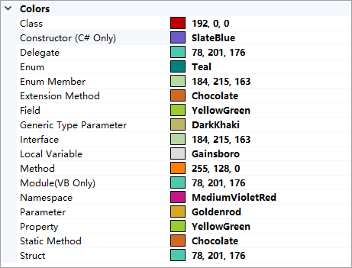

暂时无法导出,手动复制吧
最新版多一个属性,需要注意
192, 0, 0
SlateBlue
78, 201, 176
Teal
184, 215, 163
Chocolate
YellowGreen
DarkKhaki
184, 215, 163
Gainsboro
255, 128, 0
78, 201, 176
MediumVioletRed
Goldenrod
YellowGreen
Chocolate
78, 201, 176

下载扩展地址
https://marketplace.visualstudio.com/items?itemName=Xellarix.ColorCoder

