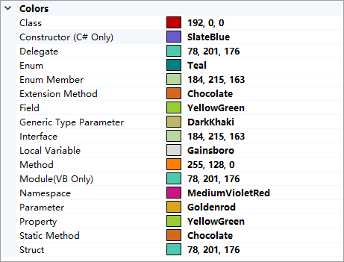

暂时无法导出,手动复制吧
192, 0, 0
SlateBlue
78, 201, 176
Teal
184, 215, 163
Chocolate
YellowGreen
DarkKhaki
184, 215, 163
255, 128, 0
78, 201, 176
MediumVioletRed
Goldenrod
YellowGreen
Chocolate
78, 201, 176

