Unix Commands Assignment
Slide no. 41
1. Create folder 'Test' in your home directory​
Ans: mkdir Test
2. Create below files​
- employeelist​
- skillset​
Ans: cat >employeelist
cat >skillset
3. Create folder Test2 in home directory​
A: mkdir Test2
3.a. create symbolink and hard link for skillset file
A: command to create symbolink:- ln -s skillset slink
command to create hardlink:- ln skillset hardlink
The output will look like below image:
3.b delete skillset file and check if hardlink and symbolic link file exists​
A: command to del skillset: rm skillset
command to check slink: cat slink
command to check hardkink: cat hardlink
The output will look like:
Symbolic link will not execute when the linked file is deleted but hardlink will execute the linked file contents even after deleting the file.
3.c Give difference between symbolic link and hard link.
A: A hard link is essentially a synced carbon copy of a file that refers directly to the inode of a file.A hard link is a direct reference to a file via its inode.By using a hardlink, you can change the original file’s contents or location and the hardlink will still point to the original file because its inode is still pointing to that file.
Symbolic links on the other hand refer directly to the file which refers to the inode, a shortcut. Symbolic links are essentially shortcuts that reference to a file instead of its inode value.Since the symbolic link is referring to the original file and not its inode value, then replacing the original file into a different folder will break the symbolic link.
4. Provide read and write permission to 'user2' group​
A: command: sudo chgrp user2 filename
5. Revoke write permission from user2 group
A: command: chmod 744 demofile
(where demofile is the filename)

6.Grant write permission for others and test it
A: Command: chmod 746 demofile
7. Revoke write permission for others
A: Command: chmod 744 demofile
8. Change the group of employeelist file to 'user3'
A: command: sudo chgrp user3 employeelist
9. Change ownership of the file to user5
A: command: chown user5 employeelist
10. check how many employees are there
A: command: wc employeelist -l
The output looks like:
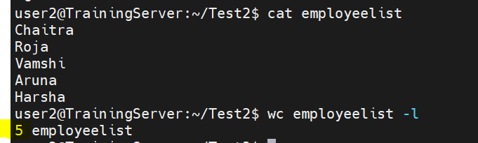

Slide no. 47
1. Create a File1
A: command: cat >File1
2. Append 2 more lines to the same file
A: command:cat >>File1
The output of above two commands is
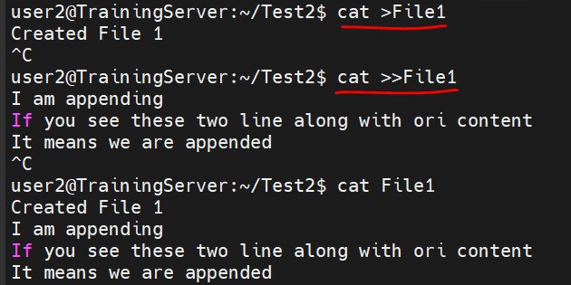

3. Create file two with few lines
A: command: cat >File2
Created file2
These two lines are initial contents of File2
4. Display contents of both File1 and File2
A: command: cat File1 File2
The output of above two commands:
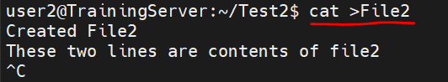

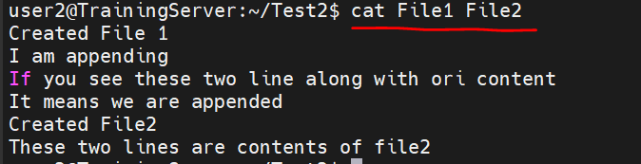

5. Concatenate both File1 & 2
A: command: cat File1 File2
6. Send the output to File3
A: command: cat File1 File2 >>File3
The ouput for 6. is:
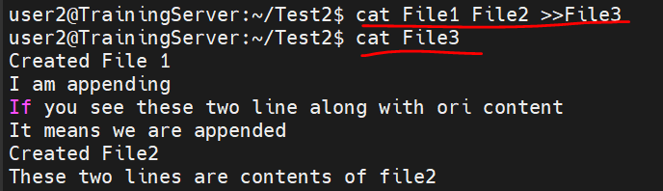

7. Read File1, File2, File3....File5
A: command: cat File1, File2, File3, File4, File5
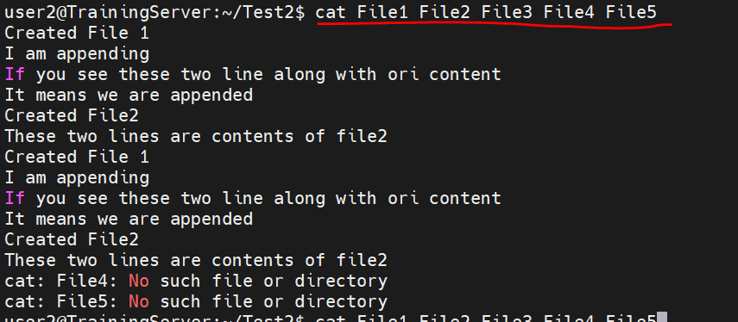

8.Redirect the errors of the above command to “errorlog”
A: command: cat File1, File2, File3, File4, File5 2>errorlog
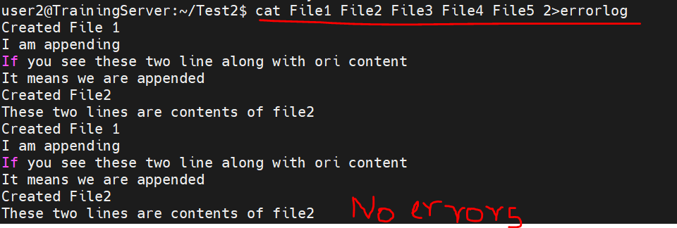
9. Concatenate name File1 to 5 and store it in File 10. if any errors, log them in the same file
A: command: cat File1, File2, File3, File4, File5 >>File10
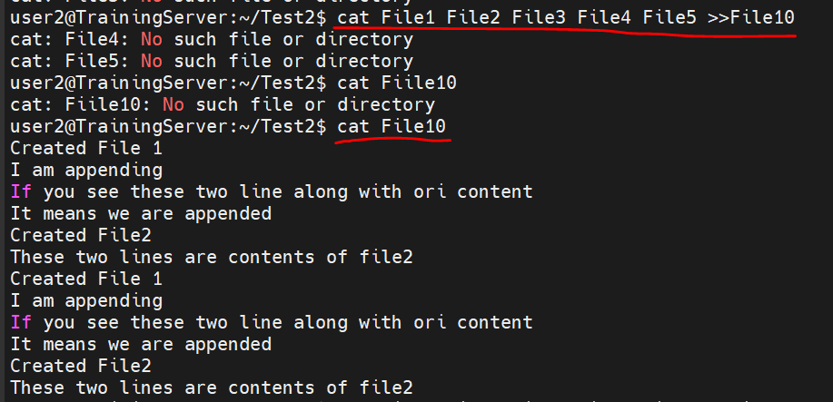
10. Copy File1 to File6. Add the errors to “errorlog”
A: command: cp File1 File6 2>errorlog
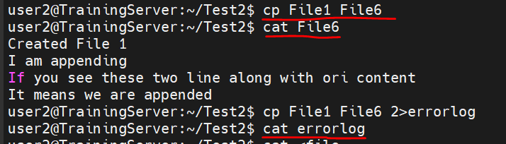

Slide no. 55
1. Retrive The 10th to 25th lines in a file
A: command: tail +10 filtersfile|head -16
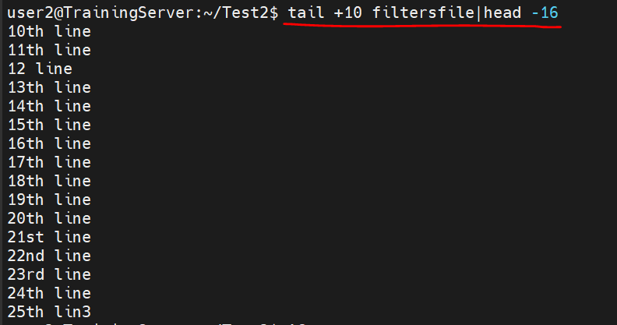

2. List only 10th line in a file
A: command: tail +10 filtersfile|head -1
3. List only the recently modified file in the current directory

A: command: find . -mmin -2 [Note to self: here, -2 refers to find the file that was modified at least 2 mins ago. Similarly, you can find files using “-mtime -2” which will give files modifies at least a day ago]
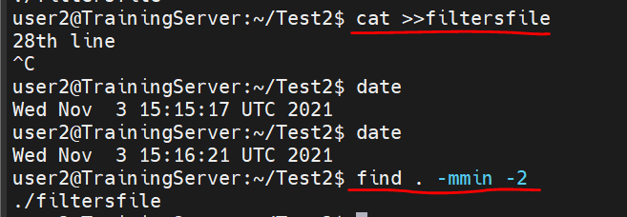

4. List only the smallest file in the current directory​
A: command: ls -lsr| sort -n| head -1
To check the file sizes command: ls -lsr
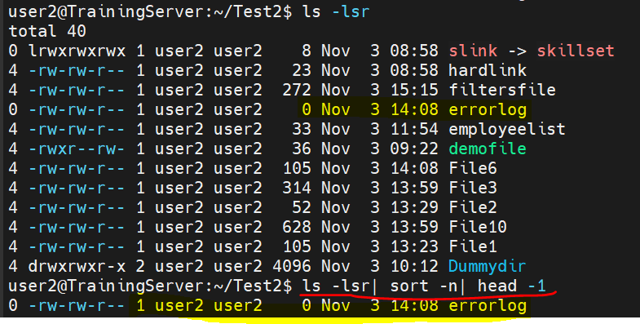

Slide no. 61
1. Lines containing A
A: command: grep "A" employeelist
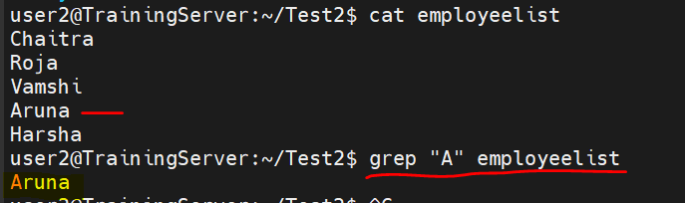
2. lines containing “The”at the beginning​
A: command: grep “^The” demofile
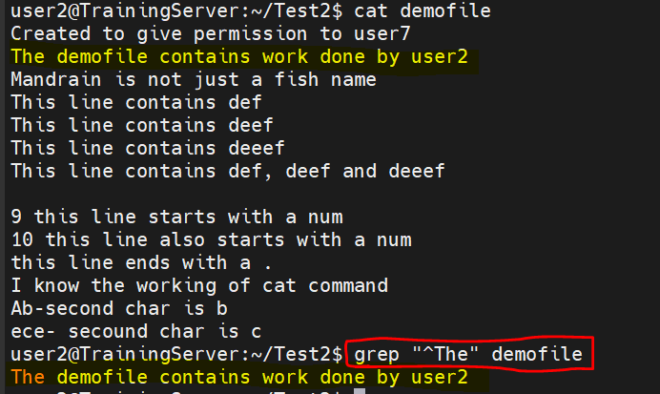

3. lines ending with .
A: command: grep "\.$" demofile [Note to self: grep can match the beginning of a line with the '^' character and the end of a line with the '$' character. Any character is matched by the '.' character, so to match a literal "." you will need to use the escaped '\.' sequence]
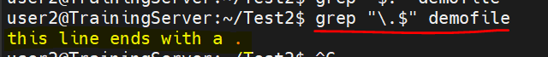

4. lines with a,b or c as the second letter
A: command: grep "^.[abc]" demofile [Note to self: [...] any character inside ‘[]’ wil be considered. Opposite of this is [^..] ]
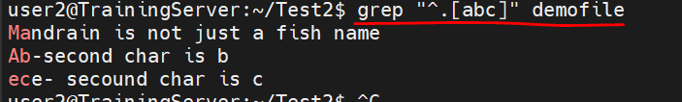

5. lines which contain def , deef or deeeef
A: command: egrep 'def|deef|deeef' demofile
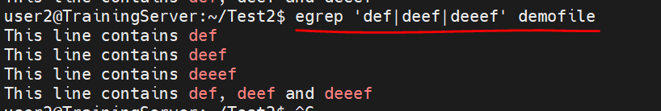

6. lines not having numbers at the beginning
A: command : grep '^[^0-9]' demofile [Note: ‘^’-The beginning of a text line and [^..]- Any character not in the list or range]
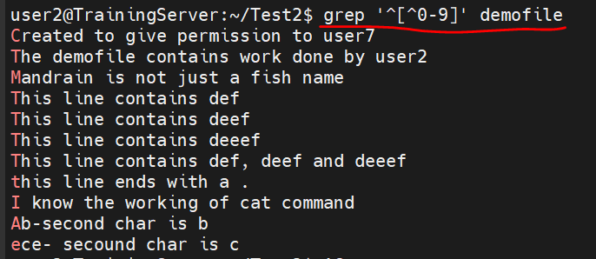

7. empty lines
A: command: grep '^$' demofile
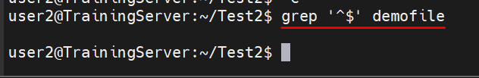

8. list the password file details of user1 – user10​
A: command: grep '^user*' ../../etc/passwd| head -10
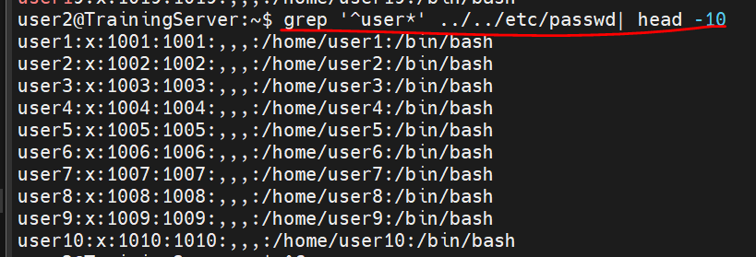

9. list only directories
A: command: ls -d */ (or)
ls -l | grep '^d' (or)
ls -l | egrep '^d'
10.

