Branch: MCA (Data Science) | Semester: 2nd
Student Name: Chaitanya Sharma | UID: 25MCD10056
Subject Name: Technical Training - I Lab | Subject Code: 25CAP-652
Section/Group: 25MCD-1(A) | Date of Performance: 06-Jan-2026

Experiment No.: 1.1

- Aim: To design and implement a sample database system using DDL, DML, and DCL commands, including database creation, data manipulation, schema modification, and role-based access control to ensure data integrity and secure, read-only access for authorized users.

- S/W Requirement: Oracle Database Express Edition and PGAdmin
- Objectives: To gain practical experience in implementing Data Definition Language (DDL), Data Manipulation Language (DML), and Data Control Language (DCL) operations in a real database environment. This will also include implementing role-based privileges to secure data.

- Task to be done:
Database Design:
  - Create multiple tables such as Department, Employee, and Project.
  - Define appropriate PRIMARY KEY and FOREIGN KEY constraints
  - Enforce NOT NULL, UNIQUE, and CHECK constraints where necessary.

Data Manipulation:
  - Insert sample records into all tables.
  - Perform UPDATE operations to modify existing records.
  - Perform DELETE operations while maintaining referential integrity.

Access Control & Security:
  - Create a role/user for a reporting staff member.
  - Grant ONLY SELECT privilege on required tables to this role/user.
  - Explicitly REVOKE CREATE privilege so that the user cannot create any database objects.
  - Ensure the user has read-only access to the database.

Schema Modification:
  - Use ALTER TABLE to add or modify a column.
  - Drop a table that is no longer required using DROP TABLE.
5. Code:
-- Create multiple tables such as Department, Employee, and Project.
-- Define appropriate PRIMARY KEY and FOREIGN KEY constraints.
CREATE TABLE TEST_TABLE (
test_id INT PRIMARY KEY,
test_value VARCHAR(20)
);
INSERT INTO TEST_TABLE VALUES
(1, 'Sample1'),
(2, 'Sample2');
CREATE TABLE DEPARTMENT (
dept_id INT PRIMARY KEY,
dept_name VARCHAR(30) NOT NULL UNIQUE CHECK(length(dept_name) > 0)
);
CREATE TABLE EMPLOYEE(
emp_id INT PRIMARY KEY CHECK(emp_id > 0),
emp_name VARCHAR(30) NOT NULL CHECK(length(emp_name) > 0),
dept_id INT REFERENCES DEPARTMENT(dept_id)
);

CREATE TABLE PROJECT(
proj_id INT PRIMARY KEY CHECK(proj_id > 0),
proj_name VARCHAR(30) NOT NULL UNIQUE CHECK(length(proj_name) > 0),
dept_id INT REFERENCES DEPARTMENT(dept_id)
);
INSERT INTO DEPARTMENT (dept_id, dept_name) VALUES
(1, 'Human Resources'),
(2, 'Information Technology'),
(3, 'Finance'),
(4, 'Marketing');
INSERT INTO EMPLOYEE (emp_id, emp_name, dept_id) VALUES
(101, 'Amit Sharma', 2),
(102, 'Priya Verma', 1),
(103, 'Rahul Mehta', 2),
(104, 'Neha Singh', 3),
(105, 'Karan Patel', 4);
INSERT INTO PROJECT (proj_id, proj_name, dept_id) VALUES
(201, 'Payroll Automation', 1),
(202, 'Library Management System', 2),
(203, 'Budget Analysis 2025', 3),
(204, 'Digital Marketing Campaign', 4);

-- UPDATE:
UPDATE DEPARTMENT
SET dept_name = 'Information Technology'
WHERE dept_name = 'IT Services';
UPDATE EMPLOYEE
SET dept_id = 2
WHERE emp_name = 'Rahul Mehta';
-- DELETE:
INSERT INTO EMPLOYEE (emp_id, emp_name, dept_id) VALUES
(107, 'A. Sharma', 4);
DELETE FROM EMPLOYEE
WHERE emp_id = 107;
-- Role/User:
CREATE ROLE reporting_role;
CREATE ROLE report_user
LOGIN
PASSWORD 'report123';
-- User inherits the role:
GRANT reporting_role TO report_user;
-- Granting SELECT permissions:
GRANT SELECT ON DEPARTMENT, EMPLOYEE, PROJECT TO reporting_role;

-- Explicitly revoking CREATE permission (Not provided by default):
REVOKE CREATE ON "Exp1.1" TO reporting_role;
-- Schema Modification:
ALTER TABLE PROJECT
RENAME COLUMN "proj_id" TO "project_id";
DROP TABLE TEST_TABLE;
6. Tables:
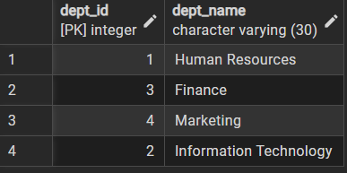

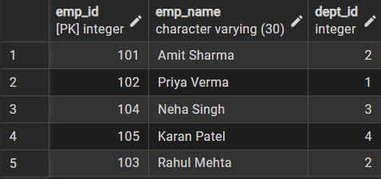

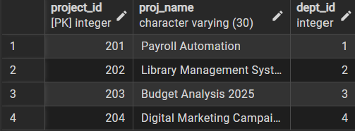

- Learning Outcomes:

- Learned to design tables using primary keys, foreign keys, and constraints to maintain data integrity.
- Understood how to modify and remove data safely using UPDATE, DELETE, and DROP operations.
- Gained practical knowledge of PostgreSQL roles and privileges to implement secure, read-only access.

