Branch: MCA (Data Science) | Semester: 2nd
Student Name: Chaitanya Sharma | UID: 25MCD10056
Subject Name: Technical Training - I Lab | Subject Code: 25CAP-652
Section/Group: 25MCD-1(A) | Date of Performance: 21-Jan-2026

Experiment No.: 2

- Aim: To implement and analyze SQL SELECT queries using filtering, sorting, grouping, and aggregation concepts in PostgreSQL for efficient data retrieval and analytical reporting.

- S/W Requirement: Oracle Database Express Edition and PGAdmin

- Objectives: Implementation of SELECT Queries with Filtering, Grouping and Sorting in PostgreSQL
- To retrieve specific data using filtering conditions
- To sort query results using single and multiple attributes
- To perform aggregation using grouping techniques
- To apply conditions on aggregated data
- To understand real-world analytical queries commonly asked in placement interviews

- Task to be done:

Step 1: Database and Table Preparation
- Start the PostgreSQL server.
- Open the PostgreSQL client tool.
- Create a database for the experiment.
- Prepare a sample table representing customer orders containing details such as customer name, product, quantity, price, and order date.
- Insert sufficient sample records to allow meaningful analysis.
- Purpose: To create a realistic dataset for performing analytical queries.

Step 2: Filtering Data Using Conditions
- Execute data retrieval operations to display only those records that satisfy specific conditions, such as higher‑priced orders.
- Observe how filtering limits the number of rows returned.

Observation: Filtering reduces unnecessary data processing and improves query efficiency.

Step 3: Sorting Query Results

● Retrieve selected columns from the table and arrange the output based on numerical values such as price.

● Perform sorting using both ascending and descending order.

● Apply sorting on more than one attribute to understand priority‑based ordering.

Observation: Sorting is essential for reports, rankings, and ordered displays.

Step 4: Grouping Data for Aggregation

● Group records based on a common attribute such as product.

● Calculate aggregate values like total sales for each group.

● Analyze how multiple rows are combined into summarized results.

Observation: Grouping transforms transactional data into analytical

insights.
Step 5: Applying Conditions on Aggregated Data

● Apply conditions on grouped results to retrieve only those groups that satisfy specific aggregate criteria.

● Compare the difference between row‑level filtering and group‑level filtering.

Observation: Conditions applied after grouping allow refined analytical reporting.
Step 6: Conceptual Understanding of Filtering vs Aggregation Conditions

● Analyze scenarios where conditions are incorrectly applied before grouping.

● Correctly apply conditions after grouping to avoid logical errors.

Observation: Understanding execution order prevents common SQL mistakes frequently tested in interviews.

4. Dataset:
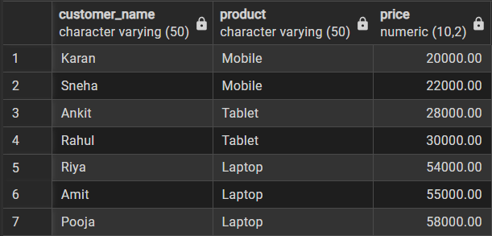

5. Code:
-- Step 1
CREATE TABLE customer_orders (
order_id SERIAL PRIMARY KEY,
customer_name VARCHAR(50),
product VARCHAR(50),
quantity INT,
price NUMERIC(10,2),
order_date DATE
);

INSERT INTO customer_orders
(customer_name, product, quantity, price, order_date)
VALUES
('Amit', 'Laptop', 1, 55000, '2024-01-10'),
('Riya', 'Laptop', 2, 54000, '2024-01-12'),
('Karan', 'Mobile', 3, 20000, '2024-01-15'),
('Sneha', 'Mobile', 1, 22000, '2024-01-16'),
('Rahul', 'Tablet', 2, 30000, '2024-01-18'),
('Pooja', 'Laptop', 1, 58000, '2024-01-20'),
('Ankit', 'Tablet', 3, 28000, '2024-01-22');
-- Step 2:
SELECT *
FROM customer_orders
WHERE price > 30000;
--Step 3:
SELECT customer_name, product, price
FROM customer_orders
WHERE price > 20000
ORDER BY price ASC;
SELECT customer_name, product, price
FROM customer_orders
WHERE price > 20000
ORDER BY price DESC;

-- Step 4:
SELECT *
FROM customer_orders
WHERE price > 30000;
-- Step 5:
SELECT product,
SUM(quantity * price) AS total_sales
FROM customer_orders
GROUP BY product
HAVING SUM(quantity * price) > 100000;
-- Step 6:
select product, sum(quantity*price) as total_revenue
from customer_orders
where order_date >= '2024-01-15'
group by product
having sum(quantity*price) > 50000;

- Output:

- Step-2:
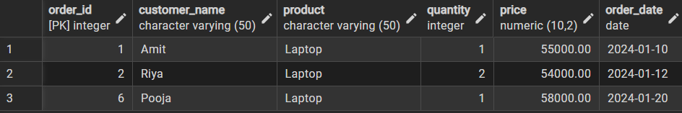

- Step-3:
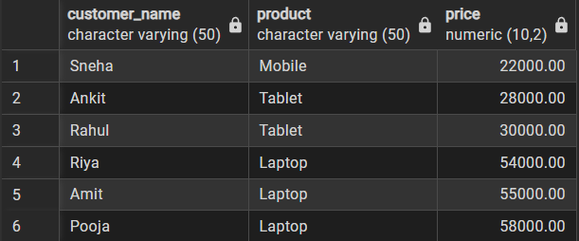
Order by ASC:

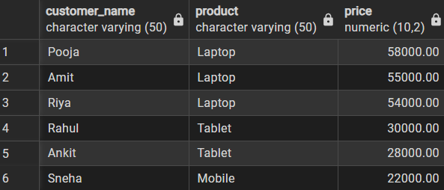
Order by DESC:

- Step-4:
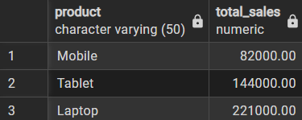

- Step-5:
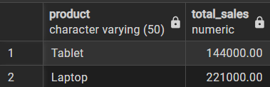

- Step-6:
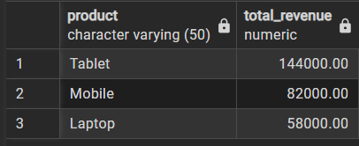

- Learning Outcomes:

- Students understand how data can be filtered to retrieve only relevant records from a database.
- Students learn how sorting improves readability and usefulness of query results in reports.
- Students gain the ability to group data for analytical purposes.
- Students clearly differentiate between row-level conditions and group-level conditions.
- Students develop confidence in writing analytical SQL queries used in real-world scenarios.
- Students are better prepared to answer SQL-based placement and interview questions related to filtering, grouping, and aggregation.

