Branch: MCA (Data Science) | Semester: 2nd
Student Name: Chaitanya Sharma | UID: 25MCD10056
Subject Name: Technical Training - I Lab | Subject Code: 25CAP-652
Section/Group: 25MCD-1(A) | Date of Performance: 27-Jan-2026

Experiment No.: 3

- Aim: To implement conditional decision-making logic in PostgreSQL using IF–ELSE constructs and CASE expressions for classification, validation, and rule-based data processing.

- S/W Requirement: PostgreSQL, PG Admin

- Objectives:

- To understand conditional execution in SQL

- To implement decision-making logic using CASE expressions

- To simulate real-world rule validation scenarios

- To classify data based on multiple conditions

- To strengthen SQL logic skills required in interviews and backend systems

- Task to be done:

- Step 1: Classifying Data Using CASE Expression
- Retrieve schema names and their violation counts.
- Use conditional logic to classify each schema into categories such as
  - No Violation
  - Minor Violation
  - Moderate Violation
  - Critical Violation

- Step 2: Applying CASE Logic in Data Updates

- Add a new column to store approval status
- Update this column based on violation count using conditional rules such as
  - Approved
  - Needs Review
  - Rejected
- Step 3: Implementing IF–ELSE Logic Using PL/pgSQL

- Use a procedural block instead of a SELECT statement.
- Declare a variable representing violation count.
- Display different messages based on the value of the variable using IF–ELSE logic.

- Step 4: Real-World Classification Scenario (Grading System)

- Create a table to store student names and marks.
- Classify students into grades based on their marks using conditional logic

- Step 5: Using CASE for Custom Sorting
- Retrieve schema details.
- Apply conditional priority while sorting records based on violation severity.
- Table:

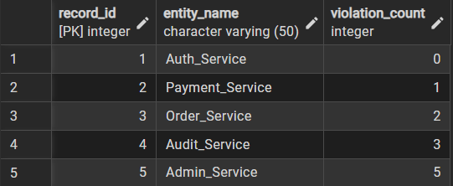

- Code:

CREATE TABLE violation_review (
record_id SERIAL PRIMARY KEY,
entity_name VARCHAR(50) NOT NULL,
violation_count INT NOT NULL CHECK (violation_count >= 0)
);
INSERT INTO violation_review (entity_name, violation_count) VALUES
('Auth_Service', 0),
('Payment_Service', 1),
('Order_Service', 2),
('Audit_Service', 3),
('Admin_Service', 5);

SELECT * FROM violation_review;

-- case statement to classify violaions:
SELECT *,
CASE WHEN violation_count = 0 THEN 'No Violations'
WHEN violation_count BETWEEN 1 and 2 THEN 'Moderate Violations'
ELSE 'Critical Violations'
END AS violations_level
FROM violation_review;

-- Adding a status column:
ALTER TABLE violation_review
ADD COLUMN status VARCHAR(20);

-- case statement to update status column:
UPDATE violation_review
SET status =
CASE WHEN violation_count = 0 THEN 'Accepted'
WHEN violation_count BETWEEN 1 AND 2 THEN 'Reveiwing'
ELSE 'Rejected'
END
WHERE status IS NULL;

-- If Else:
DO $$
DECLARE
v_count INT;
BEGIN
SELECT violation_count
INTO v_count
FROM violation_review
WHERE entity_name = 'Payment_Service';

IF v_count = 0 THEN
RAISE NOTICE 'Payment_Service: Accepted';

ELSIF v_count = 1 THEN
RAISE NOTICE 'Payment_Service: Needs Review';

ELSE
RAISE NOTICE 'Payment_Service: Rejected';
END IF;
END $$;

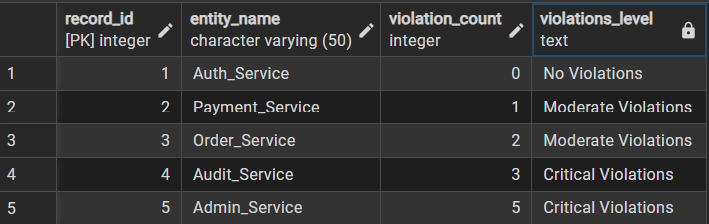

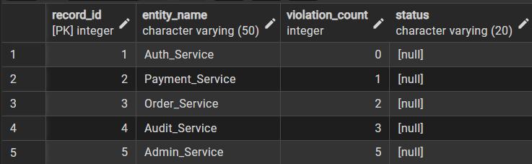

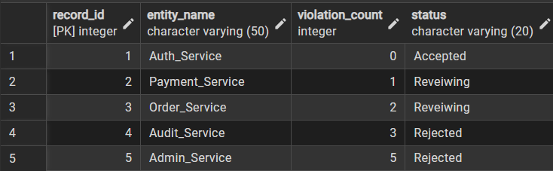

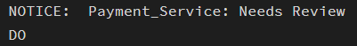

- Learning Outcomes:

- Understand and implement conditional decision-making logic in PostgreSQL using CASE expressions and IF–ELSE constructs.

- Apply rule-based classification and validation logic directly at the database level using SELECT, UPDATE, and DO blocks.

- Demonstrate backend procedural control by using PL/pgSQL to evaluate conditions and automate status assignment based on violation severity.

