Branch: MCA (Data Science) | Semester: 2nd
Student Name: Chaitanya Sharma | UID: 25MCD10056
Subject Name: Technical Training - I Lab | Subject Code: 25CAP-652
Section/Group: 25MCD-1(A) | Date of Performance: 13-Jan-2026

Experiment No.: 1.2

- Aim: You are given a database table named Students that stores academic and personal information of students in an institution. Each record includes Student ID, Student Name, City, and Percentage.

- Objectives:

Your task is to:
- Count of students with percentage > 95 Using Case Statement and Without Case Statement
- Find the average percentage of students in each city whose percentage is greater than 95 Using Case Statement and Order by percentage in Descending Order.

Assumption:
- Each city has 3 students in total
- Out of those, 2 students have percentage > 95
- Average should be calculated only on students with percentage > 95

This analysis helps the institution identify cities with high-performing students.

- S/W Requirement: Oracle Database Express Edition or PGAdmin

- Sample Tables:
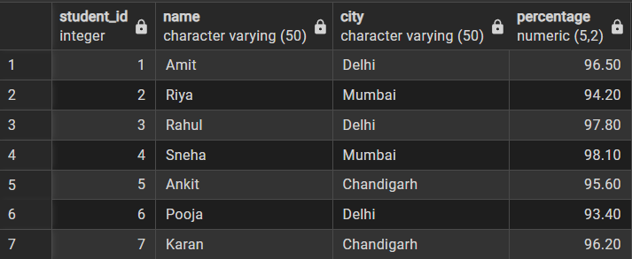

- Code:

CREATE TABLE Students (

student_id INT,

name VARCHAR(50),

city VARCHAR(50),

percentage DECIMAL(5,2)

);

INSERT INTO Students VALUES

(1, 'Amit', 'Delhi', 96.5),

(2, 'Riya', 'Mumbai', 94.2),

(3, 'Rahul', 'Delhi', 97.8),

(4, 'Sneha', 'Mumbai', 98.1),

(5, 'Ankit', 'Chandigarh', 95.6),

(6, 'Pooja', 'Delhi', 93.4),

(7, 'Karan', 'Chandigarh', 96.2);

---Without Case Statement

SELECT CITY , COUNT(*) AS STUDET_COUNT FROM Students

WHERE percentage> 95

GROUP BY city
- Output:
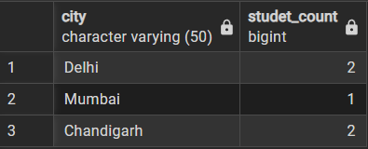

-- With CASE Statement

SELECT CITY, SUM(CASE WHEN percentage> 95 THEN 1

ELSE 0 END) AS STUDENT_COUNTS FROM Students

GROUP BY city
- Output:
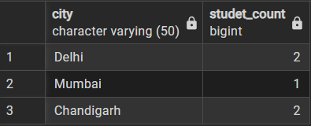

-- (II)
SELECT CITY, AVG(CASE WHEN PERCENTAGE>95 THEN PERCENTAGE ELSE
NULL END) AS STUDENT_AVG FROM Students
GROUP BY city
ORDER BY STUDENT_AVG DESC;

- Output:
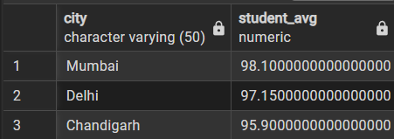

- Learning Outcomes:
- I learned how to use a CASE statement inside aggregate functions to conditionally count and calculate values without filtering rows beforehand.
- Understood the difference between using WHERE clauses and CASE statements for grouping and analyzing data across all categories.
- I learned how CASE with SUM and AVG helps perform flexible, condition-based analysis while still keeping all groups in the result set.

