FREELANCE MANAGEMENT SYSTEM
Project Report
AI Lab Project

SUBMITTED BY:
Member 1 | Zain ul Abideen  Reg No:2025888
Member 2 | Amna Aamer  Reg No:2025133

1. Project Overview
A Python-based CLI application to manage freelance work — clients, projects, invoices, earnings, and reports — all in one place, with data stored in JSON files.
Key technical highlights:
- Built entirely in Python; runs from the terminal
- Persistent storage via JSON files — auto-load on startup, auto-save on every change
- Bonus: live USD→PKR rate via web scraping (BeautifulSoup)
- Bonus: automated invoice email delivery via Gmail SMTP
Core objectives achieved:
- Persist all data using JSON files — load on startup, save on every change automatically
- Model the domain using OOP — separate Client, Project, and Invoice classes with encapsulation
- Support full CRUD (Add, View, Update, Delete) for clients, projects, and invoices
- Compute gross earnings, tax estimate, net income, and profit margin
- Generate three Matplotlib charts and save them as PNG files in the reports/ folder
- Validate all user input and handle all exceptions — no raw tracebacks ever shown
- [Bonus] Scrape live USD-to-PKR exchange rate from forex.pk using BeautifulSoup
- [Bonus] Send invoice emails directly to clients via Gmail SMTP using python-dotenv for secure credentials.

2.System Architecture and Class Design

Three-layer architecture keeps the code modular and easy to extend:
- Models layer — domain objects (Client, Project, Invoice)
- Utils layer — services: file I/O, finance, charts, email, currency
- main.py — CLI entry point with all menus and the main loop

File | What it does
main.py | CLI entry point — all menus, user prompts, and the main loop
models/client.py | Client class — stores client info with private attributes and getters/setters
models/project.py | Project class — stores project details, computes gross earning, detects overdue
models/invoice.py | Invoice and InvoiceItem classes — multi-currency support, tax, formatted print
utils/file_handler.py | JSON load/save for all three entities and auto ID generation
utils/finance.py | Pandas-based financial summary, monthly report, and client earnings report
utils/visualizer.py | Three Matplotlib charts using dark theme, saved as PNG in reports/
utils/currency.py | [Bonus] Scrapes live USD→PKR rate from forex.pk via BeautifulSoup
utils/emailer.py | [Bonus] Sends formatted invoice emails via Gmail SMTP using .env credentials
data/*.json | Persistent storage for clients, projects, and invoices
reports/*.png | Folder where generated chart images are saved

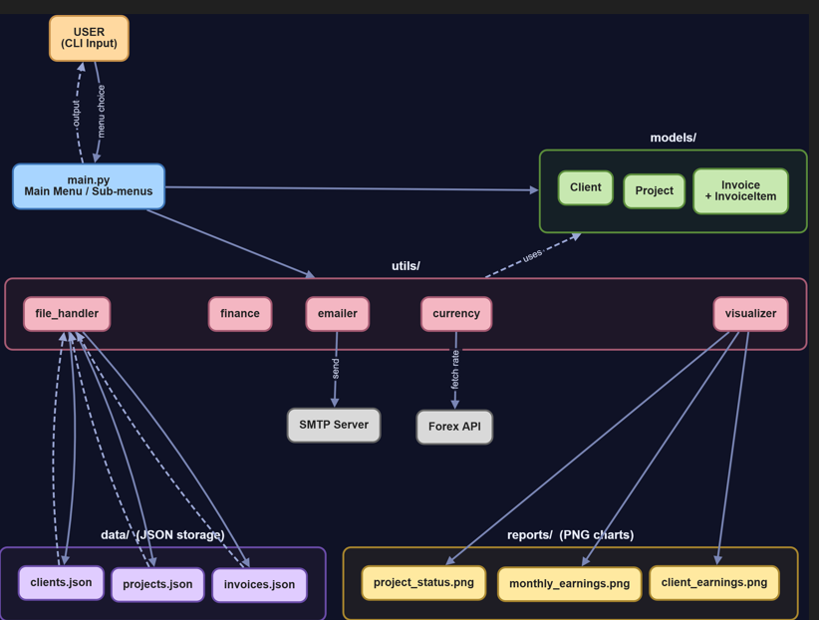

Class Design Summary

Class | Private Attributes | Methods
Client | client_id, name, email, phone, company, payment_terms | to_dict(), from_dict(), __str__()
Project | project_id, title, client_id, deadline, hourly_rate, hours_worked, status, description | gross_earning() = hourly_rate × hours_worked; is_overdue() compares deadline to today
Invoice | invoice_id, client_id, project_id, issue_date, due_days, items[], status, currency, fx_rate | subtotal(), tax_amount(), grand_total(), convert(), due_date(), display_total()
InvoiceItem | description, quantity, unit_price | total() = quantity × unit_price

All class attributes are private (double underscore prefix in Python). Outside code cannot access them directly — it must use the getter and setter methods. This is standard encapsulation. The to_dict() and from_dict() class methods handle conversion to and from JSON-friendly dictionaries, which is how the data is stored on disk.
3.Module-by-Module Implementation

3.1 Client Management (models/client.py + main.py)
Client stores six private attributes; payment terms are validated against a fixed list:
- Attributes: client_id, name, email, phone, company, payment_terms
- Allowed terms: Net 15 | Net 30 | Net 60 | Immediate
- CLI: view all, add (auto ID), update (blank = keep old value), delete
- Sample clients: Zain (Google), Ali (Meta), Doremon (ASML), Amna (Google)

3.2 Project Management (models/project.py + main.py)
Project is linked to a client via client_id and supports full CRUD:
- Attributes: title, client_id, deadline, hourly_rate, hours_worked, status, description
- gross_earning() = hourly_rate × hours_worked
- is_overdue() — flags project if deadline passed and status ≠ Completed
- Status options: Pending | In Progress | Completed | Cancelled
- 6 sample projects across 4 clients (web dev, API, design, AI tooling)

3.3 Invoice Management (models/invoice.py + main.py)
Invoice is the most feature-rich class — linked to both client and project:
- Supports multiple InvoiceItems (description, quantity, unit price)
- Auto-computes subtotal, tax (10%), and grand total
- Multi-currency: USD or PKR with live rate fetched at creation time
- fx_rate locked into invoice — display is always historically accurate
- Menu options: view, add, update status, delete, email to client

3.4 Reports and Analytics (utils/finance.py + utils/visualizer.py)
The Reports module provides four menu options:
- Full financial summary — calculate_summary() in utils/finance.py
- Month-by-month earnings breakdown — Pandas groupby on deadline month
- Client-wise earnings ranking
- Generate all three Matplotlib charts at once and save as PNG in reports/
- Only completed projects are used for tax and net income calculations

4.Bonus Features

4.1 Live Currency Conversion (utils/currency.py)
Fetches live USD→PKR rate from forex.pk at invoice-creation time:
- GET request to forex.pk; BeautifulSoup parses the RATESPAN element; 15 s timeout
- Layered error handling: network failure → missing element → fallback constant (280.0)
- User may enter a manual rate or revert to USD if fetching fails
- fx_rate is locked into the invoice at creation — historically accurate display

4.2 Automated Invoice Email (utils/emailer.py)
Sends a formatted invoice email to the client directly from the CLI:
- Uses smtplib + email.message over Gmail SMTP SSL (port 465)
- Credentials loaded from .env via python-dotenv — never hardcoded
- Pre-send checks: credentials present, client email contains @
- Email body = invoice’s own __str__() output (same view as terminal)
- Returns (success, message) tuple — caller shows clean result, no crash
- CLI flow: enter invoice ID → confirm total + email → type ‘yes’ to send

5.Financial Logic and Calculations

All financial logic lives in utils/finance.py. calculate_summary() returns a metrics dict passed to print_financial_summary() for terminal output:
- Only completed projects count toward tax and net income
- monthly_earnings_report() and client_earnings_report() use Pandas groupby
- Invoice totals always use USD base (grand_total()) for consistent summaries

Metric | Formula
Gross Earning (per project) | Project.gross_earning() = hourly_rate × hours_worked
Gross All | Sum of gross_earning() for every project regardless of status
Gross Completed | Sum of gross_earning() only for projects where status == 'Completed'
Tax Estimate | Gross Completed × 0.10 (TAX_RATE constant in Invoice class)
Net Income | Gross Completed − Tax Estimate
Profit Margin % | ( Net Income / Gross Completed ) × 100
Average Project Value | Gross Completed / number of completed projects
Total Invoiced | Sum of grand_total() across all invoices (USD base)
Total Received | Sum of grand_total() for invoices where status == 'Paid'
Total Pending | Sum of grand_total() for invoices where status == 'Unpaid'

Example using the actual sample data in the project (5 completed projects):

Metric | Value
Total Projects | 6
Completed Projects | 5
Gross Earnings — All Projects | $8,740.00
Gross Earnings — Completed Only | $7,140.00
Tax Estimate (10%) | $714.00
Net Income | $6,426.00
Profit Margin | 90.0%
Average Project Value | $1,428.00

6.Data Persistence

Three JSON files in data/ persist all state; file_handler.py owns all I/O:
- On startup: load_clients(), load_projects(), load_invoices() — empty list if file absent
- Every mutating action immediately calls the corresponding save function — no manual save step
- _load_json() catches both missing files and JSONDecodeError, returns empty list
- next_id() scans max existing ID and zero-pads to 3 digits (e.g. C003) — safe after deletions

7.Data Visualisation

utils/visualizer.py generates three dark-themed Matplotlib charts saved as PNG in reports/:
- matplotlib.use(‘Agg’) set at top — renders to file, no display needed
- Dark navy theme (#1a1a2e background, #e0e0e0 text, plt.cm.cool colormap for bars)
- Saved with dpi=150 and bbox_inches=‘tight’; plt.close() frees memory
- generate_all_charts() calls all three in sequence from the Reports menu

File | Chart Type | What it shows
monthly_earnings.png | Vertical Bar | USD earnings per month for completed projects — uses Pandas groupby on deadline month
project_status.png | Pie Chart | Percentage of projects in each status — Pending, In Progress, Completed, Cancelled
client_earnings.png | Horizontal Bar | Total USD earned per client from completed projects, sorted highest to lowest

8.Error Handling and Validation

A central get_input() loop in main.py ensures the program never crashes on bad input — it re-prompts until the user provides a valid value. All validation rules are applied in one place:

Validation | How it works
Required fields | If required=True and input is empty, re-prompts with '[!] This field is required.'
Type checking | input_type=float or int triggers ValueError catch; the user sees a clear message like 'float is required'
Range validation | min_val and max_val parameters enforce numeric bounds — e.g. hourly rate cannot be less than 0.1
Date format | get_date_input() uses datetime.strptime() to enforce YYYY-MM-DD; wrong format re-prompts
ID existence check | Before linking a project to a client, or an invoice to a project, the system verifies the ID exists
Delete confirmation | User must type 'yes' to confirm deletion — a blank Enter or anything else cancels it
File I/O errors | All JSON load/save calls in file_handler.py are in try/except; errors print a message, not a traceback
Network errors (currency) | requests.RequestException, ValueError, and bare Exception all caught in currency.py
Email errors | smtp login and send wrapped in try/except; returns (False, error_message) tuple on failure
Keyboard interrupt (Ctrl+C) | All data-entry flows catch KeyboardInterrupt and cancel gracefully; main loop has a top-level catch

9.Challenges and How We Solved Them

Challenge | Solution
Matplotlib not rendering in CLI | Set matplotlib.use('Agg') before importing pyplot. This switches to the non-interactive file-rendering backend so charts save to PNG without needing a display.
Keeping JSON files in sync with memory | Every mutating operation (add, update, delete) immediately calls the corresponding save_*() function. There is no separate 'save' step the user has to remember.
Multi-currency invoices with a snapshot rate | We store the fx_rate inside the invoice at creation time. All display methods (display_total, display_subtotal etc.) multiply by this stored rate, so the invoice always shows the original locked amount even if the live rate changes.
Currency scraping breaking if the site changes | Layered error handling catches network failures, missing HTML elements, and unexpected exceptions separately. In all cases the user gets a readable message and the option to enter a manual rate or revert to USD.
Keeping SMTP credentials secure | Used python-dotenv to load credentials from a .env file that is excluded from version control. The emailer checks for missing credentials before attempting to connect and returns a clear error message if any are absent.
Unique IDs surviving deletions | next_id() always scans all current IDs to find the maximum number. Deleting C002 does not reuse that slot — the next client gets C003 or higher, preventing ID collisions.
Linking invoices correctly to clients and projects | The add_invoice() flow first asks for a client ID, then filters projects to only those belonging to that client. The user never sees projects from other clients, so an invalid client-project link cannot be created.

10.Testing

10.1 Test Cases

Test | Expected Result | Result
Add a client with all valid fields | Client saved with auto-generated ID (e.g. C005) | PASS
Add a project with an invalid client ID | Error message shown; program continues | PASS
Create a PKR invoice — live rate available | Rate fetched and locked; invoice displays PKR amounts correctly | PASS
Create a PKR invoice — no internet | Error shown; user offered manual rate entry or USD fallback | PASS
Invoice with multiple line items | Subtotal, 10% tax, and grand total computed correctly | PASS
Generate financial summary with sample data | Gross $7,140, tax $714, net $6,426, margin 90% | PASS
Generate all 3 charts | 3 PNG files created in reports/ folder | PASS
Enter a string where a number is required | '[!] Invalid format. float is required.' Re-prompt shown | PASS
Enter a date in wrong format (DD/MM/YYYY) | '[!] Invalid date format.' Re-prompt for YYYY-MM-DD | PASS
Delete a client — confirm with 'yes' | Client removed and clients.json updated immediately | PASS
Delete a client — type 'no' | 'Deletion cancelled.' Client remains unchanged | PASS
Press Ctrl+C during data entry | '[!] Operation cancelled.' Returns to menu with no crash | PASS
Email invoice — valid credentials in .env | Email sent; success message printed | PASS
Email invoice — .env missing / empty | 'SMTP credentials are missing' shown; no crash | PASS
Load program with existing sample data | 4 clients, 6 projects, 3 invoices loaded and shown | PASS

10.2 Sample Data
The system was tested with four clients (Zain at Google, Ali at Meta, Doremon at ASML, Amna at Google), six projects across those clients, and three invoices. The projects covered a range of rates ($30–$200/hr) and statuses, which gave meaningful data for the financial summary and chart generation. All three generated charts are included in the reports/ folder of the submission.

10.3 Screenshots
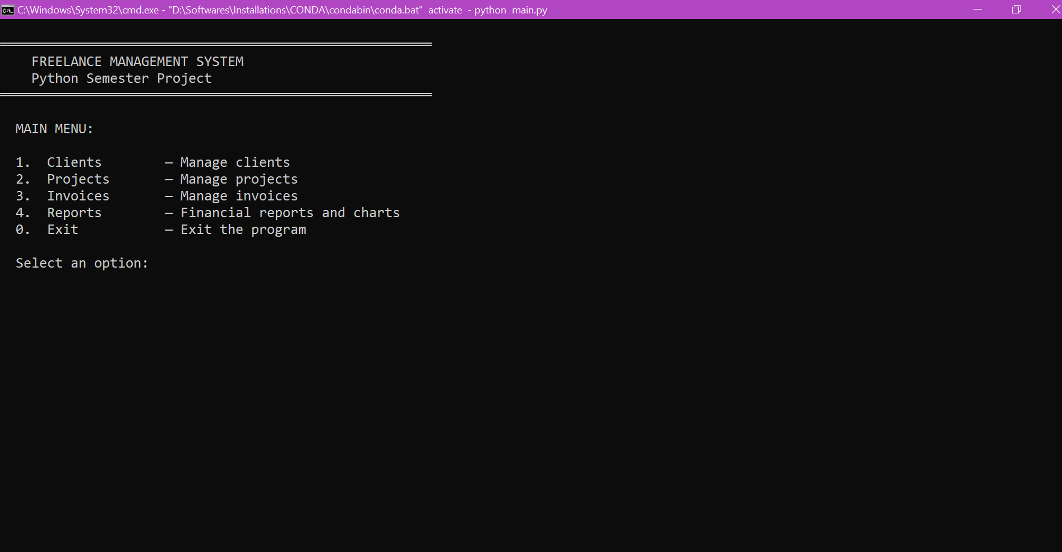
Figure: Main Menu
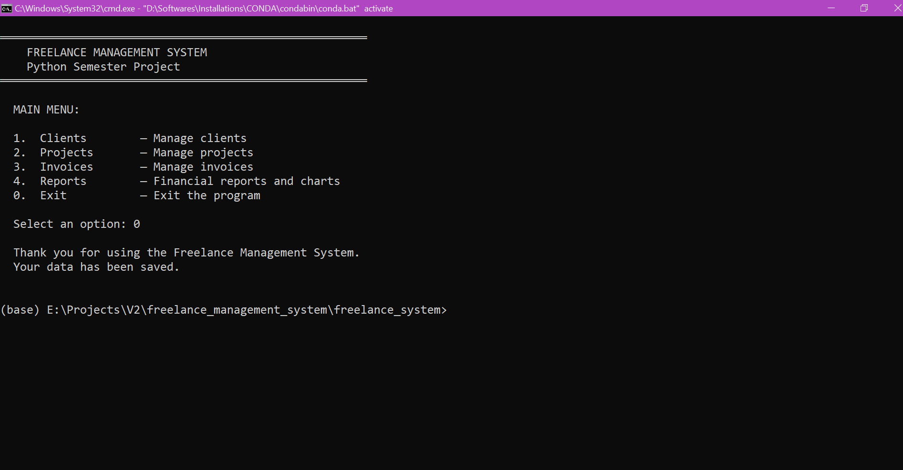
Figure: Exit / Quit
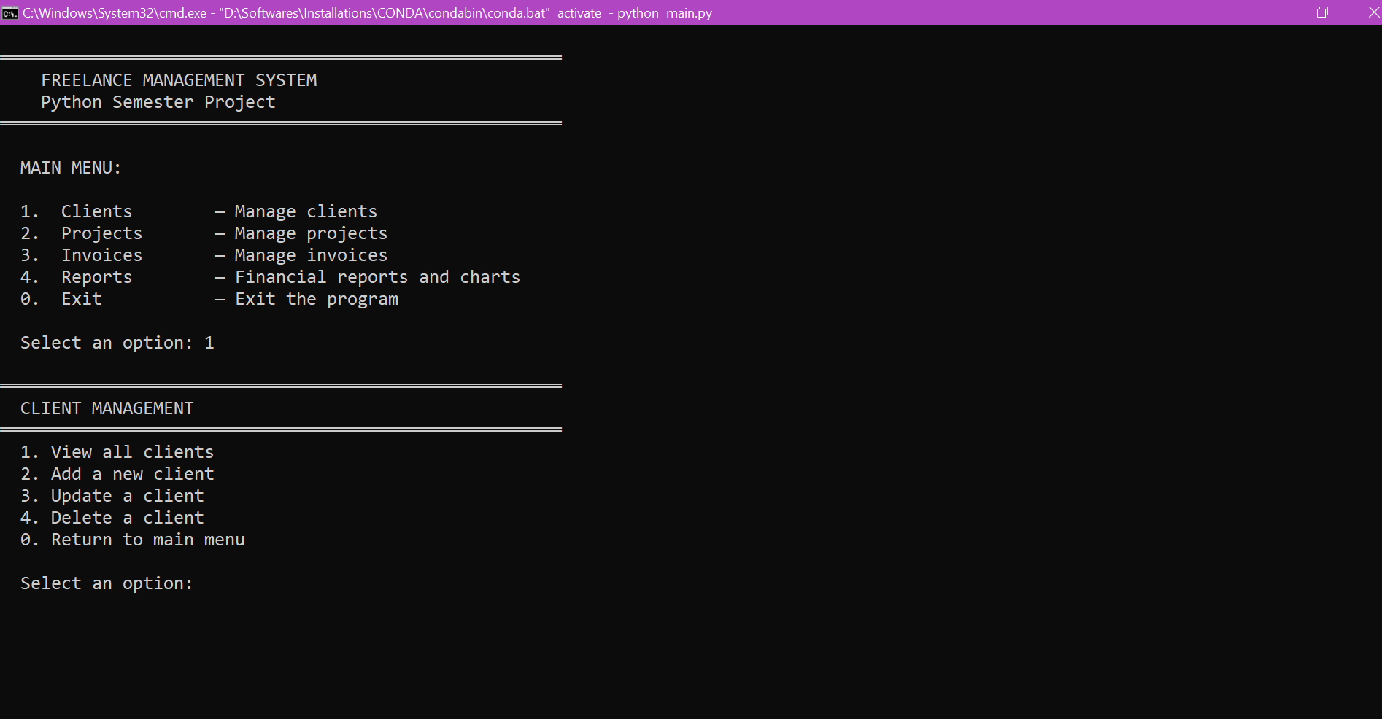
Figure: Clients Sub-Menu
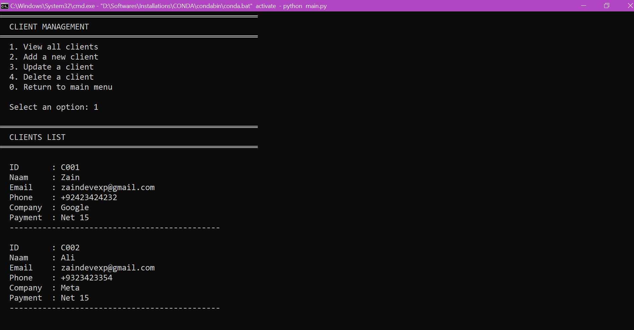
Figure: View All Clients

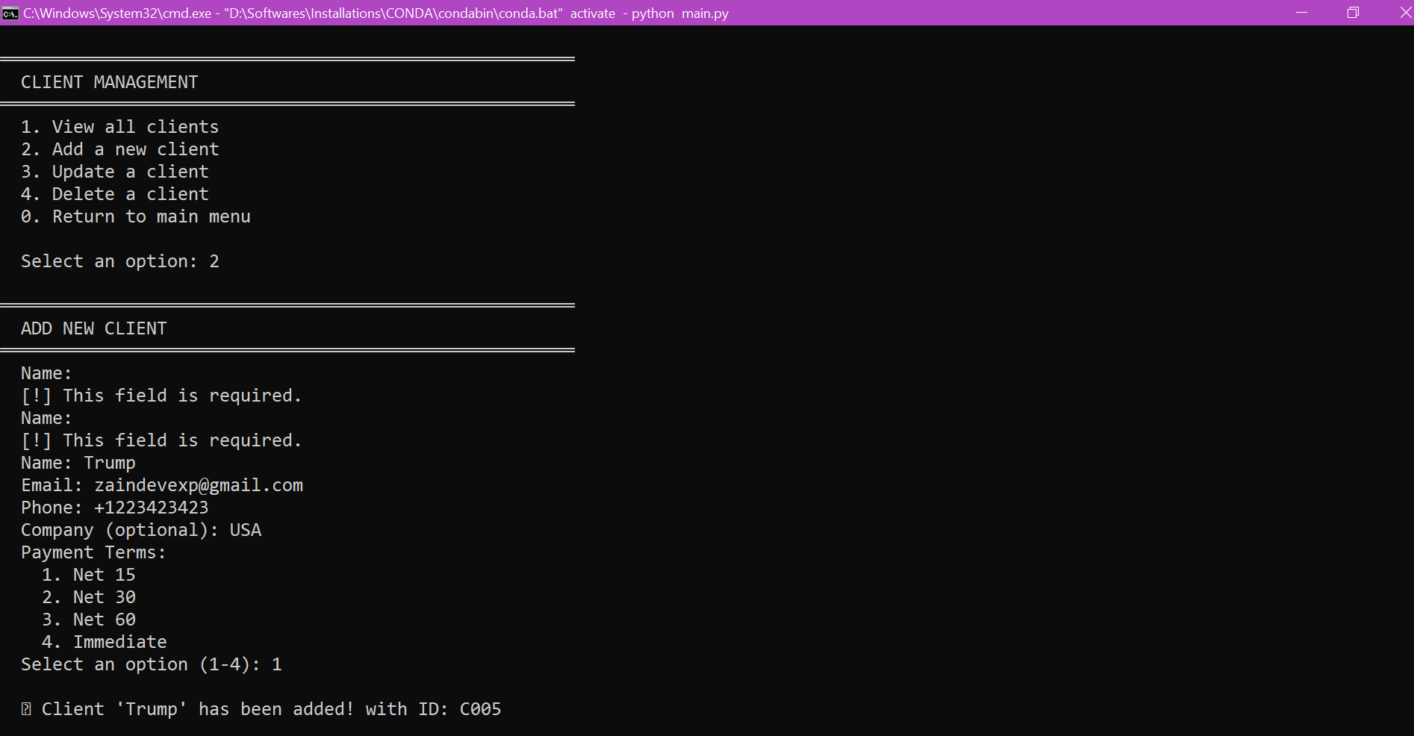
Figure: Add New Client
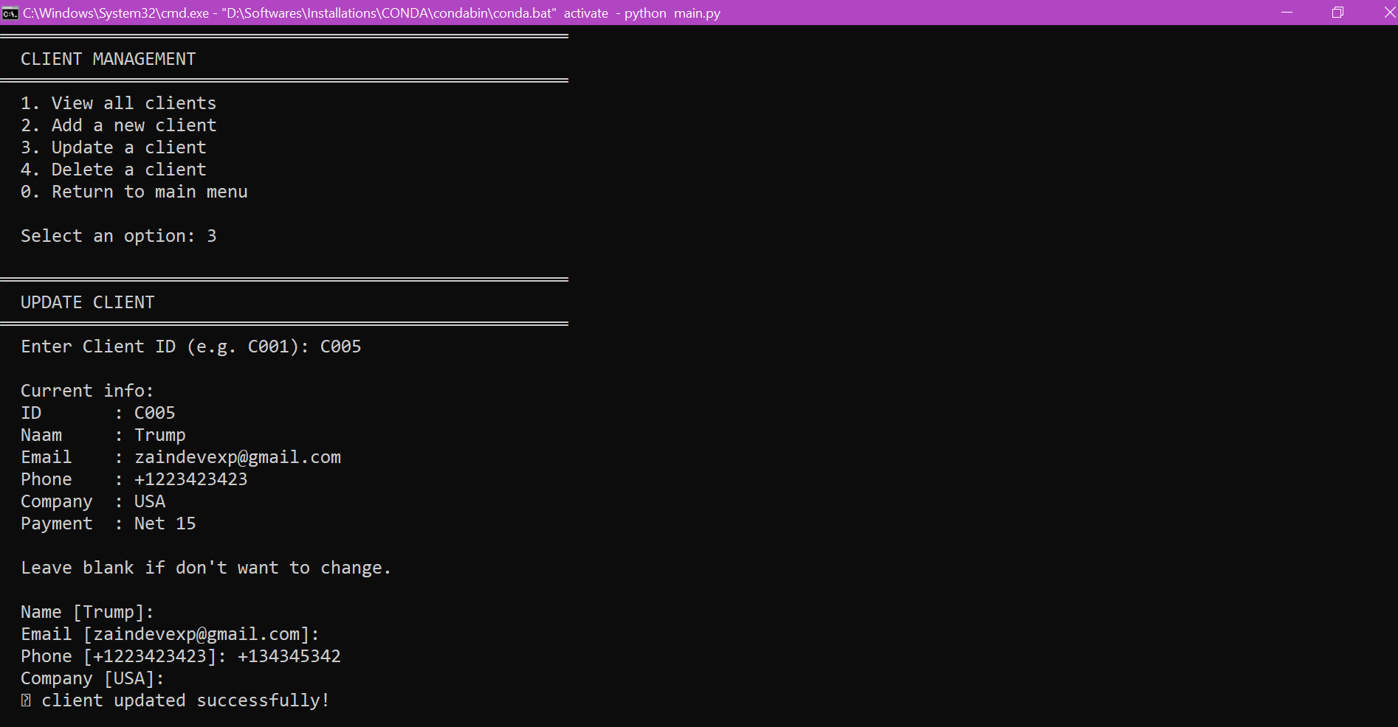
Figure: Update Client

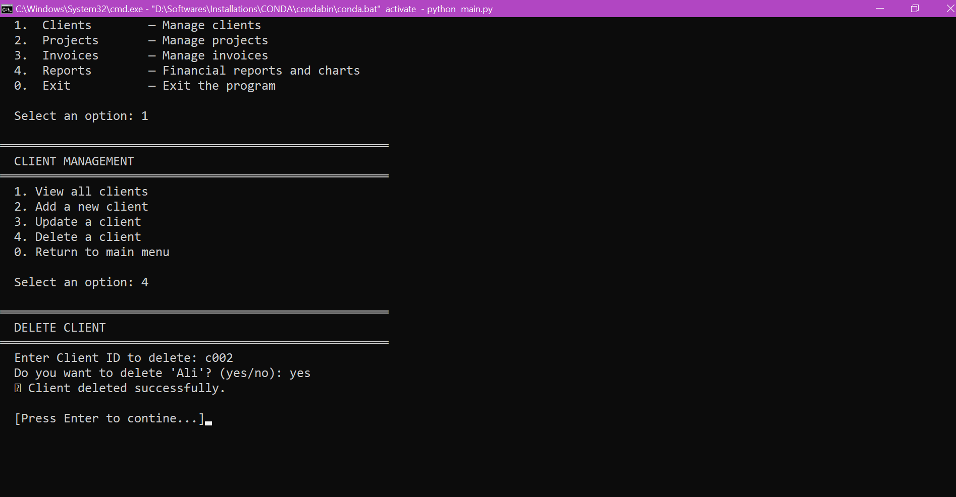
Figure: Delete Client
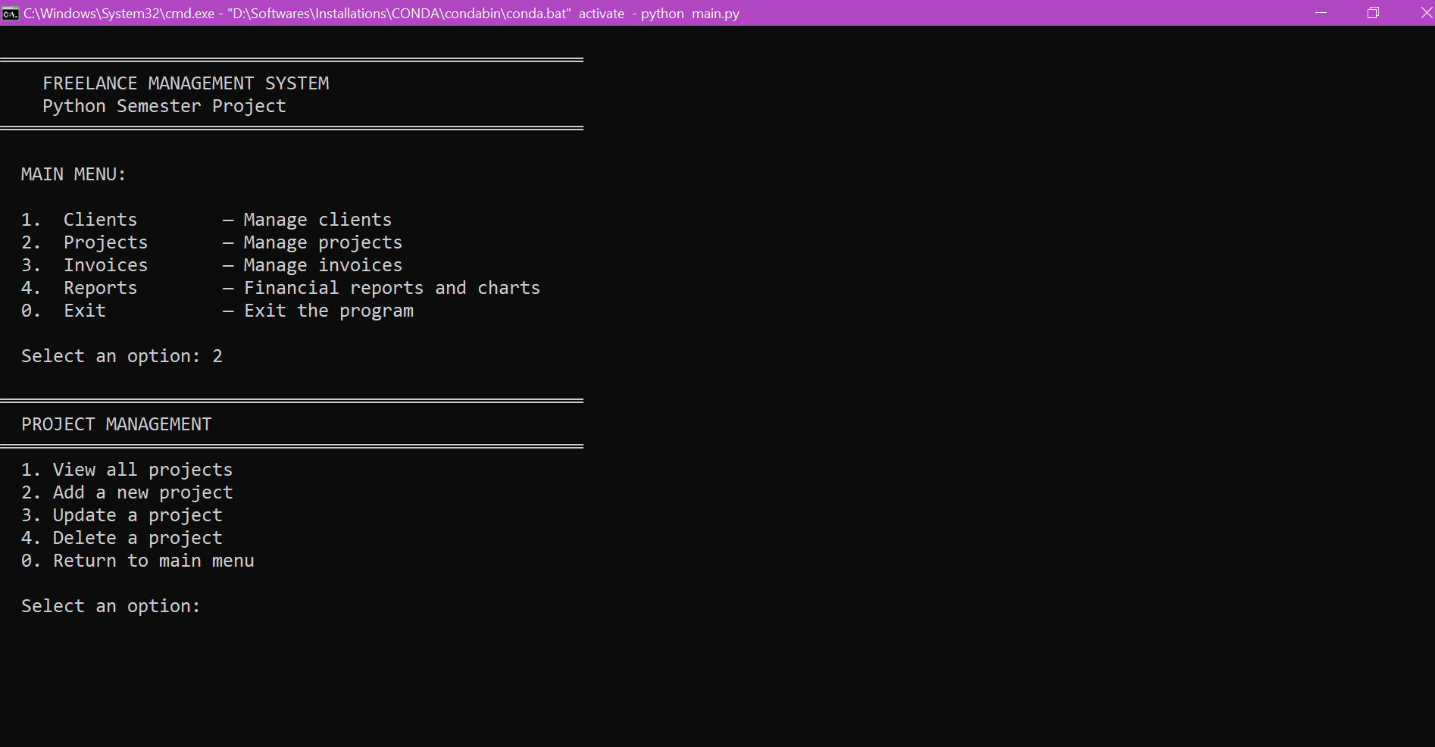
Figure: Projects Sub-Menu

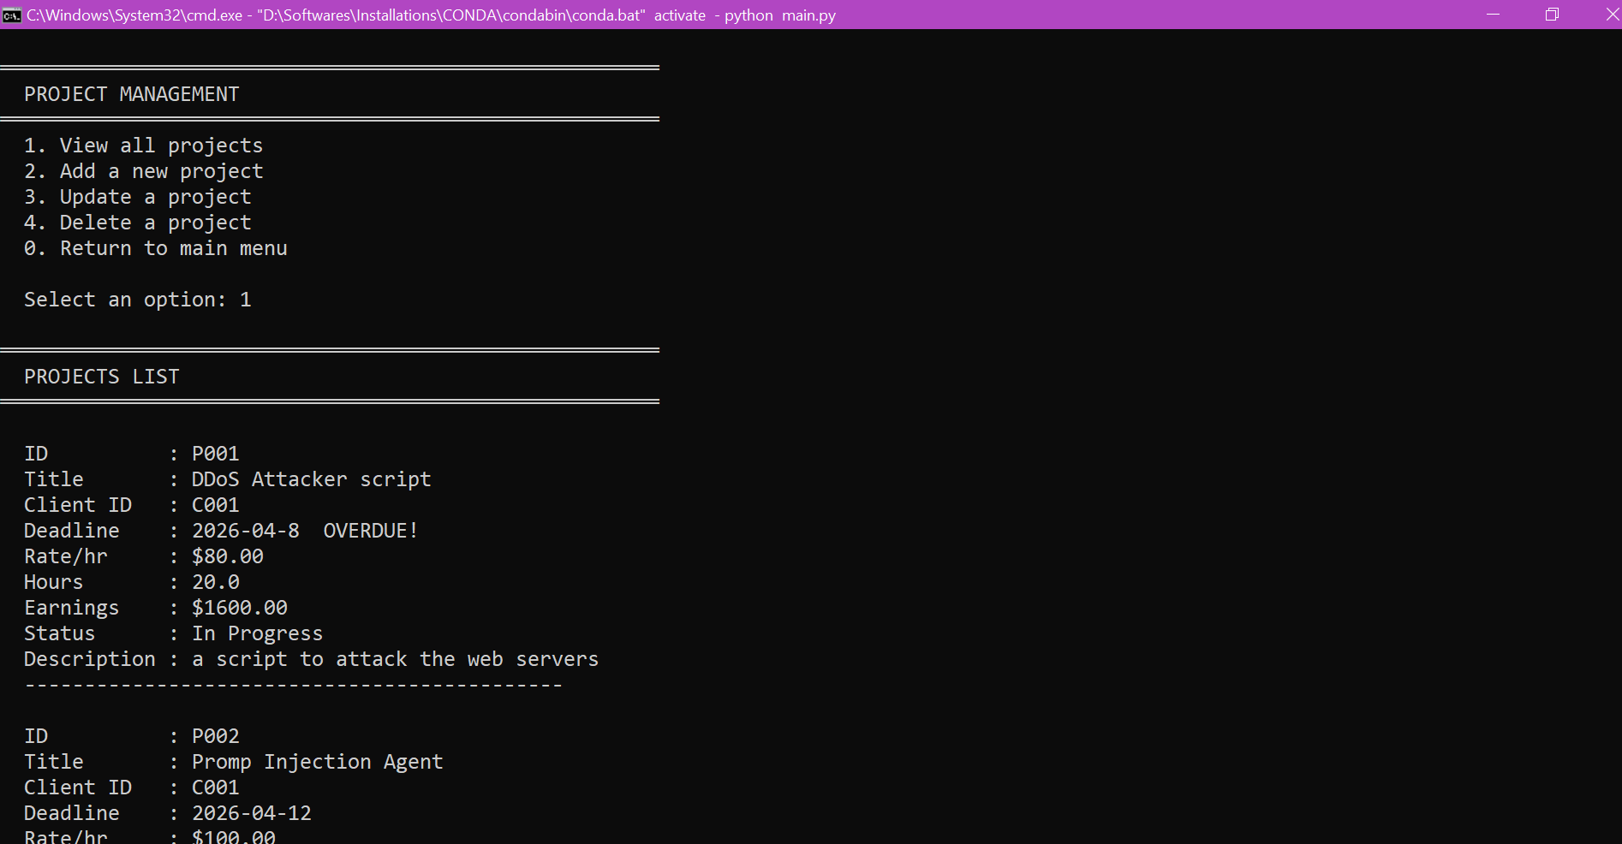
Figure: View All Projects
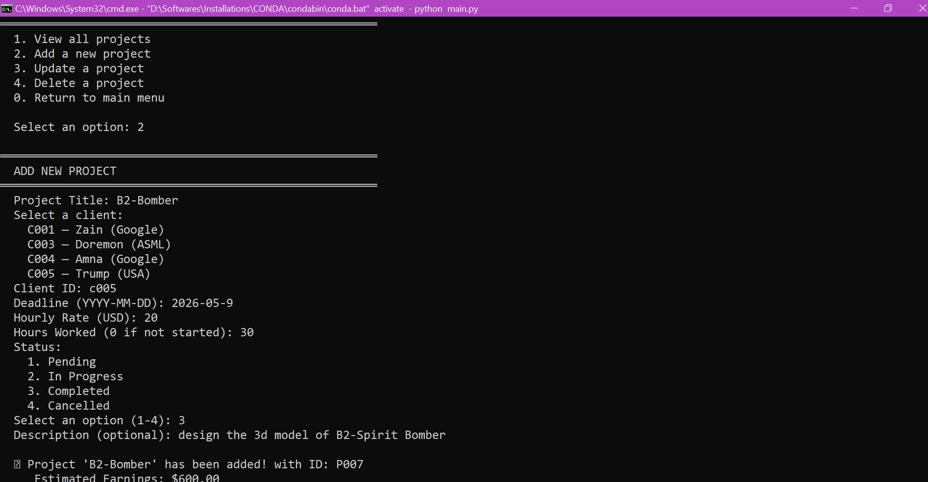
Figure: Add New Project

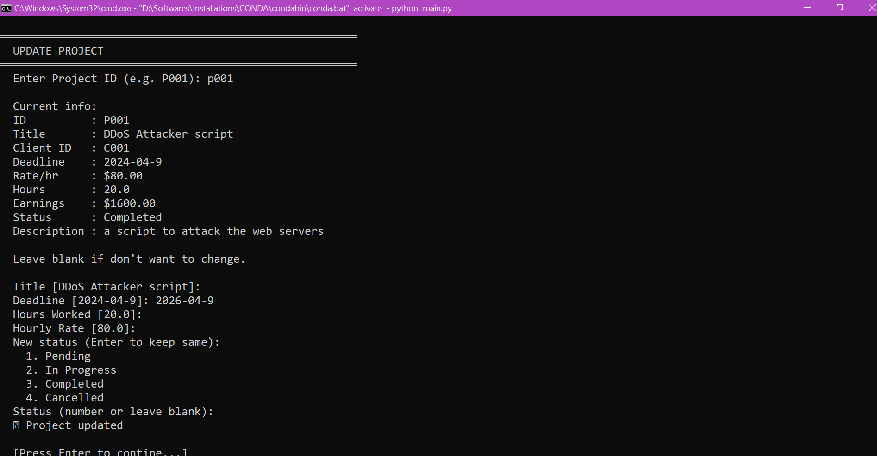
Figure: Update Project
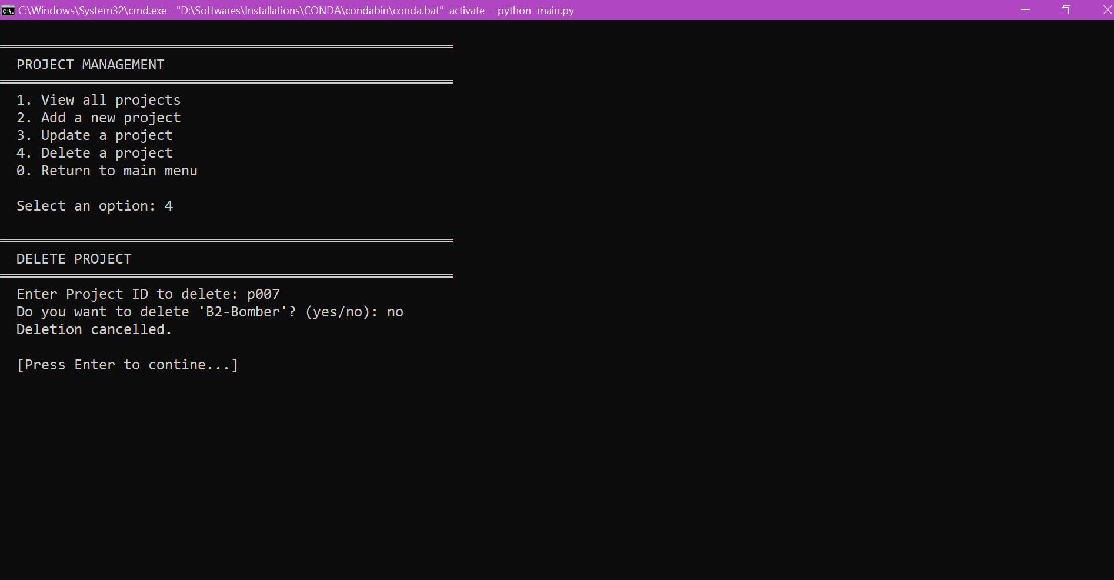
Figure: Delete Project

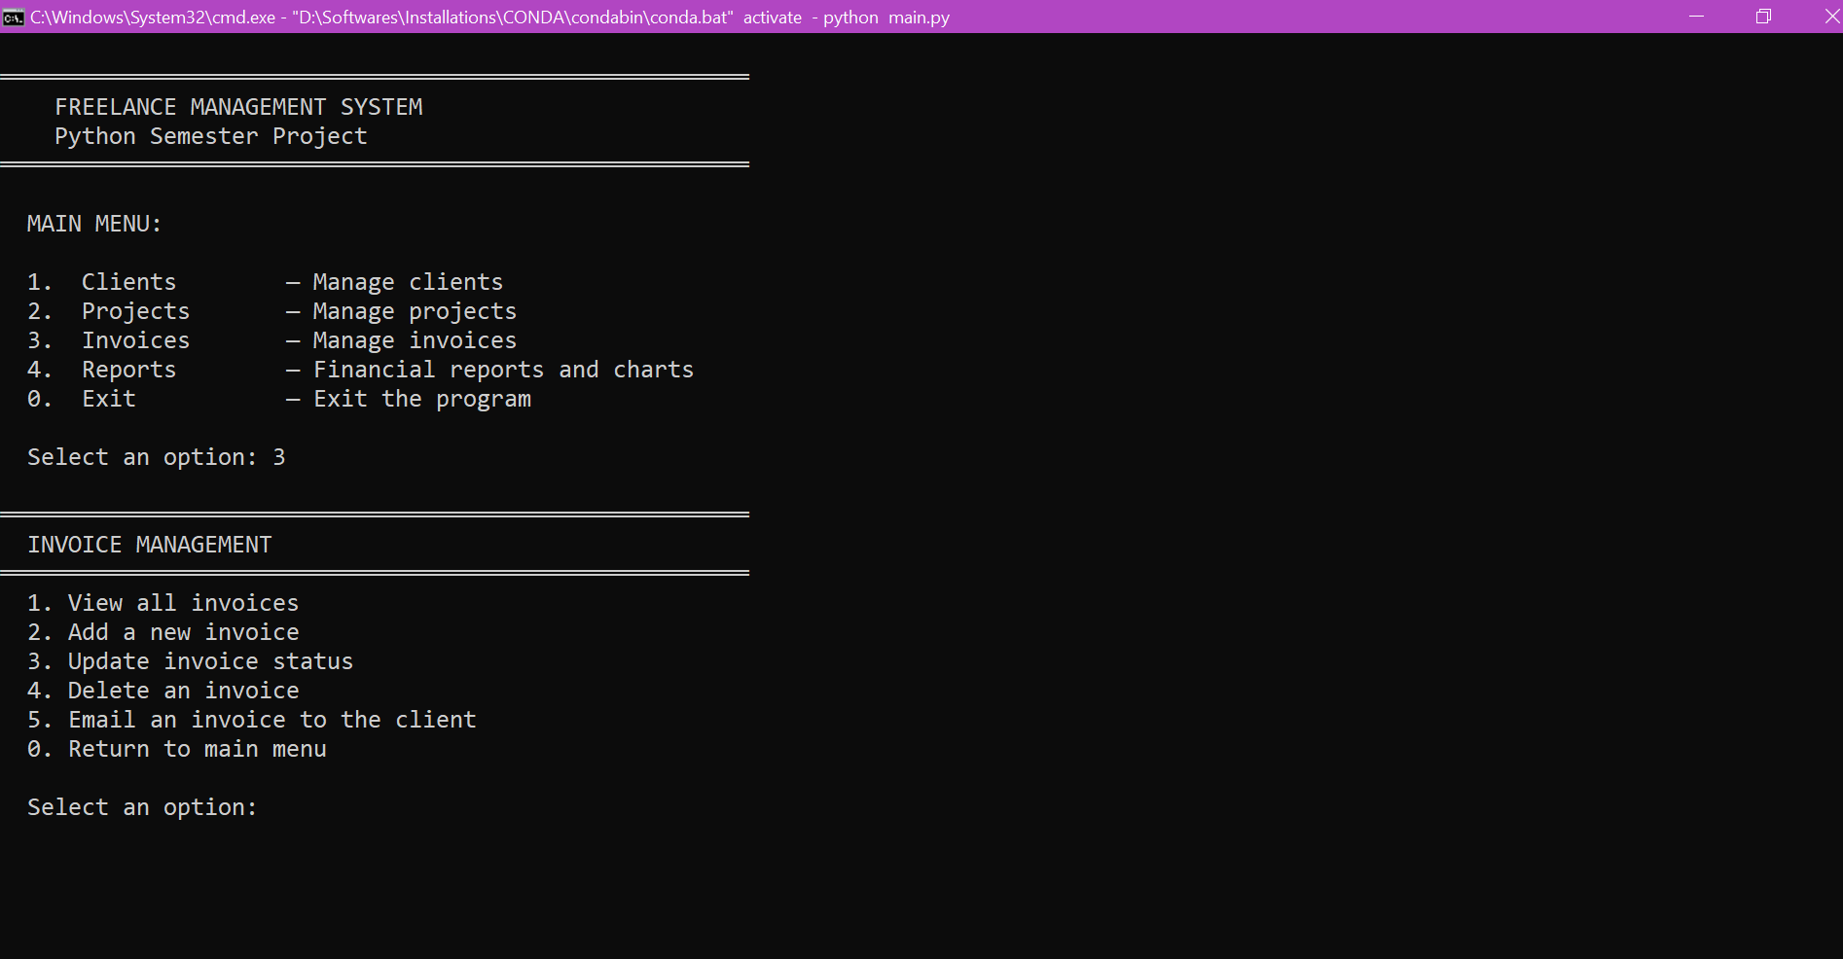
Figure: Invoices Sub-Menu
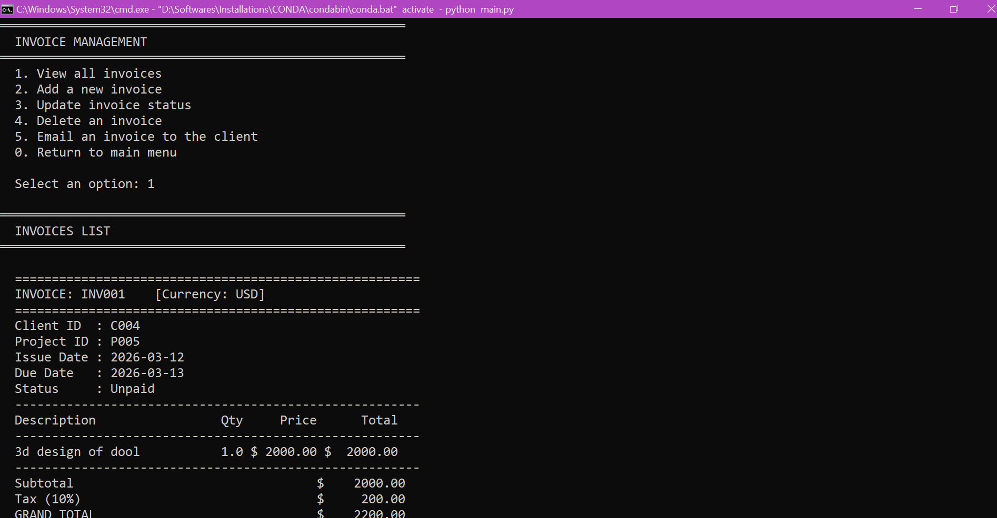
Figure: View All Invoices

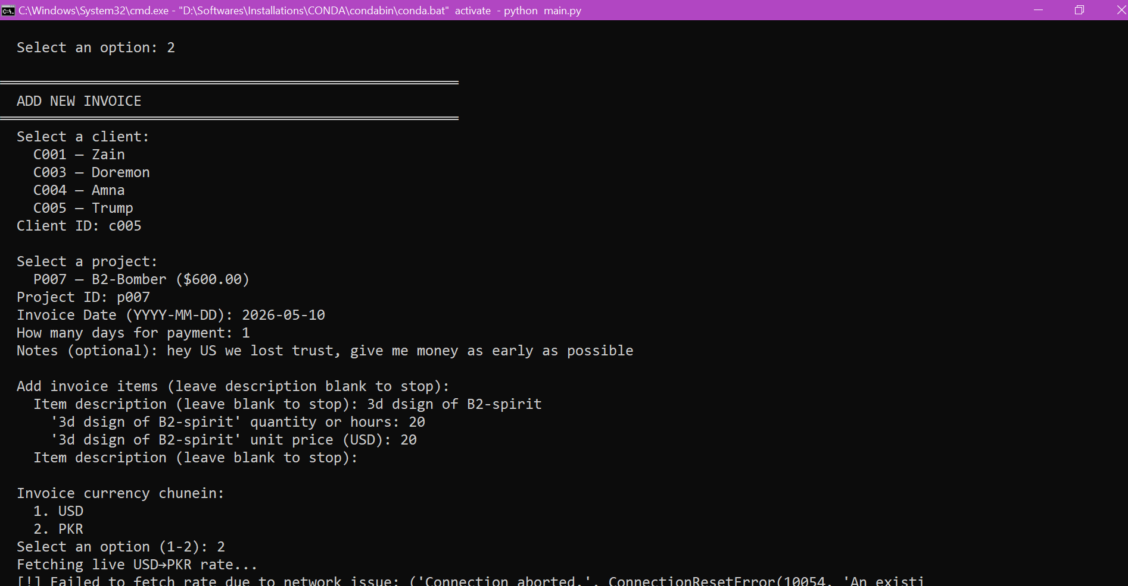
Figure: Add New Invoice
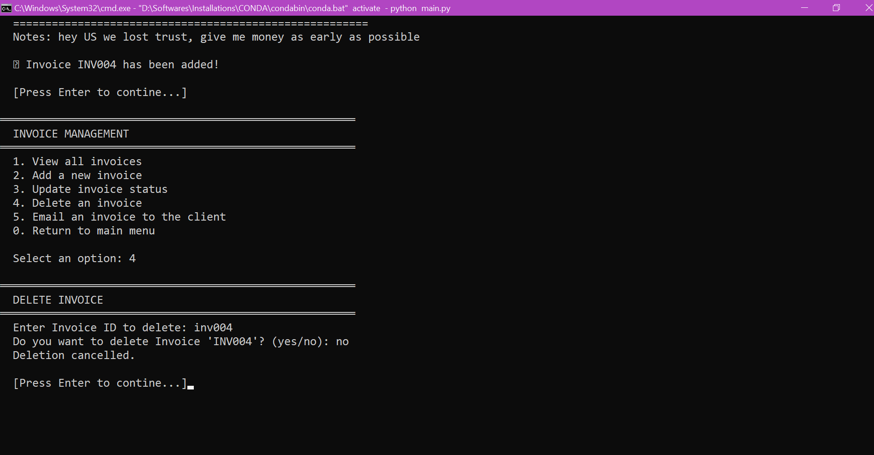
Figure: Delete Invoice

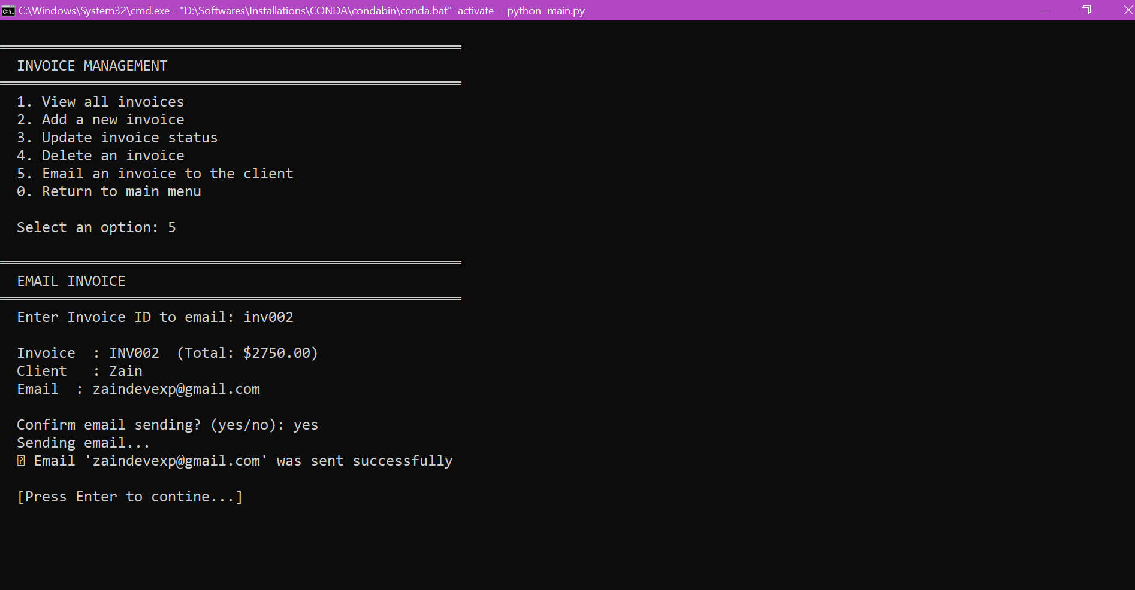
Figure: Send Invoice via Email
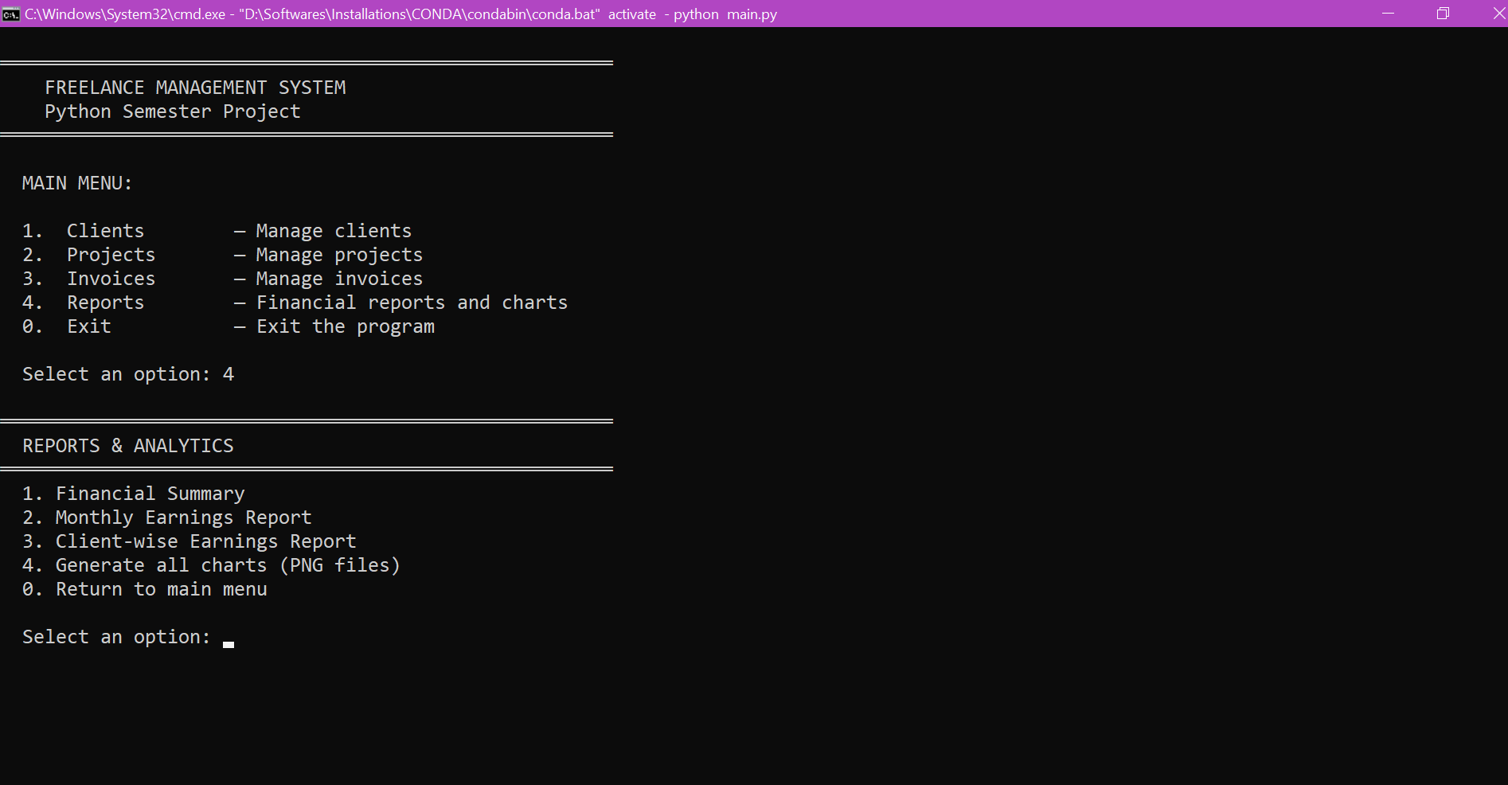
Figure: Reports Sub-Menu

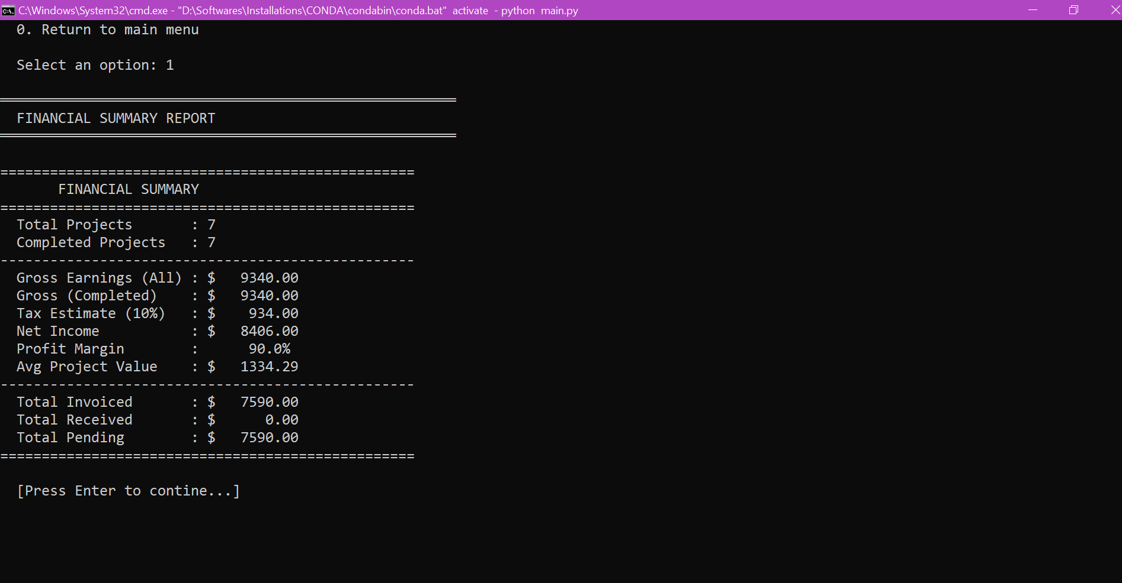
Figure: Financial Summary Report
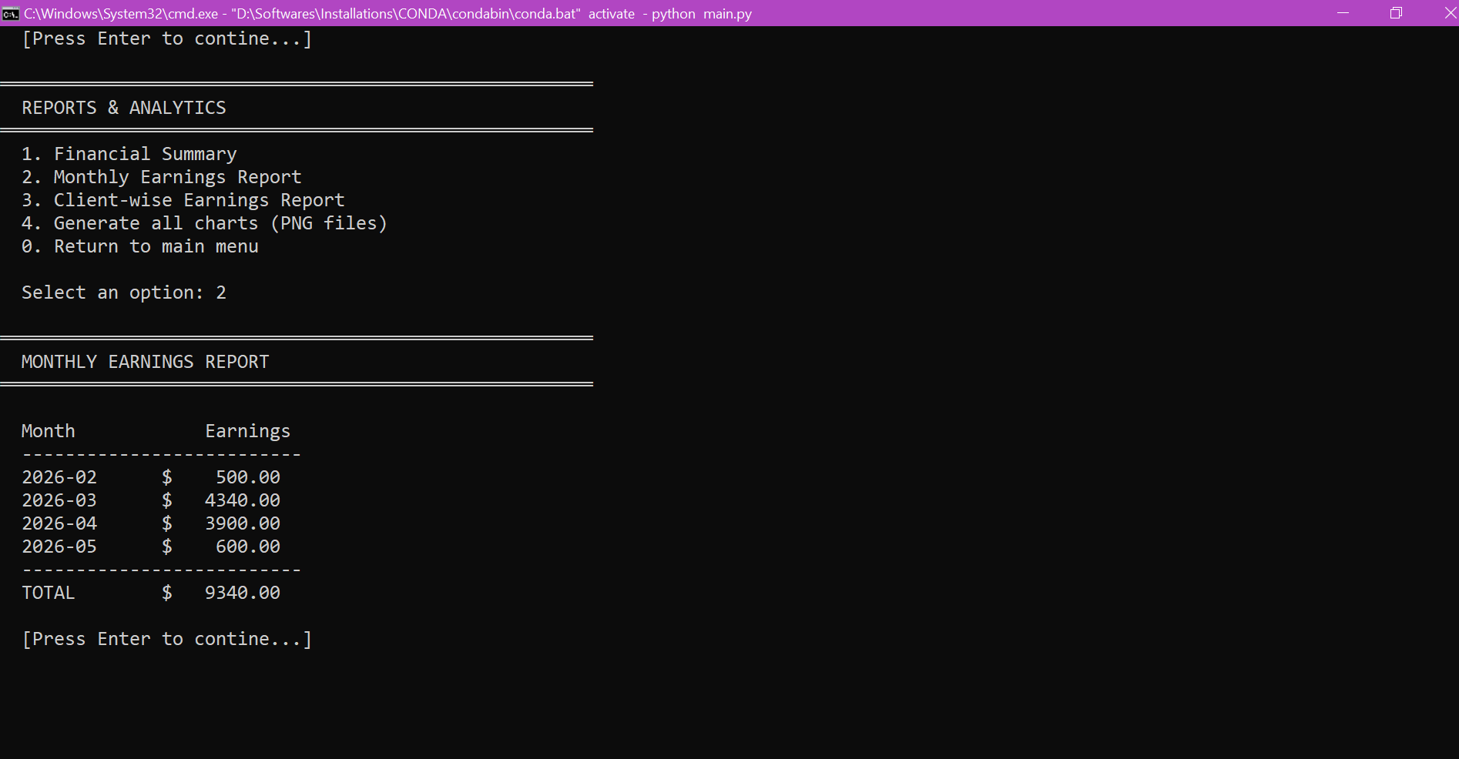
Figure: Monthly Earnings Report

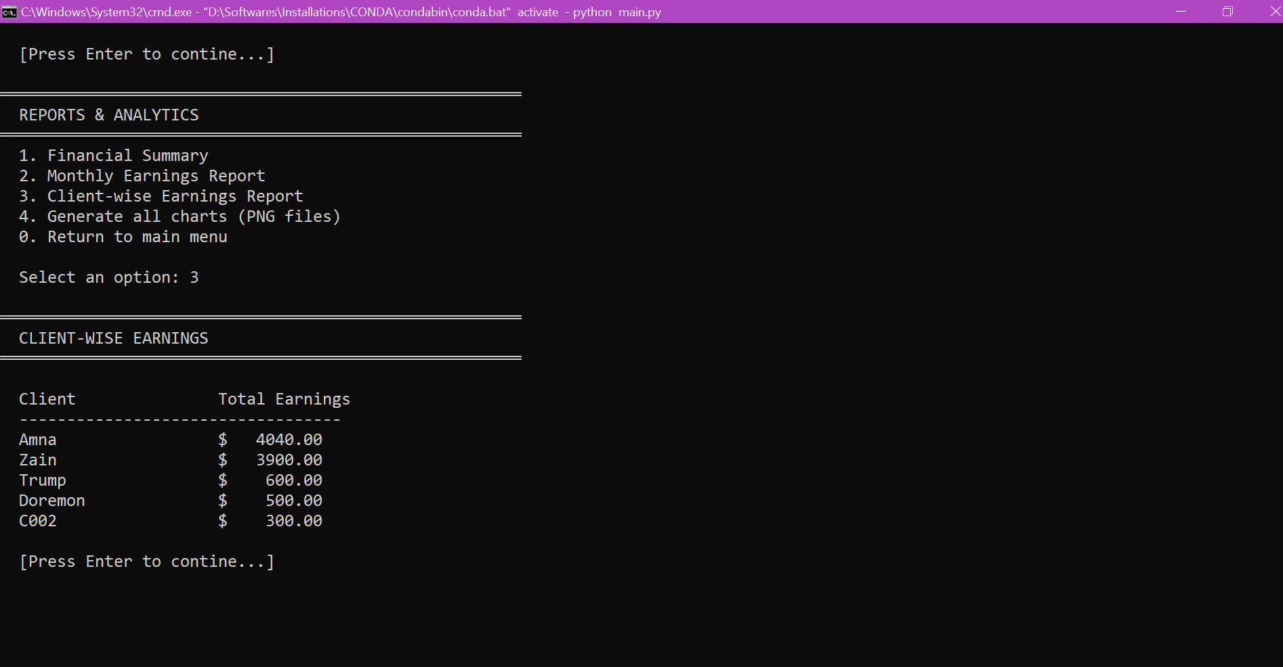
Figure: Client-Wise Earnings
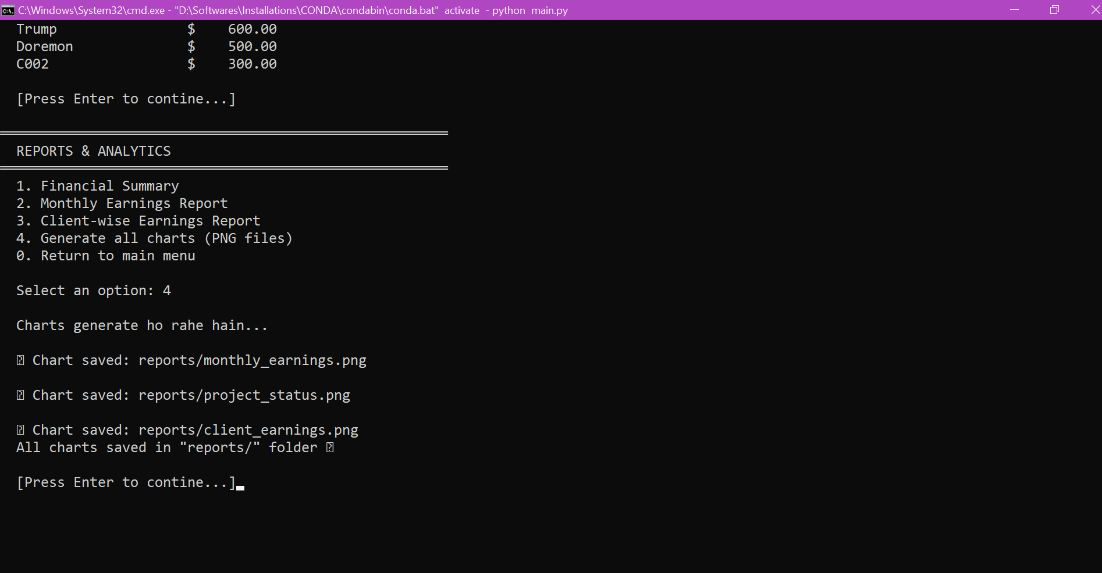
Figure: Generate All Charts

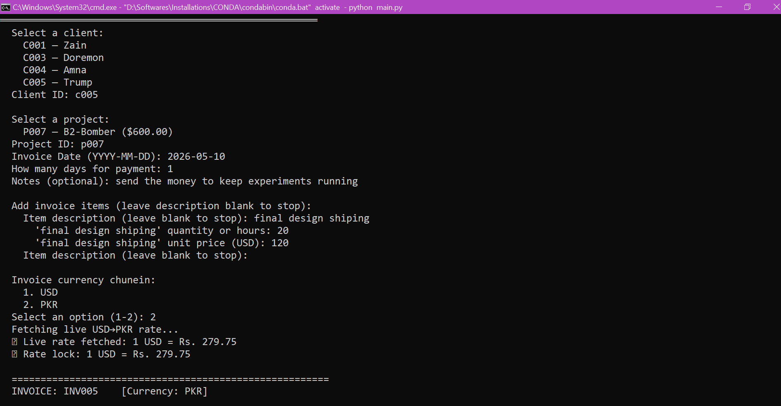
Figure: Live Currency Fetching (Bonus)

11.Conclusion
The Freelance Management System brings together every core semester concept — OOP, file handling, input validation, Pandas analytics, Matplotlib charts — plus two bonus features that required learning web scraping and SMTP email delivery independently.

What works well:
- Full CRUD for clients, projects, and invoices — nothing is read-only
- Multi-currency invoices with live rate fetching and a snapshot lock at creation time
- Invoice emailing directly from the application, with credentials stored securely in .env
- Three professional-looking dark-themed charts saved as PNG files
- Robust error handling throughout — the program never shows a raw Python traceback to the user
- Auto-saving to JSON on every change — data is never lost between sessions

If we had more time:
- Build a Tkinter GUI so the application is accessible to non-technical users
- Add support for more currencies beyond USD and PKR
- Add a task tracker within each project to break work into smaller pieces
- Add overdue invoice auto-detection and automatic status update to 'Overdue'
- Add PDF export of invoices so they can be sent as proper business documents

Overall this project gave us a clear picture of how a real-world Python application is structured. The modular folder layout made it easy to work on different parts at the same time without stepping on each other's code.

