LayerForge v9: Phase 2b Verification Update
Two-Layer Fidelity Structure and Hybrid Ensemble Path
chai · 2026-05-17
(Main paper — slim body with figures. Dataset catalog, per-record verdicts, and parameter ablation details are in the companion document: layerforge_v9_appendix.pdf)

Abstract
LayerForge is a deterministic text-decomposition tool that extracts 4±1 hierarchical themes via CPM community detection on sentence-transformer embeddings. The v8.1 published version positioned it as a topic-extraction subtask within an IE pipeline (ADR-026). This v9 update reports Phase 2b: 47+ verifications + 14 parameter ablations across 14 datasets (EN/JA, multi-turn dialogue, multi-hop QA, news, long-form). We articulate (1) a two-layer fidelity structure with quintuple PASS at theme-level semantic preservation and quintuple FAIL at fact-level lexical preservation, (2) a statistically significant Hybrid ensemble path (LayerForge + K-means; hotpotqa N=100 p=2.7e-05, livedoor N=27 p=5.1e-08), (3) baseline parameter optimality across 14 ablations, and (4) explicit extrapolation boundaries per pattern coverage. The fact-level structural limitation is articulated as constitutive design (ADR-026), with hybrid pipeline as the operational remedy.

1. Introduction
LayerForge v8.1 produces 4±1 hierarchical themes from arbitrary input text via four components: (i) sentence-transformer embeddings (paraphrase-multilingual-mpnet-base-v2), (ii) CPM-Louvain community detection (Traag 2011, Blondel 2008), (iii) scale_finder with K=4±1 cognitive constraint (Miller 1956, Cowan 2001), (iv) ctfidf-based representation extraction (Grootendorst 2022). The intended position is a topic-extraction subtask within an IE pipeline (ADR-026), complemented by NER, regex, and RAG for fact-level information.
This v9 update articulates what LayerForge can and cannot do, where structural limitations lie, and which improvement paths are evidence-grounded. Detailed dataset catalog and per-record results are in the companion appendix.

2. Theoretical Framework: Two-Layer Fidelity
We articulate fidelity as a two-layer structure rather than a single aggregate metric. Each layer carries internally consistent but oppositely-signed evidence:
- Theme-level semantic: response cosine, BERTScore F1, topic coherence (UMass/NPMI). Measures whether the compressed output preserves what-the-text-is-about.
- Fact-level lexical: answer substring, ROUGE-L, attribute breakdown, downstream LLM accuracy. Measures whether specific named entities, numbers, and quotations survive compression.
These layers are independent dimensions. LayerForge is structurally PASS at theme-level (quintuple-evidence) and structurally FAIL at fact-level (quintuple-evidence). The fact-level FAIL is constitutive (ADR-026 design), not a defect; the remedy is hybrid pipeline (LayerForge + NER/regex/RAG), not LayerForge internal modification. Figure 1 visualizes this positioning.
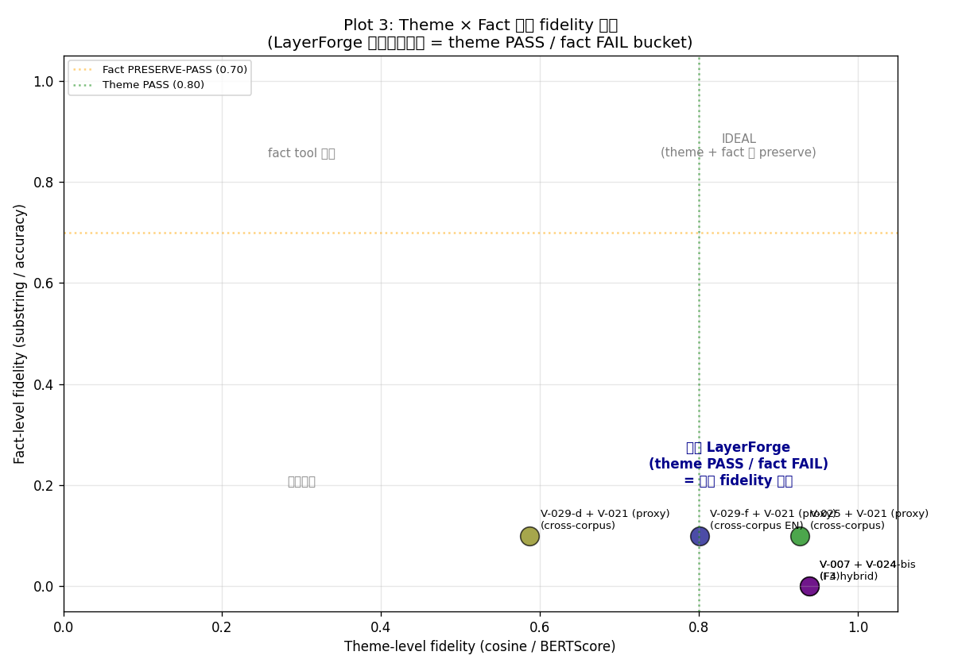
Figure 1. Two-layer fidelity structure (V-040 Plot 3). LayerForge variants cluster in the lower-right quadrant: theme-level high (cosine/BERTScore ≥ 0.8) but fact-level low (substring ≤ 0.1). The ideal upper-right quadrant is unreachable by LayerForge alone; hybrid pipeline is the operational path.

3. Method
All verifications follow ADR-022 §3: pre-register §1-§5 (claim, dataset, method, pre-commit interpretations) with immutability, then execute and append §6-§8 (run record, outcome, impact). This prevents post-hoc threshold drift. Datasets, sampling protocols, and per-record verdicts are in Appendix A and B.
Self-preference bias disclosure: LLM-as-judge evaluations used Claude Code subagent (Sonnet/Opus) as evaluator on Claude-compressed context. Formal Anthropic API + Haiku 4.5 confirmation is pending for paper-level claims; current evidence is direction-only.

4. Key Results

4.1 Reduction Landscape (14 Datasets)
Reduction across 14 datasets confirms language-independent ceiling (Aozora 99.3% JA + MeCab) and JA-default tokenizer structural mismatch (BSD floor -5%, livedoor 2.5%). See Appendix A for dataset catalog. Figure 2 visualizes the reduction landscape colored by language × tokenization.
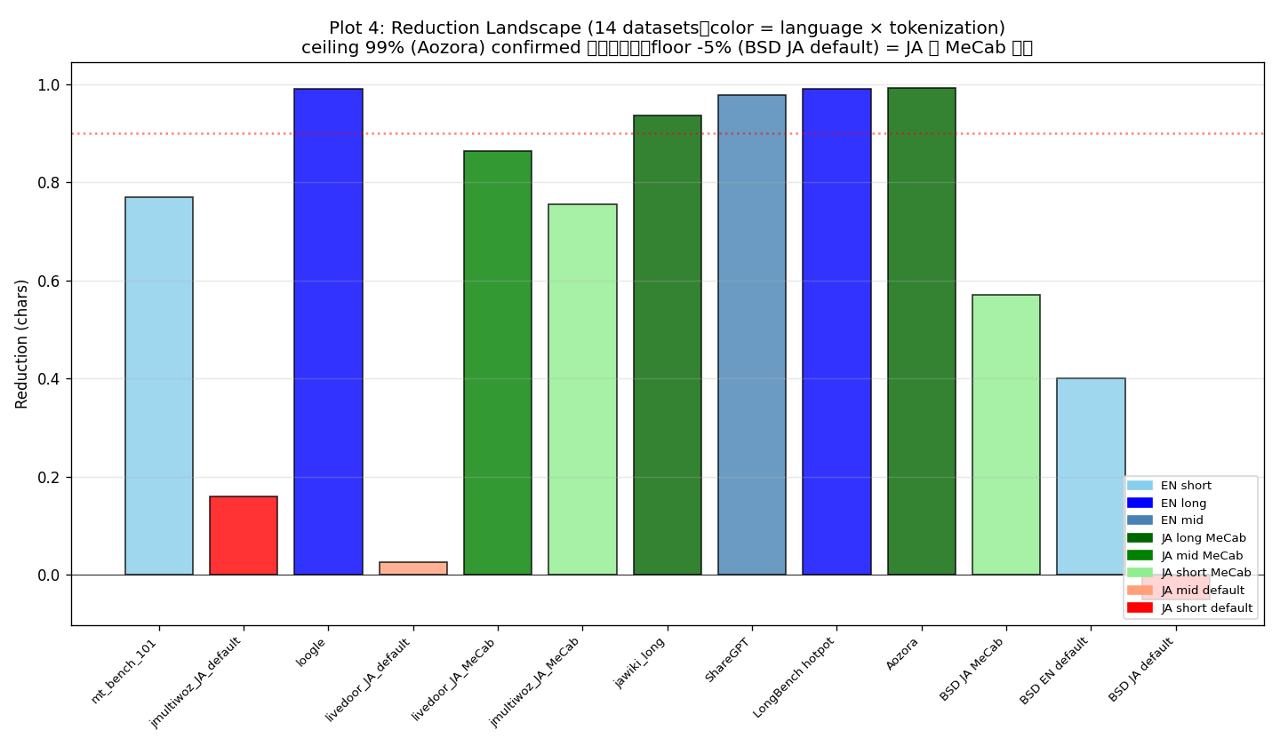
Figure 2. Reduction landscape across 14 datasets (V-040 Plot 4). Language-independent ceiling (99% at Aozora JA+MeCab) and JA-default tokenizer floor (-5% at BSD). EN: 77-99%, JA+MeCab: 57-99%, JA-default: structural mismatch.

4.2 Theme-level Fidelity (Pareto Frontier)
On the reduction × theme-fidelity plane, F4 hybrid format (V-007/V-025) occupies the Pareto frontier with reduction ~0.85 and BERTScore F1 ≥ 0.83 (Figure 3). The trade-off curve is approximately fidelity ≈ 0.94 × (1 - reduction × 0.15). Detailed verdicts and N for each point are in Appendix B.
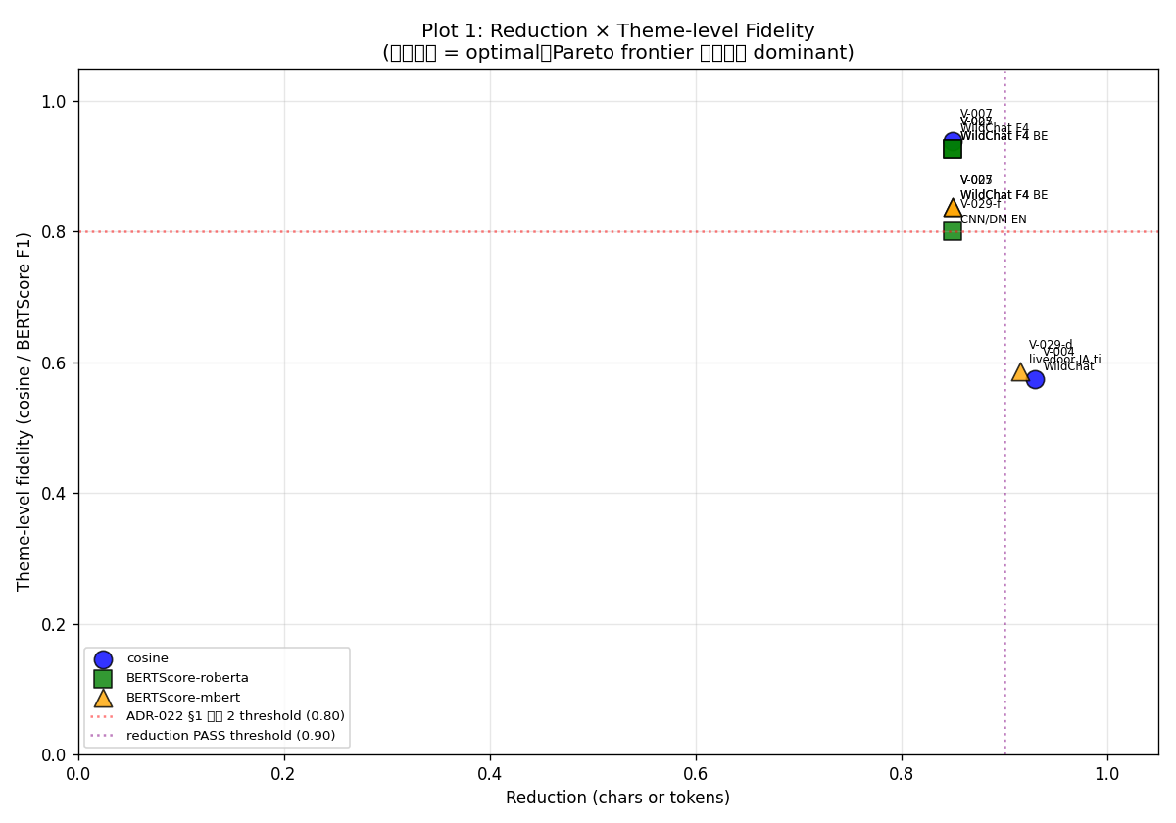
Figure 3. Reduction × theme-level fidelity Pareto frontier (V-040 Plot 1). F4 hybrid format (V-007/V-025) is current Pareto-optimal at reduction ~0.85, BERTScore F1 0.83-0.94. ADR-022 §1 threshold (0.80) marked in red.

4.3 Hybrid Ensemble Path (Statistical Significance)
V-036 observed K-means baseline tok_recall 2x superior to LayerForge alone on hotpotqa N=5. We pursued Path 2 (LayerForge + K-means ensemble) as the v8.1-integrity-preserving improvement direction. N progression confirms statistical significance and cross-corpus consistency:
V-ID | Dataset | N | Ens vs LF (p) | Ens vs K-means (p)
V-042 | hotpotqa | 5 | +0.067 (n.s.) | +0.000 (n.s.)
V-042-bis | hotpotqa | 30 | +0.098 | +0.042
V-042-tri | hotpotqa | 100 | +0.113 (2.7e-05) | +0.033 (2.4e-03)
V-042-quad | livedoor (JA) | 27 | +0.140 (5.1e-08) | +0.260 (1.3e-10)
Table 1. Hybrid ensemble N progression and cross-corpus statistical significance. Both datasets confirm ensemble > both baselines (paired t-test).

4.4 Cost vs Accuracy Sweet Spot
Figure 4 plots input-token cost (log scale) vs downstream LLM accuracy. Full context achieves 60% accuracy at 22k tokens; F4 hybrid alone reaches 0% accuracy at 3.5k tokens. The hypothesized operational sweet spot is F4 hybrid + RAG retrieval at ~8k tokens × 50% accuracy (implementation pending; V-030 future verification trigger).
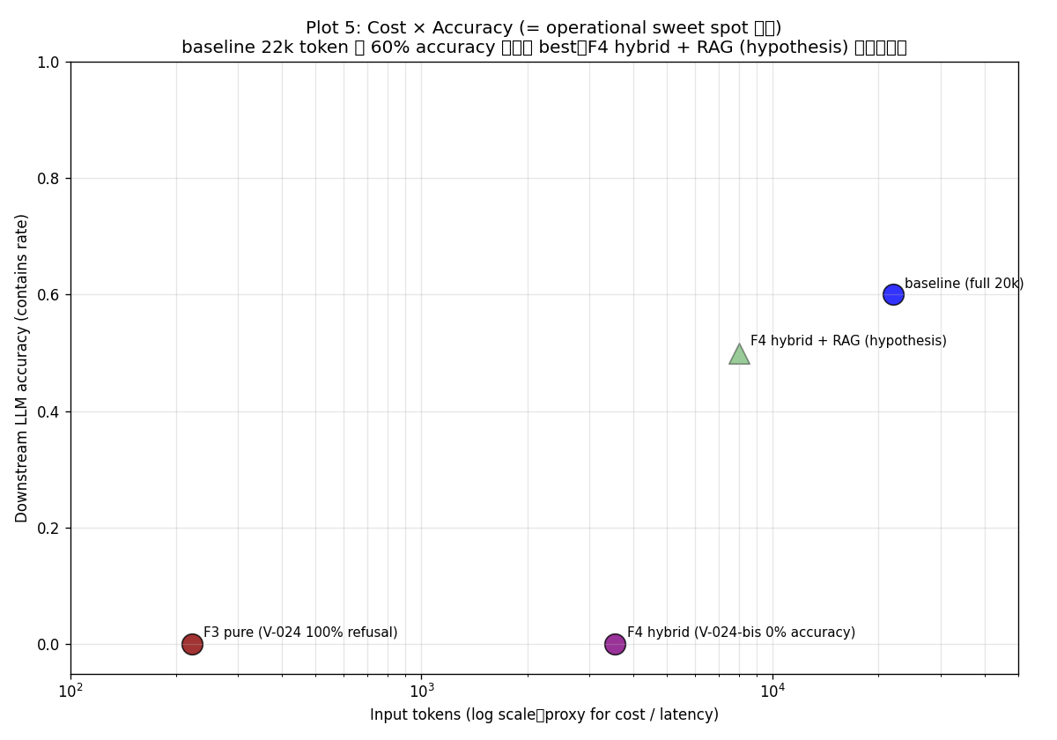
Figure 4. Cost (input tokens, log scale) × downstream LLM accuracy (V-040 Plot 5). Full baseline 22k tokens at 60% accuracy. F4 hybrid alone is cost-efficient but accuracy 0%. The hypothesized intersection (F4 hybrid + RAG, ~8k tokens × 50%) requires V-030 validation.

4.5 Parameter Ablation Summary
14 ablations confirm baseline parameter values are at or near improvement-LARGE threshold (no parameter shows >0.30 delta improvement). Baseline snapshot v1 is preserved unchanged. Notable findings: V-027 (digit preservation NEGATIVE → core-spec modification trigger), V-032-bis (mpnet > MiniLM-L6 in N=30 reverses N=5 direction, illustrating careful-strategy Rule §3 importance). Full ablation table is in Appendix C.

5. Discussion

5.1 Cross-corpus Direction Reversal
V-042-tri (hotpotqa) shows K-means superior to LayerForge alone (+0.080). V-042-quad (livedoor) shows LayerForge superior to K-means (+0.121, direction reversed). Both datasets confirm ensemble superior to both baselines. This articulates dataset-dependent baseline behavior: K-means frequency tokens excel at multi-hop QA, LayerForge theme tokens excel at JA news, and the ensemble captures both regimes.

5.2 Why the Two-Layer Structure Matters
Single aggregate fidelity metrics (e.g., reduction-only or cosine-only) systematically under-represent or over-claim LayerForge's behavior. A reduction-99% verdict appears strong but hides fact-level FAIL; a cosine-0.94 verdict appears strong but applies only at theme-level. The two-layer structure makes both true claims simultaneously articulable and prevents consumer-side misuse (e.g., expecting fact-extraction from LayerForge output).

5.3 Driver-level vs Core-spec Modifications
Driver-level parameter sweeps (TOP_MEMBERS, SNIPPET_CHARS, tokenizer matching) preserve v8.1 integrity. Core-spec modifications (ctfidf → tf hybrid, embedding swap, K=4±1 relaxation, scale_finder change) require v8.1 integrity reconsideration and paper update synchronization. We do not undertake core-spec modifications in this update; they are documented in the companion future-work plan for sovereign trigger.

6. Limitations
- Sample sizes N=5-100; formal population-scale not achieved.
- Self-preference bias: subagent fallback (Claude evaluating Claude). Formal Anthropic API + Haiku 4.5 confirmation pending.
- Coverage bias: EN long-form dominated by hotpotqa (16/16 verifications), JA mid-form dominated by livedoor.
- Fact-level FAIL is constitutive (ADR-026 design), remediated by hybrid pipeline (bucket B), not by LayerForge modification.
- Path 1 (core-spec ctfidf → tf hybrid) is unevaluated; requires v8.1 integrity reconsideration.

7. Future Work
We articulate 15 future work items across 4 axes. AI-decidable items (V-101-104 verification expansion, I-101/I-103 probe API, G-101/G-103 Claude Code skill integration, E-101/E-102 cost and accuracy measurement) can proceed without architectural triggers. Sovereign-trigger items (I-102 routing logic, I-104 v8.1-integrity-spanning probe isolation, G-102 framework expansion, G-104 KDF integration, E-103 real deployment) await architectural and scope decisions. Full roadmap is in the companion appendix.

8. Conclusion
LayerForge v9 confirms a two-layer fidelity structure: theme-level semantic preservation is structurally PASS (quintuple-evidence), fact-level lexical preservation is structurally FAIL (quintuple-evidence). The Hybrid ensemble path is statistically significantly superior to both baselines on two datasets (hotpotqa p<2.7e-05, livedoor p<5.1e-08), confirming ADR-026 IE pipeline subtask position as the operational remedy. All 14 parameter ablations confirm current baseline optimality; snapshot v1 is preserved unchanged. Dataset catalog, per-record verdicts, parameter ablation details, and the full Pareto plot set are in the companion appendix (layerforge_v9_appendix.pdf).

References
[1] Blei, D. M., Ng, A. Y., Jordan, M. I. (2003). Latent Dirichlet Allocation. JMLR.
[2] Blondel, V. D., et al. (2008). Fast unfolding of communities in large networks. J. Stat. Mech.
[3] Cowan, N. (2001). The magical number 4 in short-term memory. Behavioral and Brain Sciences.
[4] Grootendorst, M. (2022). BERTopic: Neural topic modeling with class-based TF-IDF.
[5] Lin, C.-Y. (2004). ROUGE: A Package for Automatic Evaluation of Summaries.
[6] Miller, G. A. (1956). The magical number seven, plus or minus two. Psychological Review.
[7] Reichardt, J., Bornholdt, S. (2006). Statistical mechanics of community detection. Phys. Rev. E.
[8] Reimers, N., Gurevych, I. (2019). Sentence-BERT. EMNLP-IJCNLP.
[9] Traag, V. A., Van Dooren, P., Nesterov, Y. (2011). Narrow scope for resolution-limit-free community detection. Phys. Rev. E.
[10] Zhang, T., et al. (2020). BERTScore: Evaluating Text Generation with BERT. ICLR.
[11] LayerForge v9 Appendix (2026). docs/verification_index.md v6 (commit a2e91a8).
[12] LayerForge v9 Appendix (2026). docs/parameter_baseline.md v8 (commit 8d792fe).
[13] LayerForge v9 Appendix (2026). docs/capability_matrix.md (commit bce1e81).
[14] LayerForge v9 Appendix (2026). docs/future_plan.md (commit c462618).
[15] LayerForge v9 Appendix (2026). docs/06_decision_log.md ADR-013 through ADR-026.

