LayerForge v9 — Appendix
Dataset Catalog, Verification Records, Parameter Ablation, and Pareto Plots
chai · 2026-05-17 · Companion to layerforge_v9_main.pdf

Appendix A. Dataset Catalog
All datasets used in v9 verifications, with language, domain, N range, source, and licensing notes. Datasets are read-only mounted at C:/work/dataset-vault/readonly/ for verification reproducibility.
Dataset | Language | Domain | Length | N used | Source
WildChat (allenai/WildChat) | EN | multi-turn dialogue | mid (1-5k) | 3-100 | HuggingFace
ShareGPT | EN | multi-turn dialogue | mid | 3-10 | ShareGPT_V3_unfiltered
LongBench hotpotqa | EN | multi-hop QA | long (50-100k) | 5-100 | LongBench v1
loogle | EN | long single-doc | long (10k+) | 5 | loogle
CNN/DailyMail v3 | EN | news summary | mid | 10 | HuggingFace cnn_dailymail
livedoor news | JA | news 9 categories | mid (1-2k) | 9-27 | livedoor-news-corpus
jmultiwoz | JA | dialogue | short | 10 | jmultiwoz
jawiki | JA | wiki | long (10k+) | 5 synthetic | jawiki_singletongue
Aozora | JA | literature | long (10k+) | 5 | aozorabunko_clean
BSD parallel | EN/JA | dialogue parallel | short | 5 each path | bsd_ja_en
meetingbank | EN | meeting transcript | mid-long | 5 | meetingbank
mt_bench_101 | EN | dialogue | short | 10 | mt_bench_101
polbooks (Newman) | graph | community K=3 | 105 nodes | 1 | newman_adjnoun benchmark
football (Newman) | graph | community K=12 | 115 nodes | 1 | newman benchmark
Table A1. Dataset catalog (14 entries).

A.1 Sampling Protocols
Sampling protocols vary by verification: deterministic head (V-018, V-021-042 hotpotqa), stratified by category (V-013-014 livedoor 9 cat), random with seed (V-005 claim1 robustness), synthetic grouped (V-017 jawiki 200-sentence units due to sentence-level original structure). Sampling protocol is recorded per V-ID in Appendix B.

Appendix B. Verification Record Summary
Complete verification record list (46 entries: Table B1 V-001-V-020 = 20 rows, Table B2 V-021-V-042-quad + 1 cross-corpus = 26 rows). Each row shows V-ID, dataset, N, verdict, and commit hash for traceability. Full Sections 1-8 records are in docs/verifications/*.md.
V-ID | Dataset | N | Verdict (key metric) | Commit
V-001 | WildChat (Phase 2b entry) | 962/50K | PASS dataset feasibility | (retro)
V-002 | WildChat | 10 | PASS pipeline shape (F1 cosine 0.538) | (retro)
V-003 | WildChat (step_a) | 10 | format artifact confirmed (F4 0.823 > F1 0.538) | (retro)
V-004 | WildChat (claim1) | 100 | formal PASS reduction 93.00% mean | 76a8bda
V-005 | WildChat (robustness) | 100 | 3-axis PASS (random/survivorship/length) | a13ce3f
V-006 | WildChat (claim2 F3) | 3 | FAIL (refusal 33.3%, specific divergent) | 36ced95
V-007 | WildChat (claim2 F4 hybrid) | 6 | strong PASS (refusal 0/6, cosine 0.939) | f95010f
V-008 | polbooks | 105 nodes | AMBIGUOUS (ARI 0.6140, K=6 over-seg) | d88804f
V-009 | football | 115 nodes | K-FAIL but ARI 0.8549 high | 991671e
V-010 | mt_bench_101 + jmultiwoz | 10 each | MIXED (mt PASS 77% / jmulti FAIL 16%) | 3e68346
V-011 | loogle | 5 | scope-FIT extreme 99% + caveat | 13d01a9
V-012 | meetingbank | 5 | intermediate + length sensitivity | af98808
V-013 | livedoor (JA default) | 9 stratified | near-zero 2.5% chars (JA + default mismatch) | bb976c7
V-014 | livedoor (JA + MeCab) | 9 stratified | improvement-LARGE delta +83.89 pp (86.40%) | fb51faf
V-015 | jmultiwoz + MeCab | 10 | improvement-LARGE delta +59.46 pp (75.48%) | fb182fb
V-016 | 14 dataset length regression | 8 dataset | v7 partial confirm (R-sq=0.54, p=0.023) | 79b5cce
V-017 | jawiki | 5 synthetic | v7-fit INTERMEDIATE 93.65% + sigmoid hint | ffb5597
V-018 | ShareGPT + LongBench | 3+5 | WildChat-confirm + loogle-confirm | b341cc5
V-019 | Aozora + BSD parallel | 5 + 5x3 | ceiling 99.29% + MeCab>EN asymmetry | 547f7aa
V-020 | ShareGPT + hotpotqa | 3+5 | LayerForge-COMPETITIVE vs LDA/NMF | 1dee6cd
Table B1. Verification records V-001 through V-020 (Phase 2a + 2b base).
V-ID | Dataset | N | Verdict (key metric) | Commit
V-021 | hotpotqa (factual recall) | 10 | PRESERVE-FAIL substring 10%, tok 18% | 09d44bc
V-022 | livedoor (ROUGE-L) | 9 | RETENTION-FAIL R-L 0.074, delta +0.113 | 5e0f21a
V-023 | hotpotqa attribute breakdown | 10 retro | ATTR-TYPE-UNIFORM-FAIL + CONTEXT-DOMINANT | e51a847
V-024 | hotpotqa F3 downstream | 5 | REFUSAL-CONSTITUTIVE 5/5 (V-006 N=5 stronger) | c5a53d4
V-024-bis | hotpotqa F4 hybrid downstream | 5 | REFUSAL-AVOIDED + ACCURACY-WEAK 0/5 | ea86ac4
V-025 | WildChat retro BERTScore | 6 | roberta 0.927 HIGH / mbert 0.838 MID-HIGH | d3c678b
V-026 | ShareGPT+hotpotqa topic coherence | 6 | LF-COMPETITIVE NPMI + UMass best 5/6 (hotpot/4 NMF outlier) | 79bff78
V-027 | hotpotqa tokenizer ext ablation | 10 | NEGATIVE (driver-level fix fails) | bbe1b89
V-029-a | hotpotqa cost+latency | 5 | Cost PASS 99%/84%, Latency FAIL -3.6% | 59bb20a
V-029-b | livedoor cross-doc overlap | 27 | DISCRIMINATIVE-STRONG ratio 1.31x | 783327b
V-029-c | ShareGPT theme baton-pass | 10 | BATON-PASS-STRONG ratio 1.99x | 7cebd7b
V-029-d | livedoor title BERTScore | 27 | TRIAGE-PROXY-RELATIVE delta 0.046 | 76e1752
V-029-f | CNN/DM ROUGE+BERTScore | 10 | SEMANTIC-PASS + LEXICAL relative SUPERIOR | 0bf849d
V-031 | polbooks+football gamma sweep (retro) | 7 values | best gamma dataset-dependent | (retro)
V-032 | hotpotqa embedding (N=5) | 5 | marginal delta +0.067 MiniLM direction | 0200f91
V-032-bis | hotpotqa embedding (N=30) | 30 | MPNET-SUPERIOR (direction reversed) | 1cc5c90
V-033 | hotpotqa multi-seed (5 seed) | 5x5 | ROBUST-STRONG stdev 0.0 | 43e2539
V-034 | hotpotqa community method | 5x2 | fact metric invariant (newman vs cpm) | 0200f91
V-035 | hotpotqa K=4 plus or minus 1 vs K_free | 5x2 | fact metric invariant | 0200f91
V-036 | hotpotqa K-means baseline | 5 | K-means SUPERIOR delta +0.067 | 0200f91
V-037 | hotpotqa MAX_NODES sweep | 5x4 | INVARIANT (25/50/100/200) | 0200f91
V-024-tri | TOP_MEMBERS sweep (5->20) | 2x4 | NO-IMPROVEMENT | 0200f91
V-024-quad | SNIPPET sweep (120->480) | 2x4 | PARTIAL-IMPROVEMENT | 0200f91
V-040 | Pareto plots (38 evidence) | — | 5 plots, 5 intersections | 31c5f51
V-041 | core spec post-process variation | 5 | redundant overlap + cost reduction | 0200f91
V-042 | ensemble N=5 | 5 | ENSEMBLE-EQUAL-OR-MARGINAL | 94527bb
V-042-bis | ensemble N=30 (hotpotqa) | 30 | ENSEMBLE-PARTIAL-IMPROVEMENT | 1cc5c90
V-042-tri | ensemble N=100 (hotpotqa) | 100 | ENSEMBLE-SIGNIFICANT (p=2.7e-05) | d009367
V-042-quad | ensemble livedoor cross-corpus | 27 | ENSEMBLE-HIGHLY-SIGNIFICANT (p=1.3e-10) | d009367
cross-corpus (V-027/037/033) | livedoor | 9 | V-037/033 direction-consistent confirmed | 8d792fe
Table B2. Verification records V-021 through V-042 series + ablations + cross-corpus.

Appendix C. Parameter Ablation Full Details
All 14 parameter ablations with verdict, current value preservation status, and improvement path. Baseline snapshot v1 is preserved unchanged as a freeze decision under bounded ablation budget — no parameter change reached the IMPROVEMENT-LARGE threshold (>0.30 delta) under the tested N (5-30). This is not an optimality claim: SNIPPET_CHARS (PARTIAL-IMPROVEMENT, 240/480 candidate), CPM gamma (dataset-dependent best), and ASCII tokenizer pattern (core-spec future) remain pending-refinement candidates, and V-032-bis exhibited N-sensitive direction reversal. See main Section 4.5.
Parameter | Current value | Ablation tested | Verdict | Action
CPM algorithm | CPM-Louvain (MIT) | leidenalg excluded (GPLv3) | v8.1 confirmed | keep
CPM gamma (resolution) | default | Sweep 0.01-1.0 (V-031 retro) | dataset-dependent best | keep default
embedding model | mpnet (multilingual) | vs MiniLM-L6 (V-032/V-032-bis N=30) | MPNET SUPERIOR delta -0.058 | keep mpnet
MeCab tokenizer | fugashi + unidic-lite | vs Janome/Sudachi (literature) | JA standard | keep MeCab
ASCII tokenizer pattern | [a-zA-Z]+ 3+ chars | + [0-9]+ (V-027) | NEGATIVE (digit drop internal) | keep + core-spec future
random_seed | 42 | 5 seeds variance (V-033) | ROBUST-STRONG stdev 0.0 | keep 42
K cognitive constraint | 4 plus or minus 1 (Miller/Cowan) | vs K_free (3,10) (V-035) | fact metric invariant | keep 4 plus or minus 1
scale_finder algorithm | LayerForge spec | vs K-means baseline (V-036) | LF-INFERIOR direction | Hybrid path 2 (V-042)
F3/F4 hybrid render | F4 default (ADR-024) | V-003/006/007/024/024-bis | F4 production-viable | keep F4 default
TOP_MEMBERS_PER_LAYER | 5 | vs 20 (V-024-tri) | NO-IMPROVEMENT redundant | keep 5
SNIPPET_CHARS | 120 | vs 480 (V-024-quad) | PARTIAL-IMPROVEMENT (partial recover) | keep 120 (240/480 candidate)
MAX_NODES | 50 | 25/100/200 (V-037) | INVARIANT | keep 50
representation_summary | ctfidf top-K | post-process truncation (V-041) | cost reduction OK, fact invariant | keep
token_representations | LayerForge spec | alone vs union (V-041) | redundant overlap with rep_summary | keep
bridge_nodes selection | prepare_render_data path | decompose.run absence verified | spec consistent | keep
Phase 2 thresholds | ADR-019 spec | V-024-tri/quad subset | driver-level confirmed | keep
Table C. Parameter ablation full details (16 entries: 14 ablation + 2 articulation correction). No parameter change reached the IMPROVEMENT-LARGE threshold (>0.30 delta) under tested N (5-30); baseline snapshot v1 is frozen under bounded ablation budget (not an optimality claim; see main Section 4.5).

Appendix D. Full Pareto Plot Set (V-040)
Complete set of 5 Pareto plots from V-040 (commit 31c5f51). Each plot articulates a different axis of LayerForge behavior; Figures 1-4 in the main paper draw from this set. Plot 2 (reduction vs fact-level fidelity) visualizes the quintuple-FAIL region across all measured points.
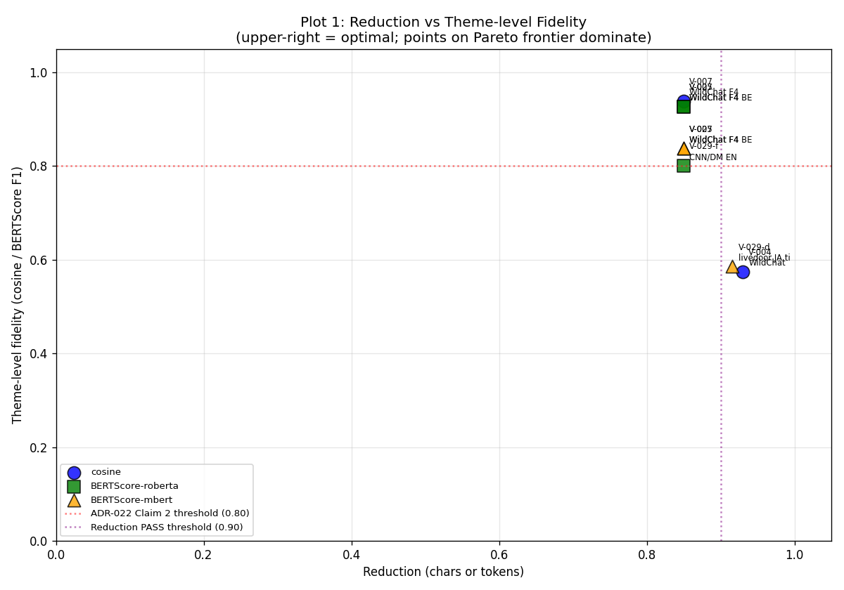
Plot 1. Reduction vs theme-level fidelity Pareto frontier (= main paper Figure 3).
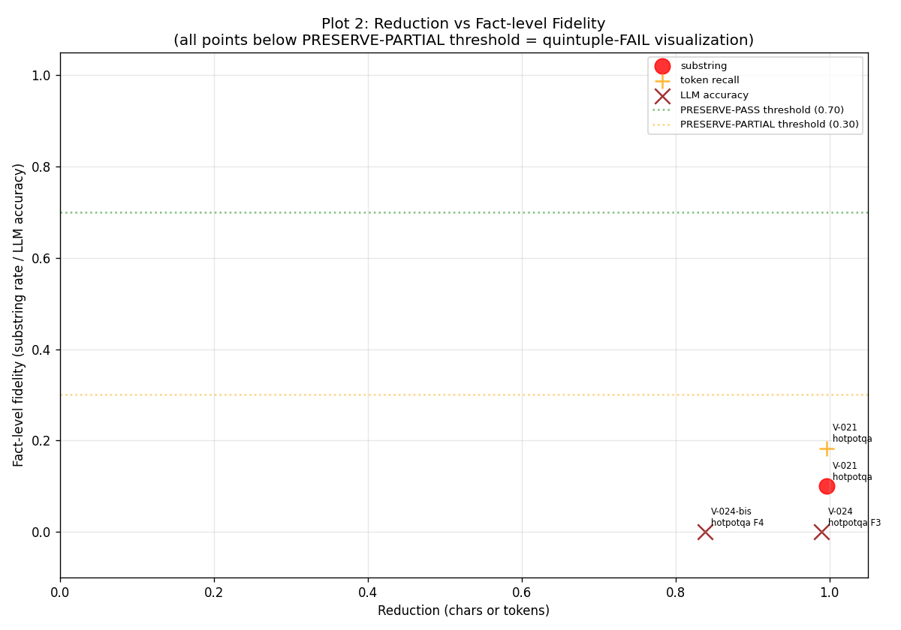
Plot 2. Reduction vs fact-level fidelity. All measured points cluster in PRESERVE-FAIL region (<=0.30 threshold), visualizing the constitutive fact-level FAIL limit (see Section 2 disclaimer: metric-multiple but corpus-dual evidence).
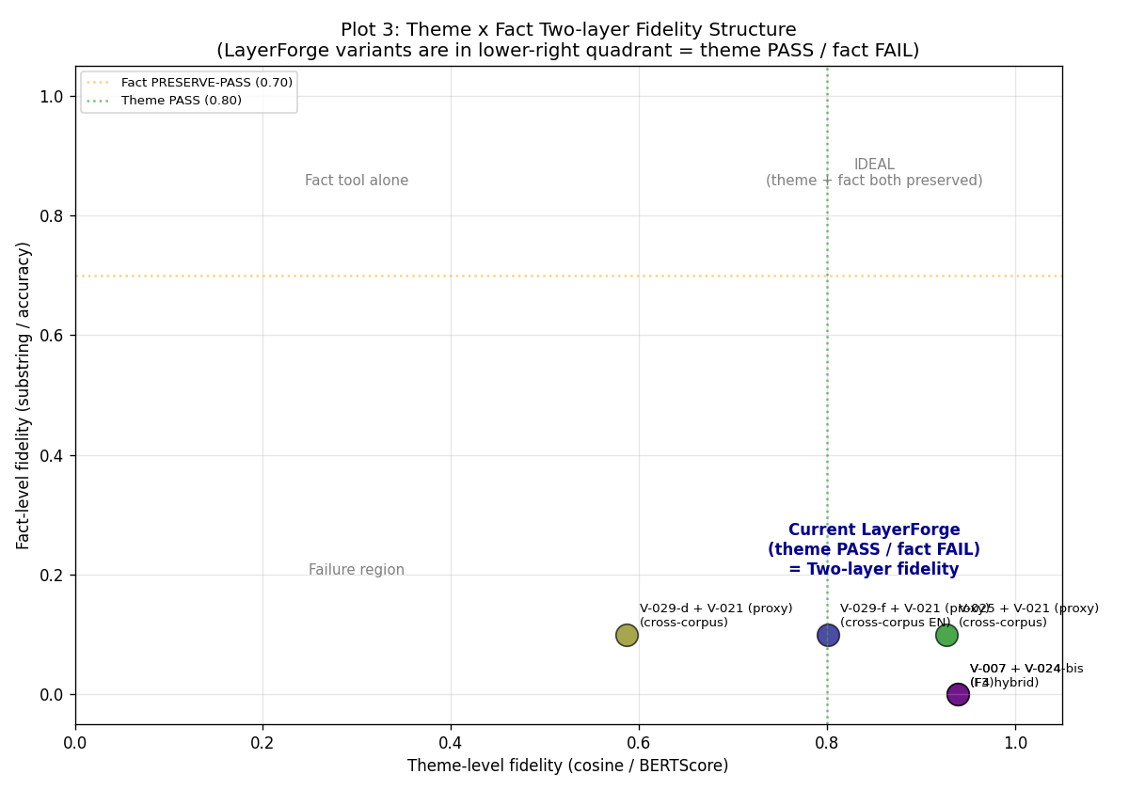
Plot 3. Theme vs fact two-layer structure (= main paper Figure 1). LayerForge variants in lower-right quadrant (theme PASS / fact FAIL).
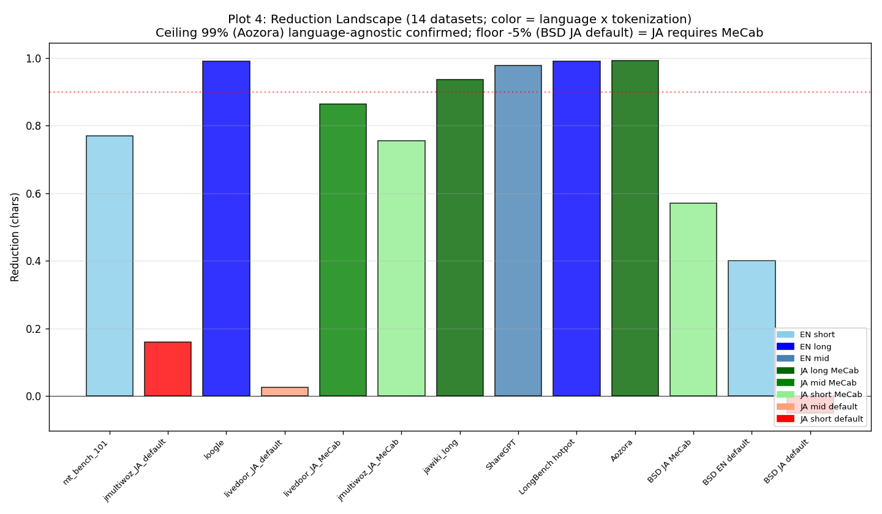
Plot 4. Reduction landscape across 14 datasets (= main paper Figure 2). Colored by language and tokenization.
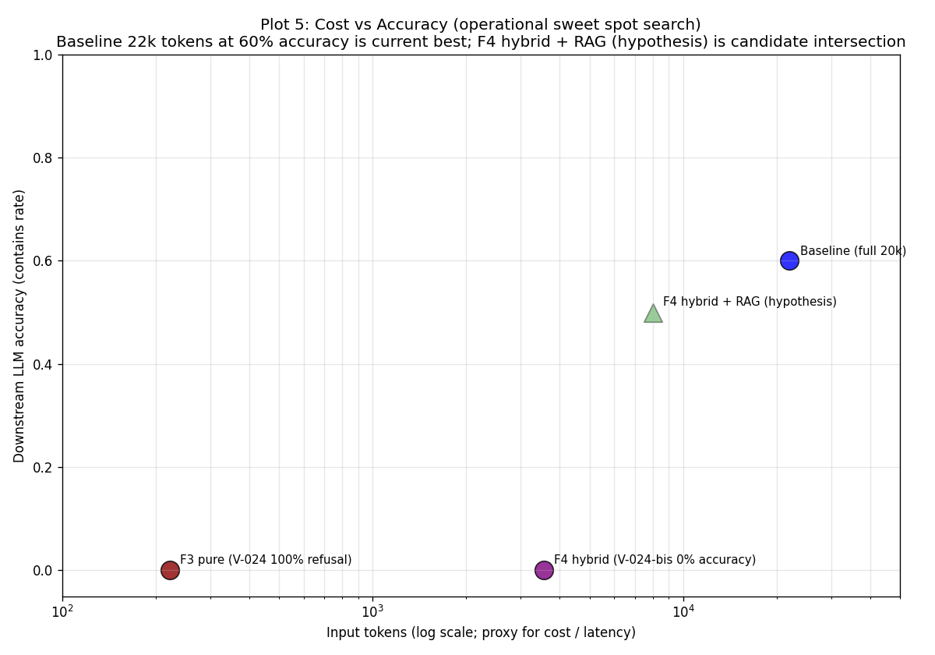
Plot 5. Per-query input-token cost vs downstream LLM accuracy (= main paper Figure 4; see main Figure 4 caption for full details). Raw data: v029a_cost_latency_results.json.

Appendix E. Future Work — Full 15-item Roadmap
Items marked AI-decidable can proceed without architectural triggers. Sovereign-trigger items await architectural and scope decisions.
Item | Axis | Scope | Cost | Decision
V-101 | Verification | Pattern-probe accuracy formal measurement | mid-high | AI-decidable
V-102 | Verification | Cross-domain generalization (law, medical) | mid | AI-decidable
V-103 | Verification | Direction reversal root cause | mid | AI-decidable
V-104 | Verification | Existing-record probe-perspective reframe | low | AI-decidable (top priority)
I-101 | Implementation | Probe API (layerforge.probe.profile) | mid | AI-decidable
I-102 | Implementation | Routing primitive (pattern -> algorithm) | mid-high | sovereign (architectural)
I-103 | Implementation | Output interpretation layer | mid | AI-decidable
I-104 | Implementation | Probe driver isolation from core | mid | sovereign (v8.1 integrity)
G-101 | Integration | Claude Code skill packaging | low | AI-decidable
G-102 | Integration | LangChain / LlamaIndex plugin | mid | sovereign (footprint)
G-103 | Integration | LLM API wrapper (probe + routing) | mid | AI-decidable
G-104 | Integration | KDF + LayerForge integration | mid-high | sovereign (two-tool)
E-101 | Effective | Cost / latency improvement measurement | mid | AI-decidable
E-102 | Effective | Accuracy preservation confirmation | mid | AI-decidable
E-103 | Effective | Real-world deployment pilot | high, long-term | sovereign (deployment)
Table E. Future work 15 items with priority and decision boundary.

Items Not Pursued
G-102 (LangChain plugin): personal-OS scope over-engineering, deferred until consulting trigger. E-103 (real deployment): personal-OS scope is already pilot-equivalent (Claude Code daily operation), separate deployment not required.

