User Guide

* **Connection Configuration**
* Amazon MWS API Connection Details
* **Getting AWS Access Key**

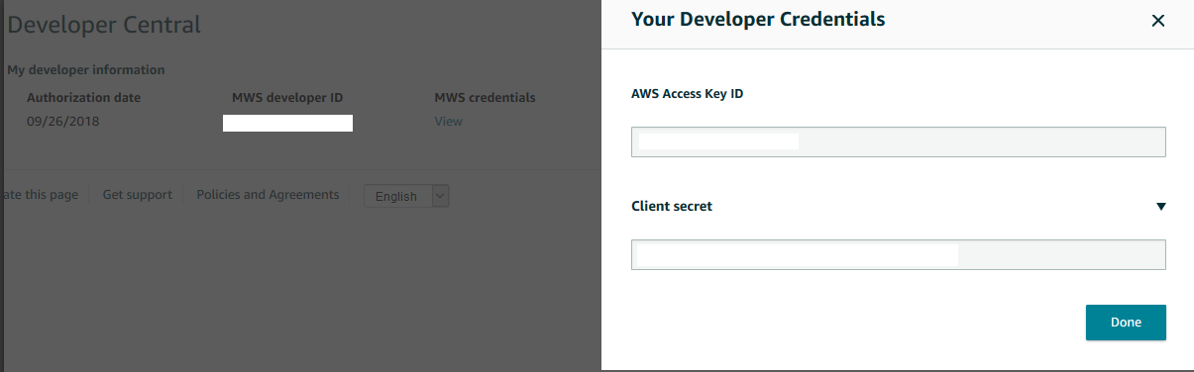

You can get aws access key id and client secret from the amazon mws developer central page.

* 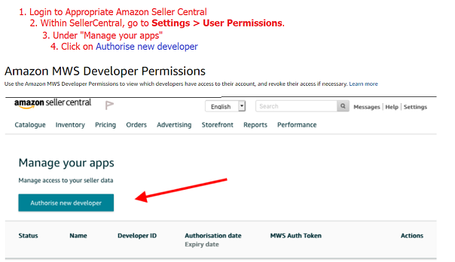**Seller ID & MWS Token**

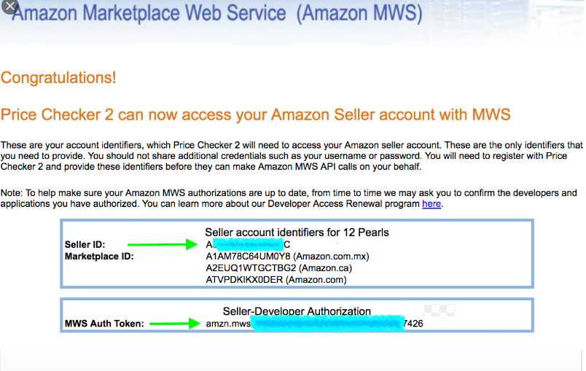For getting seller ID and MWS token, you need to authorize new developer account from your Amazon MWS seller central.