Post 2 Supplement - Fitting the Magic Formula to Your Own Tire Data

1. Recovering data from a published figure
The off-road coefficient set in off_road.py was not taken from a table. The curves themselves were therefore digitized. The page was rasterized at 300 dpi and each curve separated.. Each series is then read column by column, taking the median row of its matching pixels, with the in-plot legend masked out and a median filter plus isotonic regression applied to reject stray classifications. The script for fitting is added to the GitHub repository, and the extracted data is added as CSV in data/.
Digitization error is worst near the origin, where the curves are steepest and the markers widest relative to the gradient; treat values below about two degrees of slip angle as indicative. And the two source figures are not a matched pair: the lateral curves are dry sand on an AT 22x7-12, the longitudinal curves are sandy loam on an AT 23x8-12, and the longitudinal quantity is drawbar pull, which is already net of motion resistance.

2. Data file structure
The fitter reads Excel (.xlsx, .xls) or CSV. One header row, then three columns in this order. Column names are ignored; the order is what matters.
Column | Units | Contents
1 slip | deg or – | Slip angle in DEGREES for a lateral fit; slip ratio for a longitudinal fit
2 Fz | N | Vertical load
3 F | N | Measured force
Table 1. Required file layout. One row per measurement point.
You need at least three different vertical loads. The point of the fit is the load dependence, and a single load cannot show it. Five is comfortable. Rows with blanks are dropped.
If your force column is negative at positive slip angle, your data is in the SAE sign convention, and this model works in ISO. The fitter detects it and stops with a plain message rather than a solver traceback. Pass flip_sign=True or --flip-sign, or negate the column in the spreadsheet. Tire property files almost always use SAE, so expect this.

3. Running the fitter
From a notebook, import the function. Do not use %run: Jupyter puts its own arguments in the command line and the parser will exit.
from fit_magic_formula import fit_file

fit_file('mydata.xlsx', mode='lateral', fix_c=1.0, linear_k=True)
fit_file() # no argument opens a file picker
From a terminal, run the file:
python fit_magic_formula.py # file picker
python fit_magic_formula.py mydata.xlsx --mode lateral
python fit_magic_formula.py mydata.xlsx --mode longitudinal --shift

Option | Use it when
--mode lateral | longitudinal | Chooses whether column 1 is a slip angle in degrees or a slip ratio
--shift | Fitting drawbar pull, which does not pass through the origin
--flip-sign | Your force column is negative (SAE convention data)
--fix-c C | C came back sitting on a bound; pin it instead of fitting it
--linear-k | pK2 came back on a bound; use K = pK1·Fz instead of the saturating law
--fz0 N | You want a nominal load other than the median of the loads present
--plot FILE | Write a fit-quality plot
Table 2. Options. The same names work as keyword arguments to fit_file().
The script prints the coefficients, RMS, maximum error and R², then a paste-ready block for on_road.py or off_road.py. Fit with everything free first and read the AT BOUND warning if it appears: a coefficient resting on the edge of its allowed range is not determined by your data. It is an assumption wearing the costume of a result. Pin it deliberately and say so when you report the fit.

4. The fit behind off_road.py
Both channels were fitted with C pinned at 1.0 and the proportional stiffness law, for the reason just given: left free, C ran to a bound because it is partly degenerate with the curvature factor E on curves that have no peak, and pK2 ran to a bound because the source loads show no stiffness rolloff. Neither is determined by the data.
Coefficient | Lateral | Longitudinal | Meaning
Fz0 [N] | 1334.5 | 1334.5 | Nominal load (300 lbf)
pC1 | 1.0000 | 1.0000 | Shape factor — PINNED
pD1 | 0.5978 | 0.4441 | Friction at nominal load
pD2 | −0.0358 | −0.0300 | Load sensitivity
pE1 | 0.5927 | 0.5258 | Curvature at nominal load
pE2 | −0.2469 | −0.0826 | Load dependence of curvature
pK1 | 2.0889 | 1.7893 | Stiffness / Fz
SV [N] | — | −6.77 | Motion resistance in drawbar pull
RMS error | 22.1 N | 13.5 N | ≈ 2 % of full scale
Table 3. Fitted coefficients. Lateral: dry sand, AT 22x7-12. Longitudinal: sandy loam, AT 23x8-12. Both at 96.5 kPa.
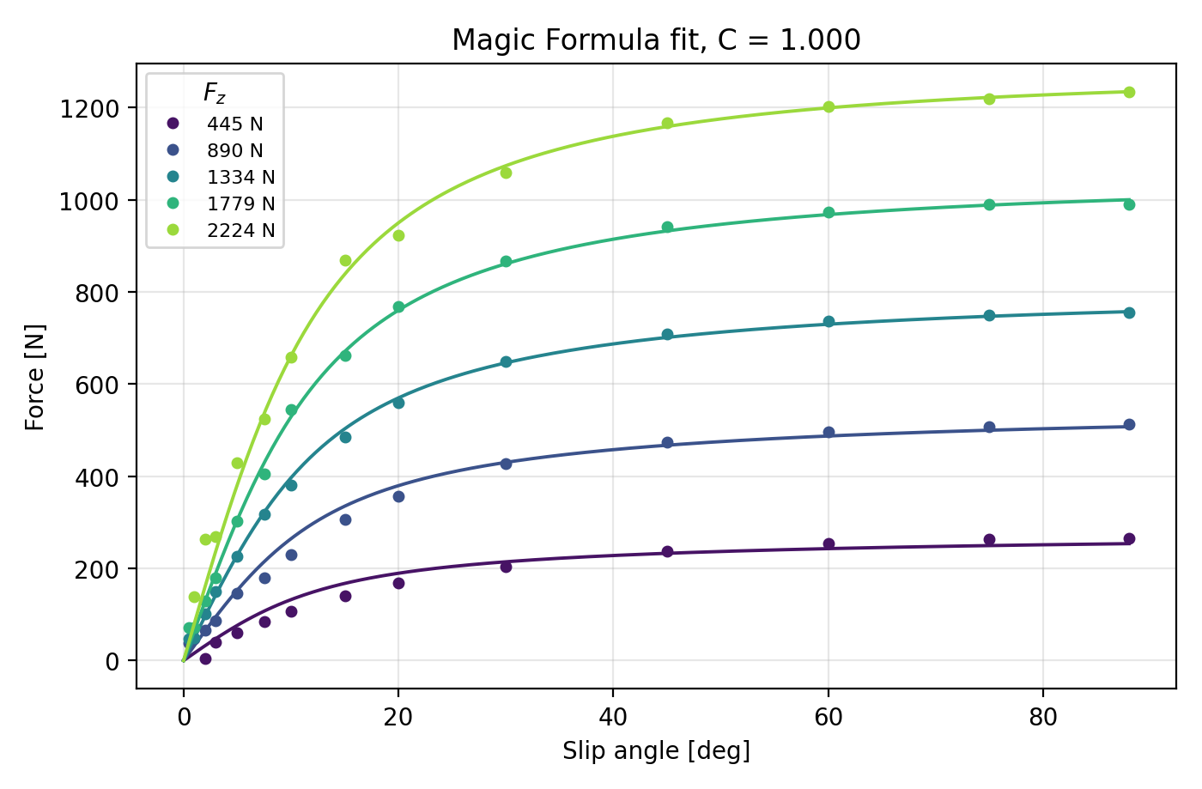
Figure 1. The lateral fit against the digitized data, all five loads fitted simultaneously.
Read before using these numbers - The source curves are terramechanics model output, not measured tire data, so the coefficients inherit every assumption in that model. The absence of a peak is partly an input rather than a finding: the shear law behind the source curves saturates monotonically by construction. And this set is not a comparison partner for on_road.py different tire, different surface, different sources. Both are teaching illustrations. Replace either with a fit to your own measurements before making a design decision.

References
Saunders, A. (2019). ESTIMATING PACEJKA (PAC2002) TIRE COEFFICIENTS FOR PNEUMATIC TIRES ON SOFT SOILS WITH APPLICATION TO BAJA SAE VEHICLES. http://asmedigitalcollection.asme.org/IMECE/proceedings-pdf/IMECE2019/59414/V004T05A081/6512802/v004t05a081-imece2019-10682.pdf

GitHub link
https://github.com/ChaiSon30/Off-road-Vehicle-dynamics.git

