Introduction
In the previous session we established where the classical on-road framework stops being valid off-road. Before we can rebuild anything, we have to be precise about the one component that every other subsystem exists to serve. Aside from aerodynamics and gravity, every force and moment that changes the vehicle's speed or direction is generated in four contact patches, each roughly the size of a hand. Springs, dampers, links, bushings, anti-roll bars and the steering system produce no useful external force by themselves. Their entire function is to place those four patches on the ground at the right load, the right camber and the right slip, for as much of the time as possible.
Every suspension decision we make in the rest of this series is ultimately a decision about tire operating point. This session builds the tire model that the remaining modules will call, and it establishes the four ideas that govern everything downstream: slip, saturation, load sensitivity, and the finite friction budget shared between longitudinal and lateral demand.
Everything in this post is generated by three small Python modules: magic_formula.py for the formula itself, and on_road.py and off_road.py for the two coefficient sets, which are called independently and never mixed. These are the workhorse for the entire series. The coefficients they run on deserve a section of their own before we go any further.
Every number in this session comes from an example coefficient file, not from a tested tire. The coefficient set used throughout is based on modifying available data, to be used as a teaching resource only. It is not a measurement of any identifiable product. The file is good for teaching how the tire behaves, i.e., characteristics such as the shape of the curves, how they change with load, how the linear range gives way to saturation, and how longitudinal and lateral demands compete. Those features are real and they transfer. The magnitudes do not. Read every friction coefficient below as illustrative of the form of the relationship, not as a value to design against. Do not use these coefficients for a design decision. The same applies to the second coefficient set introduced later, and one thing more applies to the pair of them. They describe different tires on different surfaces, drawn from different sources by different methods. They are two separate teaching illustrations, not two conditions of a controlled experiment. Nothing in this session compares their numbers, and nothing downstream should either.

The tire axis system and the two slips
The tire produces three forces and three moments at the contact patch. In the standard axis system the x-axis lies in the wheel plane pointing forward, the z-axis is normal to the road, and the y-axis completes the right-handed set. We will use four of the six components in this series, the longitudinal force $F_{x}$, the lateral force $F_{y}$, the vertical load $F_{z}$, and the aligning moment $M_{z}$. The remaining two, rolling resistance moment and overturning moment, are neglected here and will be re-introduced only where they matter.
A tire generates in-plane force only when it is made to move in a direction other than the one it is pointing, or to rotate at a speed other than the one that would roll it freely. These two ($α)$ is the angle between the wheel's heading and the direction the contact patch is actually travelling,
$$α =\tan^{-1}\left(\frac{v_{y}}{v_{x}}\right)$$
where $v_{x}$ and $v_{y}$ are the longitudinal and lateral velocity components of the wheel centre expressed in the wheel's own frame. The slip ratio ($κ)$ compares the circumferential speed of the tire to the speed at which it is actually travelling,
$$κ = \frac{ωR_{e} - v_{x}}{v_{x}}$$
with $ω$ the wheel's angular velocity and $R_{e}$ the effective rolling radius. Positive $κ$ means the tire is turning faster than the road is passing beneath it, which is driving; negative $κ$ is braking. A freely rolling tire has $κ = 0$ and produces no longitudinal force.
These two definitions do all the work in what follows, so it is worth seeing them before any force is drawn. Figure 1 shows both geometrically. Slip angle is a property of the direction the contact patch travels as viewed from above. Slip ratio is a property of how fast the tread is laid down relative to the ground, viewed from the side. Neither has anything to do with force yet. They are kinematic quantities, computed from velocities alone, and they exist whether or not the tire is capable of generating anything.
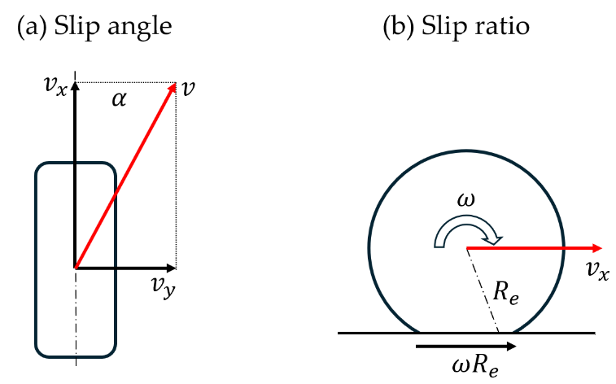
Figure 1. The two slip quantities. Left: slip angle, between the wheel plane and the travel direction of the contact patch. Right: slip ratio. The tire is drawn deflected; the dashed arc is the undeflected carcass, and the effective rolling radius Re lies between the loaded radius and the free radius R0.
Figure 2 shows how they behave as the vehicle moves. The left panel illustrates an important point that the slip angle depends on the ratio of lateral to forward velocity, not on lateral velocity alone. The same sideways motion of a wheel produces a large slip angle at walking pace and a small one at speed. A vehicle sliding at low speed is therefore deep into the nonlinear region of its tires, while the same sideways velocity at highway speed would barely leave the linear range.
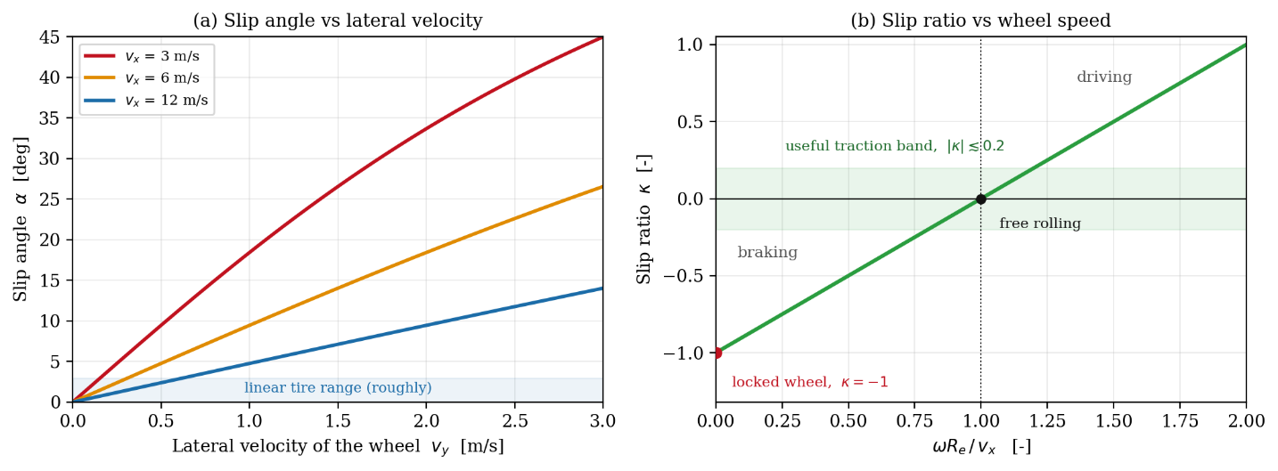
Figure 2. Left: slip angle against lateral velocity at three forward speeds. Right: slip ratio against the ratio of circumferential to forward speed, with the useful traction band shaded.
The right panel makes the equivalent point for the longitudinal channel. Slip ratio runs from minus one at a fully locked wheel, through zero at free rolling, to arbitrarily large values under wheelspin, but everything useful happens within roughly twenty percent either side of free rolling. That narrow band is the entire operating range of a traction control or anti-lock system.
In the code, both slips are inputs. They are computed from velocities by whatever is calling the tire model, and handed in as arguments: Fy(alpha, Fz) takes a slip angle in radians and a vertical load in newtons and returns a force. Nothing inside the tire model knows how the vehicle arrived at that slip angle, which is exactly the separation of concerns we want.
Sign conventions in the tire literature are a recurring source of error, so we fix one and hold it for the whole series. A positive slip angle produces a positive lateral force. This is the ISO-style convention, and it gives the familiar curve rising out of the origin. Readers coming from SAE conventions, where the lateral force is negative for positive slip angle, should note the sign flip when comparing our plots against published data.

Slip angle, cornering stiffness and the linear range
The physical origin of lateral force is worth holding in mind, because it explains the shape of every curve that follows. Think of the tread as a row of independent elastic bristles attached to the carcass. As each bristle enters the contact patch at the leading edge it is standing straight. If the tire is running at a slip angle, the carcass moves laterally relative to the ground while the bristle tip is stuck to the road, so the bristle deflects, and that deflection generates a lateral force. The further back in the patch a bristle sits, the longer it has been deflecting and the larger its force, until the local shear demand exceeds what friction against the road can hold and the tip slides.
At small slip angles no bristle is sliding. The whole contact patch is in adhesion, the deflection is proportional to slip angle, and the force is therefore linear in slip angle,
$F_{y} ≈ C_{α} α, C_{α} = \frac{∂F_{y}}{∂α}$at $α = 0$
The constant $C_{α}$ is the cornering stiffness, in newtons per radian or, more usefully for design work, newtons per degree. This single number is what makes classical handling approach tractable as it is the basis for the bicycle model, the understeer gradient and the stability derivatives.
For this coefficient set the linear approximation is within a few percent of the model up to roughly three degrees of slip angle, and unusable beyond about six. That range is not same for each tire. It shrinks with increasing load, and off-road it shrinks further as surface compliance and load fluctuation moves the operating point around. Any result we derive from cornering stiffness alone is a statement about small-disturbance behavior, not about the limit. In the code. Cornering stiffness is not stored as a coefficient. It is derived from the same parameters that produce the full curve, via cornering_stiffness(Fz), so the linear model and the nonlinear one can never drift out of agreement with each other.

Saturation
As slip angle grows, the sliding region that started at the trailing edge of the contact patch propagates forward. Force still rises, but progressively more slowly, because an increasing fraction of the patch has already given up all the shear it can hold. When the sliding region reaches the leading edge, the whole patch is sliding and the force has reached its peak,
$$F_{y,max} = D_{y} = μ_{y}\left(F_{z}\right)F_{z}$$
Past this point the curve does not stay flat and it falls away, because sliding friction is lower than the static friction, which was contributed by adhesion region before. This is the single most important feature of the tire for vehicle behavior. Below the peak, asking for more slip angle returns more force, and the vehicle is stable and predictable. Above it, asking for more slip angle returns less force. A driver who responds to a vehicle that is not turning enough by adding steering is, past the peak, actively making it worse. The same reversal at the rear axle is what makes limit oversteer divergent rather than self-correcting.
The slip angle at which the peak occurs is itself load-dependent. Off-road tires generally peak later still, and on genuinely soft ground the peak can disappear entirely.

The Magic Formula
We need a function that reproduces this shape, is continuous and differentiable everywhere, and whose coefficients have individual physical meaning so they can be fitted to measured data. Pacejka's Magic Formula does exactly this. It is an empirical curve fit, not a derivation from first principles, and it is the industry standard for steady-state tire modelling. In its canonical sine form,
$$y\left(x\right) = D sin\left(C arctan\left(Bx - E\left(Bx - arctan\left(Bx\right)\right)\right)\right)+S$$
where $x$ is the slip quantity and $y$ the resulting force. The four coefficients are not arbitrary fitting parameters; each controls a distinct visual feature of the curve. $D$ is the peak value. $C$ is the shape factor, which sets how far the curve falls off after the peak. $B$ is the stiffness factor, chosen so that the initial slope matches the measured cornering or slip stiffness, and $E$ is the curvature factor, which adjusts the sharpness of the transition into saturation. Because the initial slope of the formula is $BCD$, the stiffness factor is not fitted independently but computed from the other three,
$$B_{y} = \frac{K_{yα}}{C_{y}D_{y}}$$
The load dependence enters through a normalized load increment, which is what allows one coefficient set to cover the whole operating load range rather than requiring a separate fit at each load,
$$df_{z} = \frac{F_{z} - F_{z0}}{F_{z0}}$$
with $F_{z0}$ a nominal reference load, taken as 3.8 kN here. The peak friction ($μ_{y})$ and the cornering stiffness ($K_{yα})$ are then written as functions of this increment,
$$μ_{y} = p_{Dy1} + p_{Dy2} df_{z}, D_{y} = μ_{y}F_{z}$$
$$K_{yα} = p_{Ky1}F_{z0} sin\left(2 arctan\left(\frac{F_{z}}{p_{Ky2}F_{z0}}\right)\right)$$
Cornering stiffness rises with load, but not indefinitely. The sine-of-arctangent form makes it rise, flatten and eventually decline, which is what tires actually do. The coefficient $p_{Ky2}$ sets where that flattening occurs, in multiples of the nominal load. The longitudinal channel is built identically, with $κ$ replacing $α$ and its own coefficient set.
Table 1 lists the coefficients used. The MF tire model uses more coefficients depending on the version, however due to lack of available relevant data, those parameters cannot be fitted. The camber, ply-steer and conicity terms are dropped, since this model has neither camber nor horizontal and vertical shifts.
Coefficient | Value | Role
Fz0 | 3800 N | Nominal load
pCy1 | 1.4675 | Lateral shape factor Cy
pDy1 | 0.94002 | Peak lateral friction at nominal load
pDy2 | −0.17669 | Load sensitivity of lateral friction
pEy1, pEy2 | 0.00400, 0.000857 | Curvature of the lateral curve and its load dependence
pKy1 | 12.536 | Magnitude of cornering stiffness (sign flipped from SAE)
pKy2 | 1.3856 | Load at which cornering stiffness peaks, in units of Fz0
pCx1 | 1.5587 | Longitudinal shape factor Cx
pDx1 | 1.09 | Peak longitudinal friction at nominal load
pDx2 | −0.079328 | Load sensitivity of longitudinal friction
pEx1, pEx2, pEx3 | 0.274, 0.102, 0.0749 | Curvature of the longitudinal curve and its load dependence
pKx1 | 19.733 | Slip stiffness per unit load at nominal load
pKx2, pKx3 | 0.0934, 0.1243 | Load dependence of slip stiffness
Table 1. Coefficient set used throughout. Camber, ply-steer and conicity terms are dropped.
In the code, The four Magic Formula coefficients are never set directly. lateral_coeffs(Fz, p) builds B, C, D and E from the load and the parameter set on every call, which is what makes a single coefficient set cover the whole load range.

Load sensitivity
If friction obeyed the textbook law, the peak force a tire could produce would be exactly proportional to the load on it, and doubling the load would double the grip. In real life, the coefficient of friction of a tire falls as vertical load rises. The mechanism is that rubber friction is not Coulomb friction. As load increases, the contact patch grows and the pressure distribution within it becomes less uniform, the rubber is driven further into a regime where additional load produces proportionally less additional real contact area, and temperature within the patch rises. The net result is a peak friction coefficient that falls with load over the normal operating range, which is exactly what $p_{Dy2}$ encodes in our model.
The consequence for the vehicle is direct and unforgiving. In a corner, load transfers across an axle from the inner wheel to the outer. The axle carries the same total throughout and whatever the inner tire loses, the outer gains. But the two tires do not trade equally. The outer receives its extra load at a friction coefficient that is already falling, so it gains less grip than the inner one gives up. The axle finishes the load transfer with less lateral capability than it began with, and no suspension arrangement recovers it, because the loss belongs to the tire rather than to the mechanism that moved the load.
The penalty grows with the square of the load transfer. It means the loss is negligible in gentle cornering and severe at the limit, where load transfer is largest. It means halving the load transfer across an axle recovers three quarters of the penalty rather than half of it. And it means the penalty depends only on how much load moves, not on how stiffly or through what path it was moved. This is the reason lateral load transfer distribution is the primary handling tuning tool on any vehicle as shifting load transfer from one axle to the other does not change the total, but it changes how the quadratic penalty is split between the two axles and therefore changes the balance.
Off-road the same mechanism has a second and less familiar consequence. Vertical load on a wheel over rough terrain is not steady, and it fluctuates about some mean. Because the peak-force curve is concave in load, the average grip available over a fluctuating load is generally less than the grip available at the average load. Terrain roughness therefore costs grip even when the mean load is unchanged, and keeping normal-load fluctuation small is a genuine performance objective, not just a ride-comfort one.

Slip ratio and longitudinal force
The longitudinal channel behaves the same way for the same reason. The bristle picture carries over directly, with the deflection now along the wheel plane instead of across it. Force rises nearly linearly with slip ratio at small values, at a rate called the slip stiffness or longitudinal stiffness, then saturates as the sliding region propagates through the contact patch.
The peak longitudinal force is the operating point every anti-lock braking and traction control system is trying to hold. Beyond it, force falls and a fully locked wheel under braking, at $κ = -1$, produces meaningfully less retarding force than a wheel held near its peak. Also, it produces no to very less lateral force, which is why a locked wheel is also a steering failure.
Peak longitudinal friction is typically slightly higher than peak lateral friction on the same tire, which is reflected in the coefficients through $p_{Dx1} > p_{Dy1}$. Table 2 collects the model's key derived quantities at the four loads used in the sweeps.
Fz [N] | μy [−] | Fy,max [N] | Cα [N/deg] | Cα/Fz [1/deg] | μx [−] | κ at peak
500 | 1.093 | 547 | 156.5 | 0.313 | 1.159 | 0.180
1000 | 1.070 | 1070 | 304.8 | 0.305 | 1.148 | 0.175
1500 | 1.047 | 1570 | 438.2 | 0.292 | 1.138 | 0.170
2000 | 1.024 | 2047 | 552.0 | 0.276 | 1.128 | 0.166
Table 2. Model output at the four sweep loads.
As observed in the fifth column, cornering stiffness rises with load, more than tripling between 500 N and 2000 N, while cornering stiffness per unit load falls by only twelve percent over the same range. Both statements are true and they answer different questions. The first says a more heavily loaded tire resists a disturbance more stiffly. The second says it does so less efficiently per newton of load it is carrying, which is the same load-sensitivity story appearing in the linear range rather than at the peak.

Combined slip (The friction circle and ellipse)
A tire has one contact patch and one friction budget. Longitudinal and lateral forces are not produced by independent mechanisms; they are two components of a single shear force vector transmitted through the same rubber. The magnitude of that vector is bounded,
$$\sqrt{{F_{x}}^{2} + {F_{y}}^{2}} ≤ μ F_{z}$$
which is the friction circle. It implies that the force used for accelerating or braking is unavailable for cornering, and the trade is not linear. Because peak longitudinal and lateral friction differ, the boundary is in reality an ellipse rather than a circle,
$${\left(\frac{F_{x}}{F_{x,max}}\right)}^{2} + {\left(\frac{F_{y}}{F_{y,max}}\right)}^{2} = 1$$
Rearranging for the lateral force still available once a given longitudinal demand is being met gives the combination function used throughout this series,
$$F_{y,avail} = F_{y,max}\sqrt{1 - {\left(\frac{F_{x}}{F_{x,max}}\right)}^{2}}$$
The square root is what makes this interesting. Table 3 evaluates it, and the result is independent of load. The first half of the longitudinal budget affects the lateral force slightly, costing only thirteen percent of lateral capability, while the last ten percent costs more than half of what remains. This is the quantitative basis of every piece of advice about separating braking from cornering. Hence precision skills are required for trail braking, where a driver is operating on the steep part of the ellipse and even small errors in longitudinal demand produce large changes in available lateral force.
Longitudinal demand, Fx / Fx,max | Lateral force still available | Lateral capability lost
0 % | 100 % | 0 %
25 % | 96.8 % | 3.2 %
50 % | 86.6 % | 13.4 %
75 % | 66.1 % | 33.9 %
90 % | 43.6 % | 56.4 %
100 % | 0 % | 100 %
Table 3. The cost of longitudinal demand, evaluated at a 1000 N corner load

Outputs of On-road model
The three figures below are produced by sweeping the model over the following conditions: slip angle from −20 to +20 degrees and slip ratio from −0.45 to +0.45, each at vertical loads of 500, 1000, 1500 and 2000 N. That is roughly 50 to 200 kg per corner, the range a light off-road vehicle actually lives in.
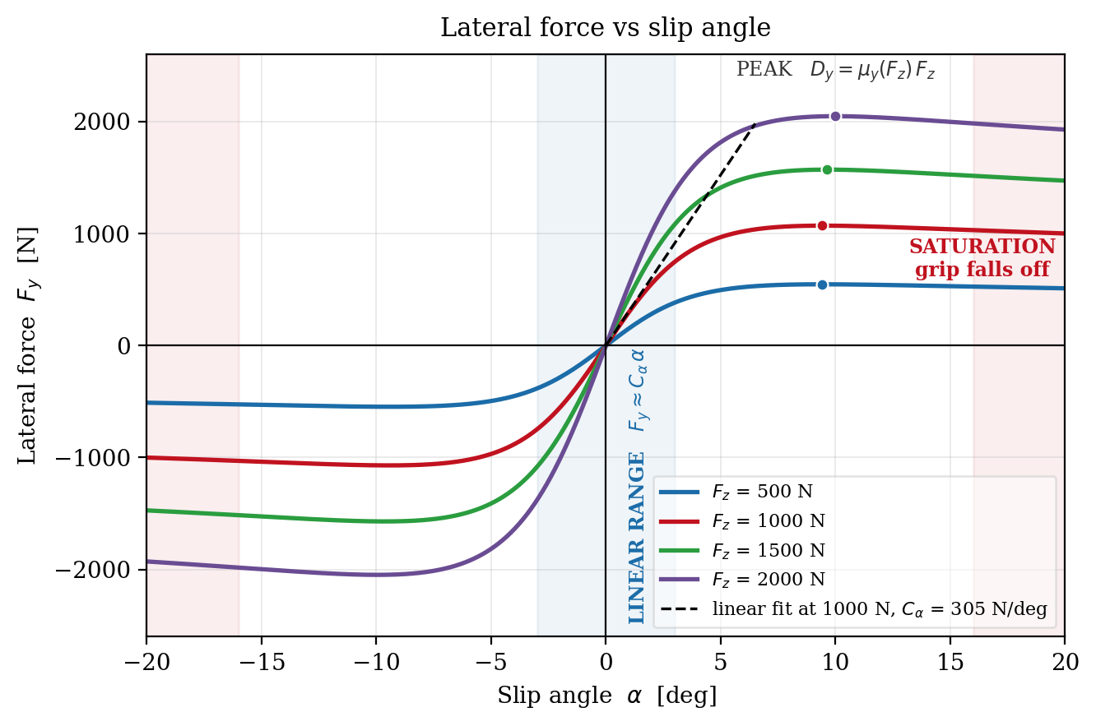
Figure 3. Pure-slip lateral force against slip angle for four vertical loads. The dashed line is the linear approximation at 1000 N; markers indicate the peak of each curve.
Figure 3 contains the three regimes in one picture. Near the origin every curve is straight and the dashed cornering-stiffness line lies on top of the nominal-load curve. By three degrees, the curves have visibly departed from it, and by six the linear model overpredicts substantially. Each curve then reaches a peak and then saturates. Note that the higher-load curves peak later as well as higher. This means the operating point moves rightward as the tire is loaded, so a vehicle in a corner is not merely asking its outer tire for more force, it is asking it to work at a larger slip angle to get it.
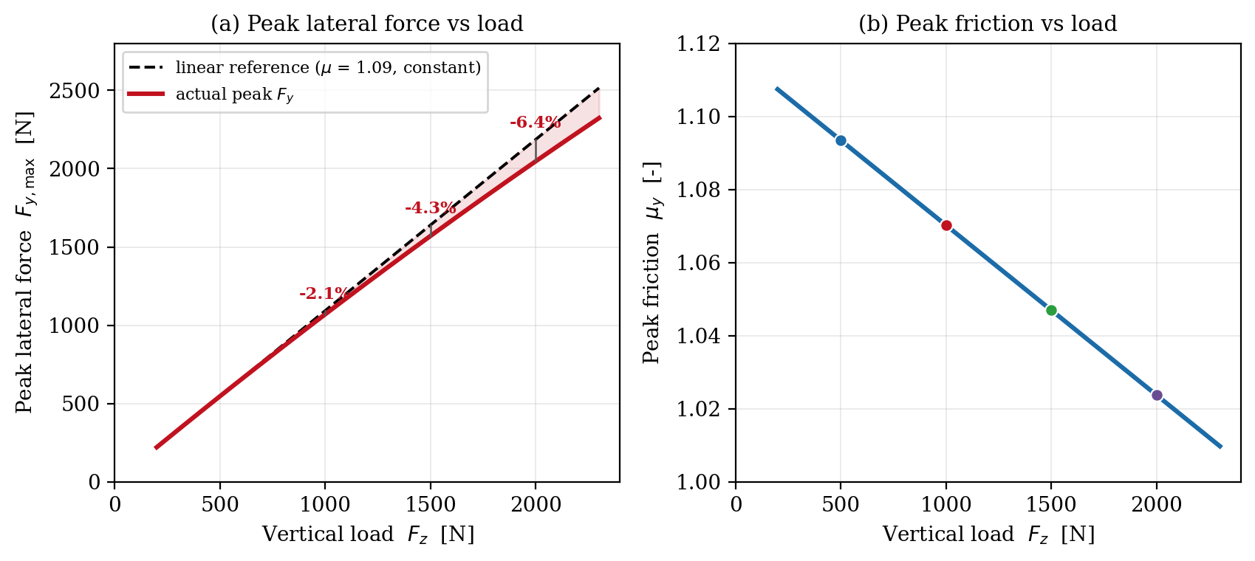
Figure 4. Left: peak lateral force against vertical load, compared with a constant-friction reference through the 500 N point. Right: the underlying decay of peak friction with load.
Figure 4 isolates load sensitivity. The dashed line is what the tire would deliver if friction were constant at its 500 N value; the solid line how the tire actually behaves. The shaded gap is grip that a constant-friction model would predict, and the vehicle would never see. Hence, a light vehicle operates on the flatter part of the friction-versus-load curve, so it suffers less from load transfer than a heavy one does. The right panel shows the cause, which in this model is a straight line by construction. Real tires show linear relationship over the working range and depart from it at very low and very high loads.
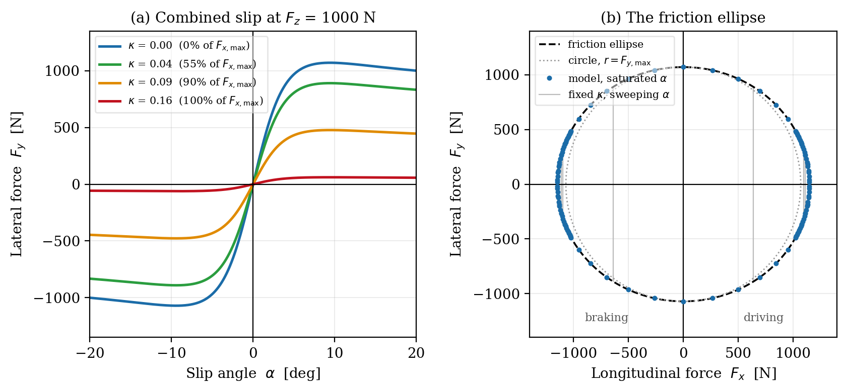
Figure 5. Left: lateral force against slip angle at four fixed slip ratios, 1000 N. Right: the resulting force locus, with the friction ellipse and a circle of radius Fy,max for comparison.
Figure 5 shows the friction budget being spent. In the left panel, a tire operating at a slip ratio of 0.04, generates fifty-five percent available maximum longitudinal force and costs about sixteen percent of lateral capability. At 0.16 slip ratio, which generates the maximum longitudinal force, leaves almost zero lateral capacity. The right panel plots the same data as a force locus. Each grey line is one fixed slip ratio with slip angle swept, and the markers are the saturated points, which trace the ellipse exactly by construction. The dotted circle shows how little the ellipse departs from a circle for this tire, since the two peak friction values differ by about fifteen percent at this load.

The off-road model
A second coefficient set is also included, which is fitted on data generated from an analytical tire-terrain interaction model, from published literature. Figure 6 shows both, on separate axes.
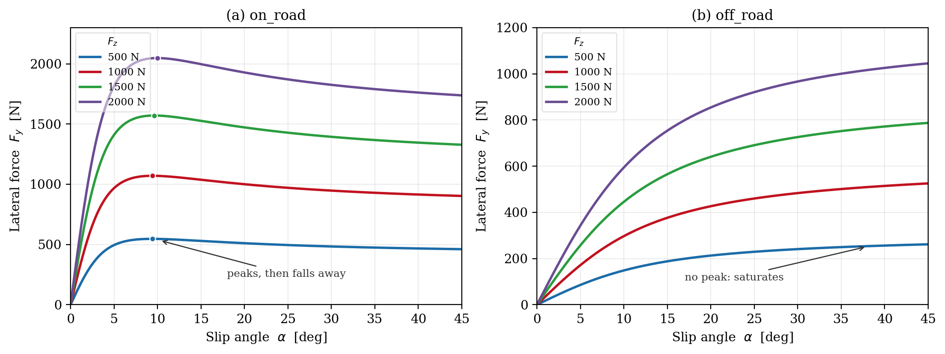
Figure 6. Left: the on-road set, which peaks and falls away. Right: the off-road set, which saturates without a peak.
These two models must not be compared with each other. They describe different tires, of different sizes and constructions, on different surfaces, derived from different sources by different methods. A difference in their numbers cannot be attributed to surface, to construction, or to anything else, because everything varies at once..
What can be taken from the pair is qualitative, and it is limited to one observation. The left curve, which shows behavior of a tire on road, has a maximum; past it, more slip angle returns less force. The right curve, for tire on deformable surface, does not have a maximum and it climbs and saturates. Everything said earlier in this session about saturation reversing the response, and governing limit behavior, belongs to the on-road dynamics. That distinction is real, it matters for off-road work, and it is worth carrying forward.
The absence of a peak in the second model follows partly from the shear law used to generate the source curves, which saturate monotonically by construction. Loose sand is believed to behave this way but dense or compacted soil can show a peak followed by a lower residual strength.
Everything above is on-road tire behaviour, presented in on-road terms, and it needs to be understood before it can be modified. Few things change when the surface stops being rigid pavement.
- Peak friction is not a property of the tire. The coefficient we have been calling $μ_{y}$ is a property of the tire and surface together. It changes with soil composition, moisture, and compaction, and it can change within a single corner. A single fitted coefficient set therefore describes one surface condition, and results carry the surface as an assumption.
- On soft soil the limit is set by the terrain, not the tire. When the ground shears before the rubber does, the force limit is the shear strength of the soil, and the Magic Formula's friction ceiling is no longer the binding constraint. This is where Bekker's pressure-sinkage and shear-displacement relations replace the friction model (will be discussed in upcoming chapters).
- Inflation pressure is a variable, not a constant. This holds true for on-road dynamics as well but off-road vehicles deliberately reduce pressure to enlarge the contact patch and reduce ground pressure. This changes cornering stiffness, peak friction and the slip angle at which the peak occurs, all of which are fixed coefficients in our model. Studies that compare pressures need a coefficient set per pressure.

How the code is organized
The model is split across three files, and uploaded to the GitHub repository (linked attached below).
- magic_formula.py holds the formula itself, the sine kernel, the load-dependent construction of B, C, D and E, and the friction ellipse. It knows no coefficients.
- on_road.py holds one coefficient set for on-road tire and calls into the kernel.
- off_road.py holds the other coefficients, fitted on analytical data generated from analytical tire-terrain interaction model, and is otherwise identical in interface.
Keeping the two coefficient sets in separate files rather than as options inside one is a deliberate choice. They are called independently, they are never selected by a flag, and neither is a default.
What this series uses these models for is lateral force. The whole point of the modules ahead is handling and most of it is governed by $F_{y}$. The longitudinal channel is implemented to draw the friction ellipse, because a tire's lateral capability cannot be discussed honestly without showing what braking and driving take away from it.
The combined slip is handled by ellipse scaling of the pure-slip curves rather than by Pacejka's full combined-slip weighting functions, which would need roughly a dozen further coefficients that cannot be fitted without combined-slip test data. These are practical limitations as comprehensive tire test datasets are unavailable for our application.

Limitations
This model is steady-state and isotropic in time. It has no relaxation length, so it responds to a change in slip angle instantaneously, whereas a real tire needs roughly half a rotation to build lateral force. Any question about steering response or on-center feel is therefore outside its reach.
It also has no camber thrust, no aligning moment and hence no pneumatic trail, no temperature or wear state, no inflation pressure dependence, and no turn slip. The coefficients used to describe a tire on dry pavement do not have a definitive source and are only used to teach relevant concepts. No conclusion in this session should be read as a numerical prediction for any real tire, and certainly not for an off-road one.

Closing remarks
Four key takeaways that carry forward –
- A tire generates force only in response to slip, and that relationship is linear only over a narrow range.
- The force saturates, and past saturation the response reverses sign in a way that dominates limit behavior.
- Grip does not scale with load, so any load transfer costs the axle capability, quadratically.
- The longitudinal and lateral demands share one budget, spent along a square root rather than a straight line.
Every one of these will reappear as a constraint on a design decision. All four are properties of the shape of the tire curves. The exact shape and magnitudes may not suite your vehicle, and that is the subject of the supplement to this session. A general least-squares fitting tool, so that a team with any measured data at all can replace either coefficient set with one it can defend.
The next session takes the first step outward from the contact patch, i.e., suspension and steering kinematics, and how camber, toe, roll centers and the steering axis determine the operating point that the tire actually sees.

References
Pacejka, H. B. (2012), Tire and Vehicle Dynamics. Elsevier. https://doi.org/10.1016/B978-0-08-097016-5.00013-9
Saunders, A. (2019). ESTIMATING PACEJKA (PAC2002) TIRE COEFFICIENTS FOR PNEUMATIC TIRES ON SOFT SOILS WITH APPLICATION TO BAJA SAE VEHICLES. http://asmedigitalcollection.asme.org/IMECE/proceedings-pdf/IMECE2019/59414/V004T05A081/6512802/v004t05a081-imece2019-10682.pdf

GitHub link
https://github.com/ChaiSon30/Off-road-Vehicle-dynamics.git

