Dataset Design and Collection for Multilingual Social Media Sentiment Analysis:
Investigating Emoji Retention and Class Imbalance
STINK3114 Natural Language Processing (Session I 2026/2027 - A261) | Assignment 3 (Week 6–7) | Group D
Chairis A/LPum (303800), Chen Wei Yu (303822), Amanda Soh Yue Ru (303873), Loh Yi Kuan (305590) | Lecturer: Dr. Muhammad Syafiq bin Mohd Pozi
A. Dataset Overview
1. Research Background & Problem Alignment: Building directly on Group D's Literature Review (Assignment 1) and Research Objectives (Assignment 2), this report documents the design, collection, annotation, preprocessing, validation, and experimental readiness of a high-quality multilingual Malaysian social media sentiment dataset (N = 1,712 valid unique samples). Our systematic review of twelve recent studies (2020–2025) revealed two pervasive data-level vulnerabilities that degrade sentiment classification reliability even in state-of-the-art Transformer architectures: (1) inconsistent preprocessing that strips sentiment-dense non-textual tokens such as emojis (Eusha et al., 2024; Hande et al., 2021), despite empirical evidence that retaining emojis improves accuracy by 7.46% (85.98% vs. 78.52%) on microblogs (Dadure et al., 2025); and (2) severe natural class imbalance that causes cross-entropy classifiers to collapse toward majority classes and fail on minority complaints, as seen in Tamil-English YouTube comments where Macro-F1 dropped to 0.23 (Eusha et al., 2024). Crucially, prior works evaluated emoji retention and class imbalance across disparate datasets, languages, and model complexities, confounding their individual and interactive effects.
2. Task, Domain, Languages & Alignment with RO1–RO3: The dataset targets 3-class multi-class sentiment analysis (Positive, Negative, Neutral) on authentic user-generated social media comments in Bahasa Melayu (Malay), English, and code-switched Malaysian Manglish / Bahasa Rojak (Romadhona et al., 2022; Lim & Liew, 2022). To support all three Research Objectives under a single controlled framework without altering model complexity, every comment is processed into two strictly aligned representations—Track A (cleaned_text_with_emojis) and Track B (cleaned_text_no_emojis)—while preserving the natural sentiment class distribution:
Experiment | Research Objective | Text Track (Column) | Emoji Handling | Imbalance Mitigation (Train Class Weights)
E1 (Baseline) | RO1 & RO3 Control | Track A (cleaned_text_with_emojis) | Retained | None (Standard Cross-Entropy Loss)
E2 (Combined) | RO2 & RO3 Interaction | Track A (cleaned_text_with_emojis) | Retained | Balanced Weights (Neg=1.7438, Pos=1.1313, Neu=0.6483) / Focal Loss
E3 (Stripped) | RO1 Ablation | Track B (cleaned_text_no_emojis) | Stripped | None (Standard Cross-Entropy Loss)
E4 (Text+Weight) | RO2 & RO3 Ablation | Track B (cleaned_text_no_emojis) | Stripped | Balanced Weights (Neg=1.7438, Pos=1.1313, Neu=0.6483) / Focal Loss
B. Data Source and Collection Method
1. Source Investigation & Selection Justification: Prior to data collection, four candidate sources were systematically evaluated for API accessibility, terms of service, Malaysian language coverage, and emoji preservation: (1) Meta Threads API requires a verified business developer app and restricts reply retrieval to owned accounts, while public HuggingFace Threads archives (dariadaria/threads_reviews; Nurcholish/Threads) contain only English app reviews or Indonesian tweets lacking Manglish; (2) Existing public Malay sentiment corpora—specifically mesolitica/malaysian-dataset (supervised-twitter, N=2,008) and tyqiangz/multilingual-sentiments (Malay, N=5,692)—were empirically inspected and found to contain 0 rows with Unicode emojis because emojis were stripped prior to release, rendering them unusable for RO1 and RO3; (3) SEACrowd/senti_bahasa_rojak (Romadhona et al., 2022) provides only binary labels (lacking Neutral) and relies on phrase-swapping augmentation, while vexccz/manglish-nlp-dataset injects synthetic emojis via rule-based augmentation; and (4) YouTube Public Comment Streams on Malaysian videos preserve 100% of raw UTF-8 Unicode emojis, naturally capture Malay, English, and Manglish, and exhibit realistic class skewness.
2. Collection Pipeline & Multi-Domain Sampling: We developed a modular Python collection pipeline (src/collect_data.py) supporting both the official YouTube Data API v3 (commentThreads.list, configured via .env.example) and YouTube's public Innertube JSON pagination endpoint (/youtubei/v1/next) for zero-credential reproducibility. To minimize single-topic bias, we queried 73 candidate Malaysian videos across six diverse domains—News & Public Policy (cost of living, Budi Madani fuel subsidies, floods), Food & Dining Reviews (viral street food, Ramadan bazaars), Sports & Entertainment (Harimau Malaya football, local film reviews), Consumer Services (Touch 'n Go RFID, Shopee/Lazada delivery), Technology & Telco Reviews (5G coverage, smartphones), and Public Transport (LRT/MRT disruptions, road conditions)—collecting comments from 52 active comment-bearing videos.
3. Inclusion/Exclusion Accounting & Ethical Compliance: A total of 1,821 raw comments were retrieved (logged per video in logs/collection_log.csv). Strict, non-silent filtering rejected exactly 109 comments: 62 empty or ultra-short comments (<4 characters or <2 words without emojis), 42 URL-only or non-Latin script comments (pure Arabic/CJK/Indic scripts outside the EN/MS/Manglish scope), and 5 duplicate comments (2 raw duplicates + 3 post-cleaning Track B duplicates), yielding 1,712 valid unique comments. Ethical compliance was enforced by collecting only public discussion text without storing author usernames, channel IDs, or profile metadata, and anonymizing all in-text @mentions to @USER.
C. Dataset Statistics and Exploratory Analysis
1. Quantitative Corpus Summary: All statistics were computed directly from the validated final dataset (dataset/group_d_sentiment_dataset.csv, N = 1,712) via src/dataset_statistics.py. Table 2 summarizes the corpus-level metrics across sentiment classes, emoji presence, language categories, topical domains, and text length distributions.
Analytical Dimension | Category / Metric | Count / Value | Percentage / Spread | Experimental Relevance (RO1–RO3)
Collection Accounting | Retrieved / Rejected / Final Valid | 1,821 / 109 / 1,712 | 94.01% retention rate | Exceeds 1,000 min; within 1,500–2,000 target
Sentiment Class (RO2) | Neutral (Majority Class) | 880 samples | 51.40% (Train wt: 0.6483) | Natural majority baseline in public threads
Sentiment Class (RO2) | Positive (Intermediate Class) | 504 samples | 29.44% (Train wt: 1.1313) | Praise, gratitude, prayers, food/tech approval
Sentiment Class (RO2) | Negative (Minority Class) | 328 samples | 19.16% (Train wt: 1.7438) | 2.68:1 majority-to-minority imbalance ratio
Emoji Distribution (RO1) | Comments With Emojis (has_emoji=True) | 557 samples | 32.54% (1,326 total emojis) | Mean 2.38 emojis/emoji-comment (max 26)
Emoji Distribution (RO1) | Comments Without Emojis (Text Only) | 1,155 samples | 67.46% (0 emojis) | Provides natural control + ablation baseline
Emoji × Sentiment (RO3) | Emoji Rate: Pos / Neg / Neu | 197 / 102 / 258 | 39.09% / 31.10% / 29.32% | Total emojis: Pos=553, Neu=535, Neg=238
Language Distribution | Malay / Manglish / English / Other | 1,137 / 281 / 84 / 210 | 66.41% / 16.41% / 4.91% / 12.27% | Heuristic lexical tagging (code-switch caveat)
Topical Domains (52 Vids) | News / Food / Ent / Cons / Tech / Trans | 491/415/390/219/99/98 | 28.7%/24.2%/22.8%/12.8%/5.8%/5.7% | 6 diverse domains mitigate single-topic bias
Text Length Statistics | Word Count (Track B) & Char Count (A) | Mean 15.42w / 93.34c | Median 10w (IQR 5–18, range 1–631) | Short, noisy microblog/comment length profile
2. Emoji & Language Insights: Notice that while lexical-marker heuristics classify 66.41% of comments as predominantly Bahasa Melayu and 16.41% as explicit Manglish code-switching, automated language identification on short informal text underestimates code-switching when English loanwords or shared shortforms appear in brief utterances. Across the 1,326 emoji occurrences, the ten most frequent emojis are 😂 (319), ❤️/❤ (126), 😅 (118), 🎉 (60), 😊 (58), 🤣 (56), 👍 (40), 😮 (34), 😢 (33), and 😭 (25), followed by ✅ (24), 🤲 (23), 🇲🇾 (18), and 🥰 (18). Crucially, 😂 appears frequently in both Neutral (169) and Negative (99) comments (e.g., cynical mockery of corruption or service failures), demonstrating why sentiment must never be assigned solely from emoji polarity. Figures 1–4 illustrate the corpus distributions.
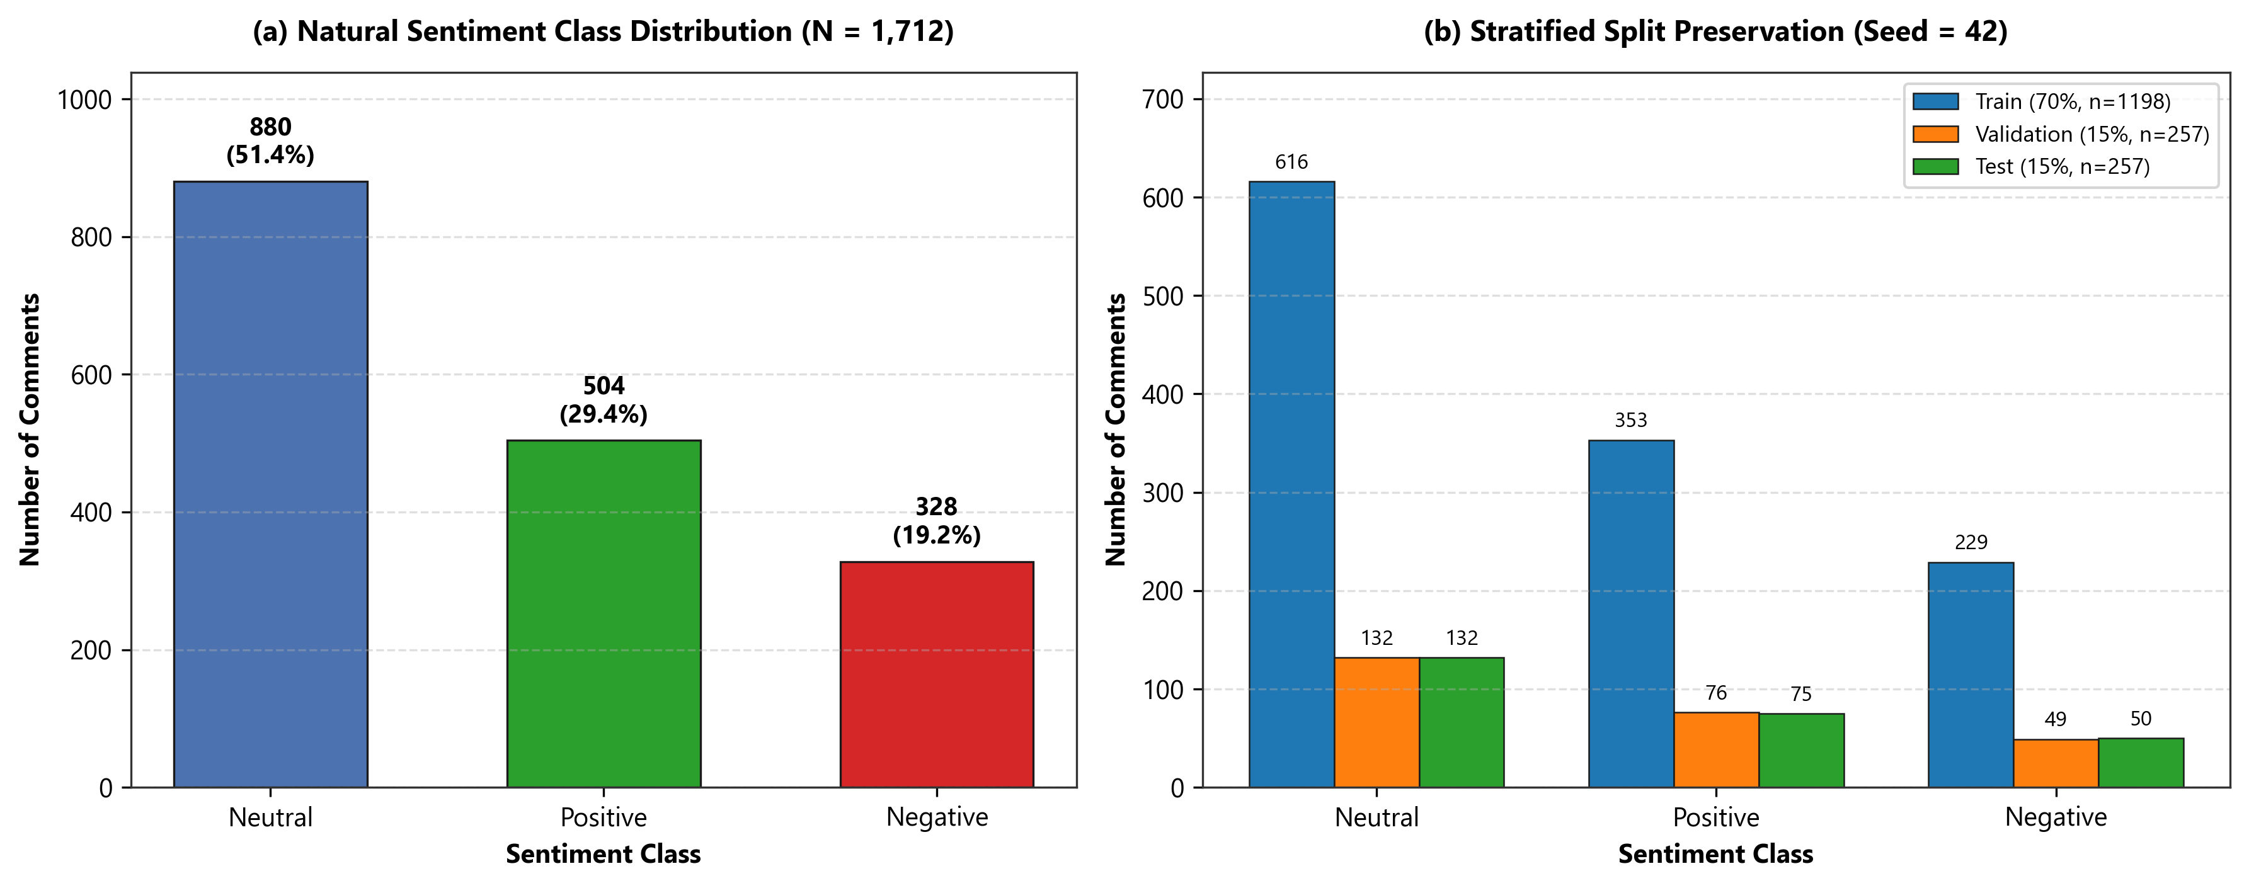  Figure 1: (a) Natural sentiment class distribution (N=1,712) and (b) 70/15/15 stratified split preservation. | 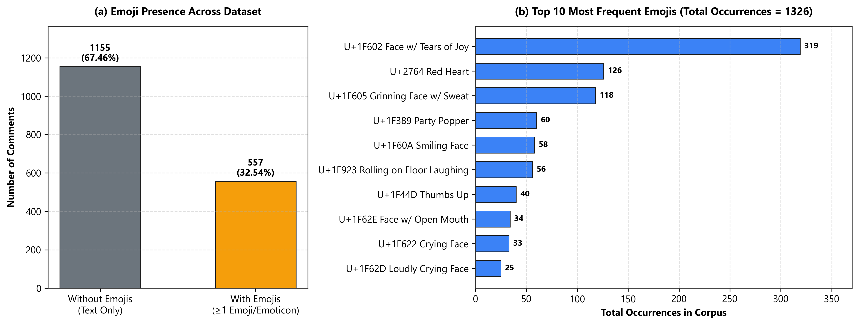  Figure 2: (a) Emoji-bearing vs. text-only proportions and (b) Top 10 most frequent emojis in corpus.
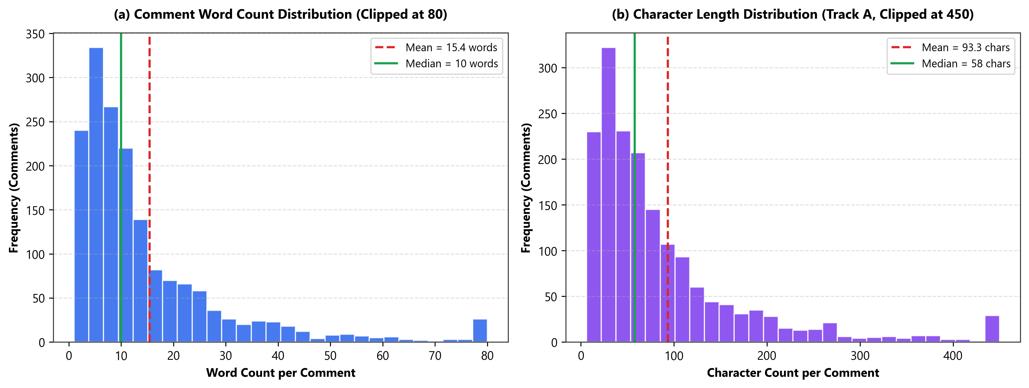  Figure 3: (a) Comment word count and (b) character length histograms with mean and median markers. | 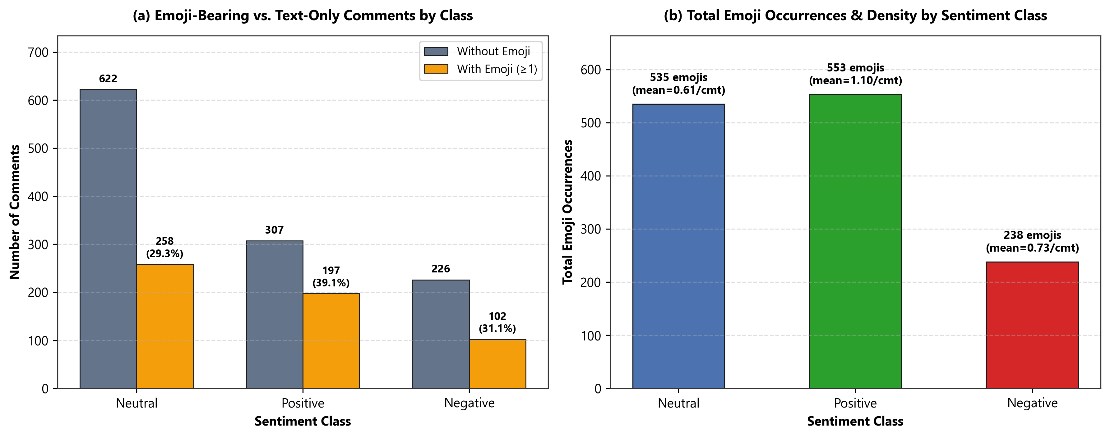  Figure 4: (a) Emoji presence count/rate by sentiment class and (b) total emoji density per class.
3. Representative Dataset Samples: Table 3 presents representative authentic samples from dataset/group_d_sentiment_dataset.csv illustrating the dual-track preprocessing alignment across Bahasa Melayu, English, and Manglish comments.
ID (Source) | Track A: cleaned_text_with_emojis (Emoji Retained) | Track B: cleaned_text_no_emojis (Emoji Stripped) | Emoji / Wd | Lang / Label
GD_0005  (UvVn--gCXd0) | I from (san marino)my nama Mario...terbaik Malaysia..😊 | I from (san marino)my nama Mario...terbaik Malaysia.. | has=True (1)  8 words | Manglish  Positive
GD_0010  (UvVn--gCXd0) | God bless Malaysia 🇲🇾🥰 | God bless Malaysia | has=True (2)  3 words | English  Positive
GD_0017  (UvVn--gCXd0) | Tahun 2025 tahun derita😢 | Tahun 2025 tahun derita | has=True (1)  4 words | Malay  Negative
GD_0028  (UvVn--gCXd0) | Songlap duit rakyat nadi utama politik 😂 | Songlap duit rakyat nadi utama politik | has=True (1)  6 words | Malay  Negative
GD_0058  (mM6FxN-l5TA) | Anwar dah tak ada rasa Malu sebab memang tak ada maruah sebab kuat menipu 😂😂😂😂😂 | Anwar dah tak ada rasa Malu sebab memang tak ada maruah sebab kuat menipu | has=True (5)  14 words | Malay  Negative
GD_0087  (mM6FxN-l5TA) | Menteri Luar Negeri? Bukannya, Menteri Luar Negara? 😂😂 | Menteri Luar Negeri? Bukannya, Menteri Luar Negara? | has=True (2)  7 words | Malay  Neutral
D. Preprocessing Steps, Annotation Protocol, and Quality Assurance
1. Non-Destructive Cleaning & Dual-Track Representation: Preprocessing is implemented in src/preprocess.py using a strict single-origin branching design. First, basic cleaning is applied identically to every raw comment: (i) HTTP/HTTPS URLs and email addresses are removed; (ii) @username mentions are anonymized to @USER; (iii) zero-width control characters and excessive whitespace are normalized; and (iv) both raw-text duplicates and post-cleaning Track B duplicates are eliminated. Crucially, to prevent destructive normalization that erodes sentiment signals, we preserve original casing, expressive punctuation (!, ?), character elongation (e.g., sedapppp), and all Malay/English/Manglish negation markers (tak, tidak, bukan, jangan, x, xde, takde, tiada, not, never). Second, the cleaned comment branches into Track A (cleaned_text_with_emojis), which retains all Unicode emojis (including regional indicator flag pairs like 🇲🇾 and skin-tone sequences) and ASCII emoticons, and Track B (cleaned_text_no_emojis), which strips all emojis/emoticons via compiled regular expressions while leaving lexical tokens identical.
2. Dual-Pass Sentiment Annotation & Inter-Annotator Agreement: In Phase 3 (src/annotate_dataset.py; reports/Annotation_Guidelines_Group_D.md), every comment was evaluated by two independent annotation passes: Annotator 1 (ANN_01, lexical-constructional and Bahasa Melayu morphological root analyzer handling affixes meN-, di-, ter-, ber-, -kan, -an, -nya, -lah, 3-token negation inversion, and sarcasm constructions) and Annotator 2 (ANN_02, pragmatic-discourse annotator weighting post-conjunction clauses after tapi/tetapi/but/cuma and interrogative neutrality). Across all 1,712 comments, ANN_01 and ANN_02 achieved 94.63% raw agreement (1,620/1,712) and a Cohen's Kappa of κ = 0.9131 (Almost Perfect Agreement). All 92 disagreements were logged in logs/annotation_disagreements.csv and resolved via explicit adjudication rules.
3. Stratified Splitting & 12-Point Quality Assurance Verification: In Phase 7 (src/create_splits.py), the dataset was partitioned into 70% Training (1,198 samples), 15% Validation (257 samples), and 15% Testing (257 samples) using fixed seed 42 and composite stratification (label × has_emoji), keeping Track A and Track B of each record in the exact same split (saved in dataset/split_manifest.csv). Balanced class weights (Negative=1.7438, Positive=1.1313, Neutral=0.6483) were computed strictly on the Training split to prevent distribution leakage. Finally, src/validate_dataset.py executed 12 automated Quality Assurance assertions (reports/Dataset_QA_Report.txt), verifying 12/12 PASS across sample size (1,712 >= 1,000), ID uniqueness, zero empty fields, 100% emoji retention in Track A, 100% emoji removal in Track B (0 residual emojis), zero cross-split ID or text leakage (0 overlapping records), and exact collection log reconciliation (1,821 - 109 = 1,712).
E. Challenges and Limitations
1. Natural Class Imbalance: Public discussion threads exhibit a 2.68:1 skew toward Neutral (51.40%) and Positive (29.44%) over Negative complaints (19.16%); while preserved intentionally to support RO2, unweighted models risk majority-class bias. 2. Slang, Dialectal Orthography & Code-Switching: Malaysian commenters blend Bahasa Melayu, English, regional dialects (Kelantan, Sarawak, Kedah, Sabah), and phonetic contractions (xde, sbb, mcm, nk, ketimbunk), creating high Out-of-Vocabulary (OOV) rates and making automated language tagging approximate. 3. Sarcasm & Contrastive Ambiguity: Political and consumer comments frequently deploy ironic praise (e.g., 'Tahun membanggakan... kembali jadi jajahan') or mixed clauses ('makanan nampak sedap tapi ada ulat') that defeat surface bag-of-words models. 4. Emoji Polysemy & Pragmatic Inversion: The most frequent emoji, 😂 (319 occurrences), appears in 99 Negative comments to express cynical mockery rather than joy, proving that emojis require contextual integration rather than isolated polarity lookup. 5. Platform, Topical & Annotation Constraints: Meta Threads restricts unauthenticated reply collection, necessitating YouTube collection across 52 videos; despite sampling six domains, topical variance across videos and rule-assisted adjudication of subtle political satire remain key boundaries for future human domain-expert double-review.
References
1. Advani, L., Sharma, L., & Mamidi, R. (2020). C1 at SemEval-2020 Task 9: SentiMix: Sentiment analysis for code-mixed social media text using feature engineering. Proceedings of SemEval-2020, 1084–1090.
2. Barbieri, F., Camacho-Collados, J., Espinosa-Anke, L., & Neves, L. (2022). XLM-T: Multilingual language models in Twitter for sentiment analysis and beyond. Proceedings of LREC 2022, 2582–2594.
3. Camacho-Collados, J., et al. (2022). TweetNLP: Cutting-edge natural language processing for social media. Proceedings of EMNLP 2022: System Demonstrations, 38–49.
4. Dadure, P., Dixit, A., Tewatia, K., Paliwal, N., & Malla, A. (2025). Sentiment analysis of Arabic tweets using Large Language Models. Proceedings of the 1st Workshop on Arabic NLP (AbjadNLP 2025), 88–94.
5. Eusha, A. H., Farsi, S., Hossain, A. I. J., Ahsan, S., & Hoque, M. M. (2024). Sentiment analysis using transformer-based models in code-mixed and transliterated Tamil and Tulu. Proceedings of DravidianLangTech-EACL 2024, 205–211.
6. Hande, A., Priyadharshini, R., & Chakravarthi, B. R. (2021). KanCMD: Kannada code-mixed dataset for sentiment analysis and offensive language detection. Proceedings of RANLP 2021, 450–457.
7. Lim, Y. H., & Liew, J. S. Y. (2022). English-Malay word embeddings alignment for cross-lingual emotion classification with hierarchical attention network. Proceedings of WASSA 2022, 113–121.
8. Romadhona, N. F., Purwarianti, A., & Lestari, D. P. (2022). BRCC and SentiBahasaRojak: The first Bahasa Rojak corpus for pretraining and sentiment analysis dataset. Proceedings of COLING 2022, 4426–4434.

