No logo supplied | Brightwater Research Studio

Reducing first-month cancellations for an independent bookshop’s subscription box: what the evidence supports and what it does not

Reference  BRS-LQ-2026-11 | Intended audience  Owners and shop-floor leads at Lantern & Quire Books | Prepared by  Brightwater Research Studio
Date
8 October 2026

Summary
Most cancellations happen in the first four weeks, and the main stated reason is that the first box did not match what members expected [1, 2]. A short welcome email that sets expectations reduced first-month cancellations in a small test, but the test is too small to size the effect with confidence [3].

Goals
• Lower first-month cancellations without discounting the box.
• Learn which expectation gaps matter most to new members.

Constraints
• Two staff hours a week available for member communication.
• No change to the box price this season.

Evidence: when members leave, and the reasons they give when asked at cancellation
Across the spring cohort, 61% of all cancellations happened within the first four weeks [1]. Of members who gave a reason, the most common was that the first selection “wasn’t my kind of book” [2].
Share of cancellations by week since joining, spring 2026 cohort [1]
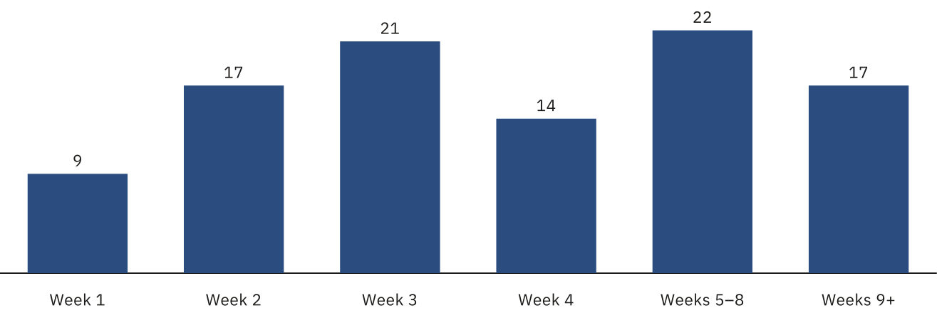
Week since joining · Share of cancellations (%) · Unit: % of all cancellations
Week since joining | Share of cancellations (%)
Week 1 | 9
Week 2 | 17
Week 3 | 21
Week 4 | 14
Weeks 5–8 | 22
Weeks 9+ | 17
Cancellations peak in week 3 (21%). Weeks 1–4 together account for 61% of all cancellations; weeks 5–8 for 22% and weeks 9 onward for 17%.
In a two-arm test, members who received a welcome email describing how books are chosen cancelled less often in their first month (8 of 112) than members who did not (15 of 109) [3]. The difference is encouraging, but with fewer than 250 members in total it could be chance.
“I loved the idea, but the first book felt like it was picked for someone else.” [2]

Recommendations
1. Send the welcome email to every new member, and keep a 10% hold-out to keep measuring its effect.
2. Add a three-question taste card at sign-up, and use it for the first selection only.
3. Review week-3 cancellations monthly; benchmarks suggest a two-hour weekly budget is enough at this size [4].
The email test is small. Treat its effect size as directional until the hold-out has run for a full season.

Sources
1. Subscription cohort summary, Q2 2026 (sample source). Northbridge Reader Panel — fictional. July 2026. Table 3
2. Exit-survey responses from cancelled members (sample source). Lantern & Quire Books — fictional. August 2026. Question 4
3. Onboarding email test, two-arm comparison (sample source). Brightwater Research Studio — fictional. 14 September 2026. Results, para. 2
4. Independent bookshop operating benchmarks 2026 (sample source). Guild of Small Booksellers — fictional. May 2026

