**OUTPUT SCREENSHOT**

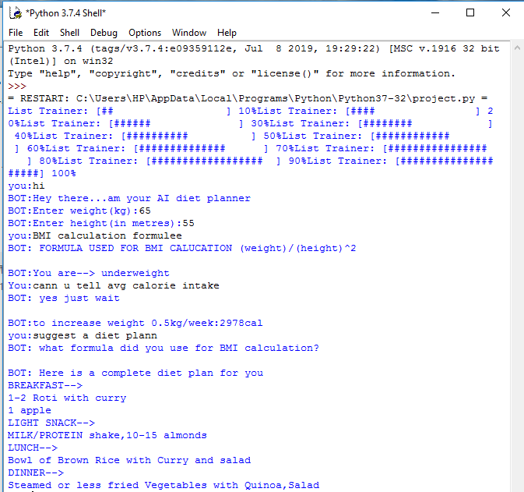

**Fig 4. Output screenshot 1**

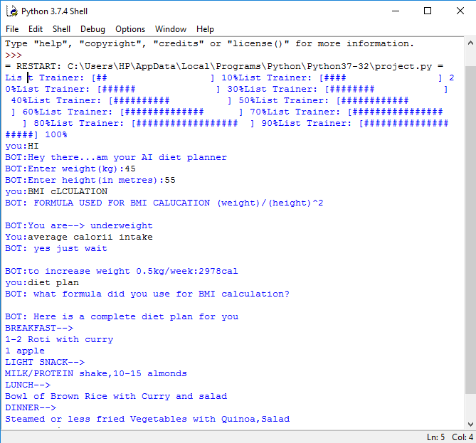

**Fig 5. Output screenshot 2**