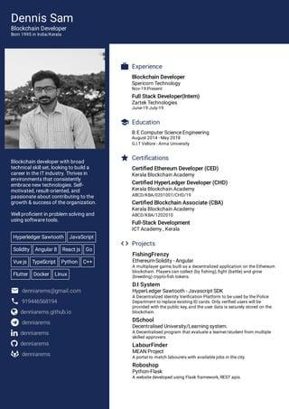

Dennis Sam

Blockchain Developer

Blockchain developer with broad technical skilooking to build a career in the IT industry Thrives i that consistently

Technologies Self-

vated, result oriented, and

ontributing to the

growth & success of the organization

**Well proficient in problem solving and using software tools**

Hyperledger Sawtooth JavaScript Solidity Angular

Reactjs Go

Veje TypeScript Python C

Flutter Docker Un

der@gmail.com

denniams github.io

**in de**

Experience Blockchain Developer Spericom Technology

Full Stack Developer) Zartes Technologies

Education

BEComputer Science Engineering

* Certifications

Certified Ethereum Developer (CED) Kerala Blockchain Academy

**Certified HyperLedger Developer (CHD) Kerala Blockchain Academy AB/A/29101/CH/**

Certified Blockchain Associate (CBA) Kerala Blockchain Academy ABCD/NA/1202010

Full-Stack Development ICT Academy.Kerala

<> Projects

Fishing Frenzy

Ethereum Soldity Angular

DI System

Hyperledger Sawtooth SDK

DSchool

**Decentralised University/Learning system**

**LabourFinder**

MEAN Project

Roboshop Python-Flask