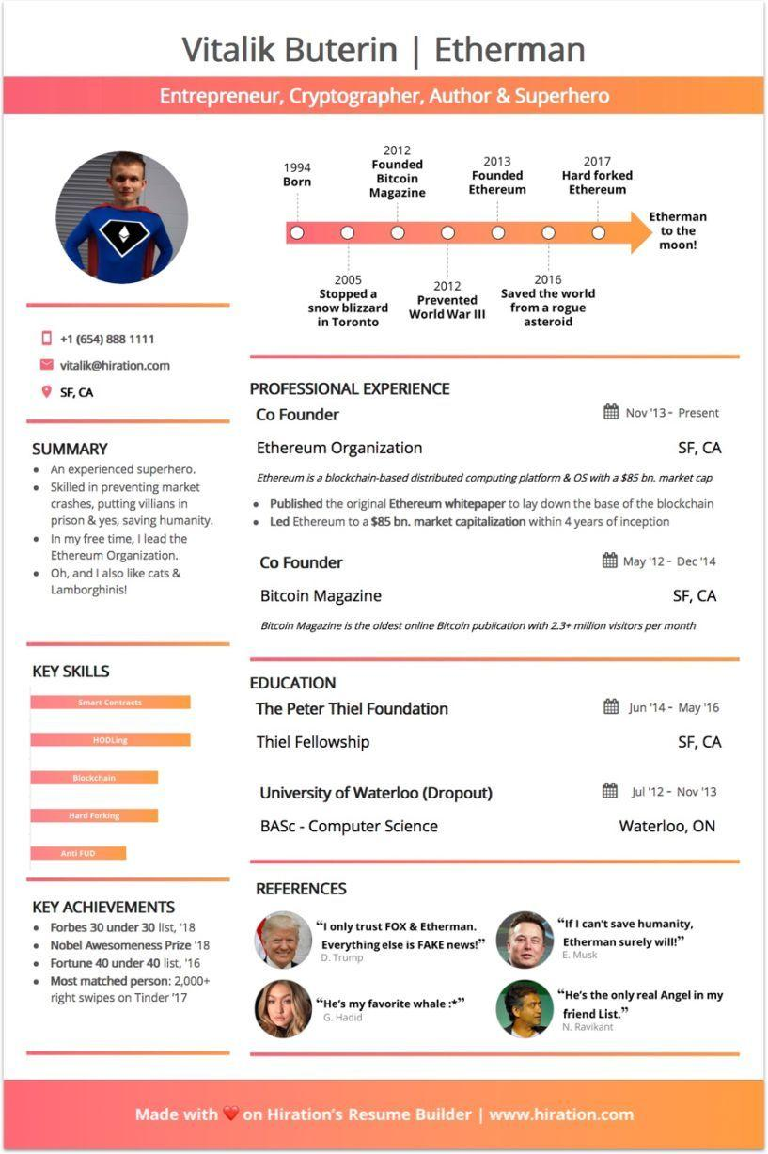

Vitalik Buterin | Etherman

Entrepreneur, Cryptographer, Author & Superhero

+1 (654) 888 1111

vitalik@hiration.com

SF, CA

2012

**1994 Born**

Founded Bitcoin Magazine

**2013 Founded Ethereum**

2017 Hard forked Ethereum

2005

**Stopped a snow blizzard**

**in Toronto**

2012 Prevented World War III

**2016 Saved the world from a rogue asteroid**

**Etherman to the moon!**

SUMMARY

• An experienced superhero. ⚫ Skilled in preventing market crashes, putting villians in prison & yes, saving humanity. In my free time, I lead the Ethereum Organization. Oh, and I also like cats & Lamborghinis!

PROFESSIONAL EXPERIENCE

Co Founder

Ethereum Organization

Nov '13- Present

SF, CA

*Ethereum is a blockchain-based distributed computing platform & OS with a $85 bn. market cap*

• Published the original Ethereum whitepaper to lay down the base of the blockchain • Led Ethereum to a $85 bn. market capitalization within 4 years of inception

Co Founder

Bitcoin Magazine

May '12-Dec '14

SF, CA

*Bitcoin Magazine is the oldest online Bitcoin publication with 2.3+ million visitors per month*

KEY SKILLS

**Smart Contracts**

HODLing

Blockchain

Hard Forking

**EDUCATION**

The Peter Thiel Foundation

Thiel Fellowship

University of Waterloo (Dropout)

BASC - Computer Science

**Anti FUD**

Jun '14 May '16

SF, CA

Jul '12 Nov '13

Waterloo, ON

KEY ACHIEVEMENTS • Forbes 30 under 30 list, '18 ⚫ Nobel Awesomeness Prize '18 • Fortune 40 under 40 list, '16 • Most matched person: 2,000+ right swipes on Tinder '17

REFERENCES

"I only trust FOX & Etherman. Everything else is FAKE news!" D. Trump

**"He's my favorite whale:*" G. Hadid**

**"If I can't save humanity, Etherman surely will!" E. Musk**

"He's the only real Angel in my friend List."

N. Ravikant

**Made with on Hiration's Resume Builder | www.hiration.com**