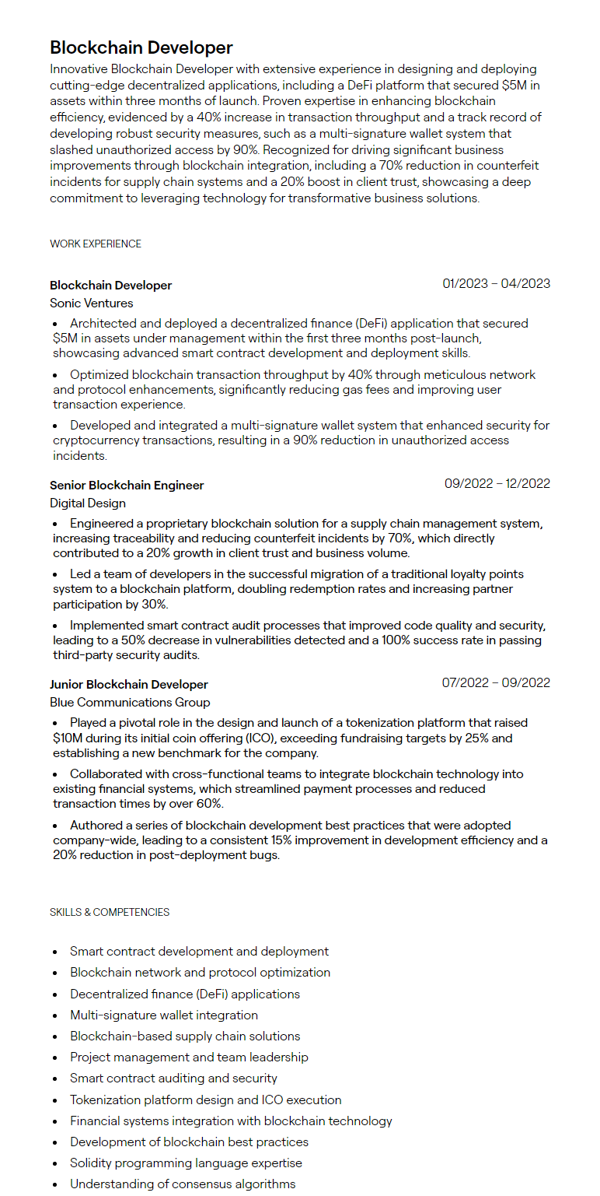

Blockchain Developer

Innovative Blockchain Developer with extensive experience in designing and deploying cutting-edge decentralized applications, including a DeFi platform that secured $5M in assets within three months of launch. Proven expertise in enhancing blockchain efficiency, evidenced by a 40% increase in transaction throughput and a track record of developing robust security measures, such as a multi-signature wallet system that slashed unauthorized access by 90%. Recognized for driving significant business improvements through blockchain integration, including a 70% reduction in counterfeit incidents for supply chain systems and a 20% boost in client trust, showcasing a deep commitment to leveraging technology for transformative business solutions.

WORK EXPERIENCE

Blockchain Developer Sonic Ventures

01/2023 - 04/2023

• Architected and deployed a decentralized finance (DeFi) application that secured $5M in assets under management within the first three months post-launch, showcasing advanced smart contract development and deployment skills.

• Optimized blockchain transaction throughput by 40% through meticulous network and protocol enhancements, significantly reducing gas fees and improving user transaction experience.

• Developed and integrated a multi-signature wallet system that enhanced security for cryptocurrency transactions, resulting in a 90% reduction in unauthorized access incidents.

Senior Blockchain Engineer

Digital Design

09/2022-12/2022

• Engineered a proprietary blockchain solution for a supply chain management system, increasing traceability and reducing counterfeit incidents by 70%, which directly contributed to a 20% growth in client trust and business volume.

• Led a team of developers in the successful migration of a traditional loyalty points system to a blockchain platform, doubling redemption rates and increasing partner participation by 30%.

• Implemented smart contract audit processes that improved code quality and security, leading to a 50% decrease in vulnerabilities detected and a 100% success rate in passing third-party security audits.

Junior Blockchain Developer

Blue Communications Group

07/2022-09/2022

• Played a pivotal role in the design and launch of a tokenization platform that raised $10M during its initial coin offering (ICO), exceeding fundraising targets by 25% and establishing a new benchmark for the company.

• Collaborated with cross-functional teams to integrate blockchain technology into existing financial systems, which streamlined payment processes and reduced transaction times by over 60%.

• Authored a series of blockchain development best practices that were adopted company-wide, leading to a consistent 15% improvement in development efficiency and a 20% reduction in post-deployment bugs.

SKILLS & COMPETENCIES

•

Smart contract development and deployment

·

Blockchain network and protocol optimization

·

Decentralized finance (DeFi) applications

•

Multi-signature wallet integration

•

Blockchain-based supply chain solutions

•

Project management and team leadership

·

Smart contract auditing and security

·

Tokenization platform design and ICO execution

•

Financial systems integration with blockchain technology

Development of blockchain best practices

•

Solidity programming language expertise

•

Understanding of consensus algorithms