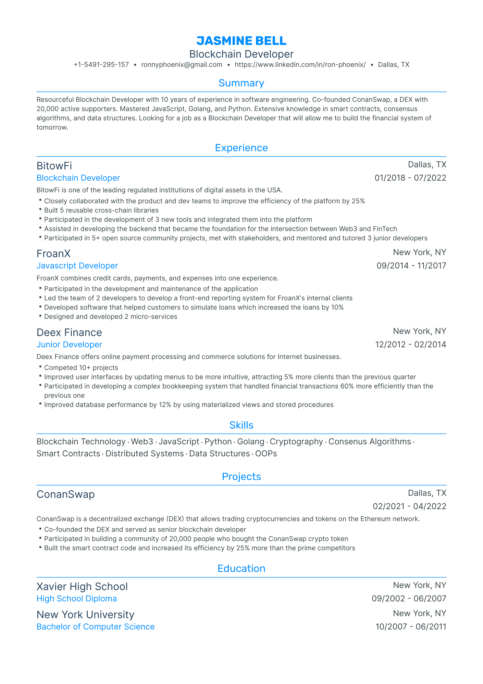

JASMINE BELL Blockchain Developer

+1-5491-295-157 • ronnyphoenix@gmail.com

·

https://www.linkedin.com/in/ron-phoenix/⚫ Dallas, TX

Summary

Resourceful Blockchain Developer with 10 years of experience in software engineering. Co-founded ConanSwap, a DEX with 20,000 active supporters. Mastered JavaScript, Golang, and Python. Extensive knowledge in smart contracts, consensus algorithms, and data structures. Looking for a job as a Blockchain Developer that will allow me to build the financial system of tomorrow.

Experience

BitowFi

Blockchain Developer

BitowFi is one of the leading regulated institutions of digital assets in the USA.

Closely collaborated with the product and dev teams to improve the efficiency of the platform by 25%

• Built 5 reusable cross-chain libraries

• Participated in the development of 3 new tools and integrated them into the platform

Dallas, TX 01/2018 - 07/2022

• Assisted in developing the backend that became the foundation for the intersection between Web3 and FinTech

• Participated in 5+ open source community projects, met with stakeholders, and mentored and tutored 3 junior developers

FroanX

Javascript Developer

FroanX combines credit cards, payments, and expenses into one experience.

• Participated in the development and maintenance of the application

• Led the team of 2 developers to develop a front-end reporting system for FroanX's internal clients

• Developed software that helped customers to simulate loans which increased the loans by 10% • Designed and developed 2 micro-services

Deex Finance

Junior Developer

New York, NY 09/2014 11/2017

New York, NY

12/2012 - 02/2014

•

Deex Finance offers online payment processing and commerce solutions for Internet businesses. Competed 10+ projects

• Improved user interfaces by updating menus to be more intuitive, attracting 5% more clients than the previous quarter

• Participated in developing a complex bookkeeping system that handled financial transactions 60% more efficiently than the previous one

• Improved database performance by 12% by using materialized views and stored procedures

Skills

Blockchain Technology Web3. JavaScript Python Golang Cryptography. Consenus Algorithms. Smart Contracts Distributed Systems Data Structures OOPS

Projects

ConanSwap

Dallas, TX 02/2021-04/2022

ConanSwap is a decentralized exchange (DEX) that allows trading cryptocurrencies and tokens on the Ethereum network.

• Co-founded the DEX and served as senior blockchain developer

• Participated in building a community of 20,000 people who bought the Conan Swap crypto token

• Built the smart contract code and increased its efficiency by 25% more than the prime competitors

Education

Xavier High School

High School Diploma

New York University

Bachelor of Computer Science

New York, NY

-

09/2002 06/2007

New York, NY

10/2007 - 06/2011