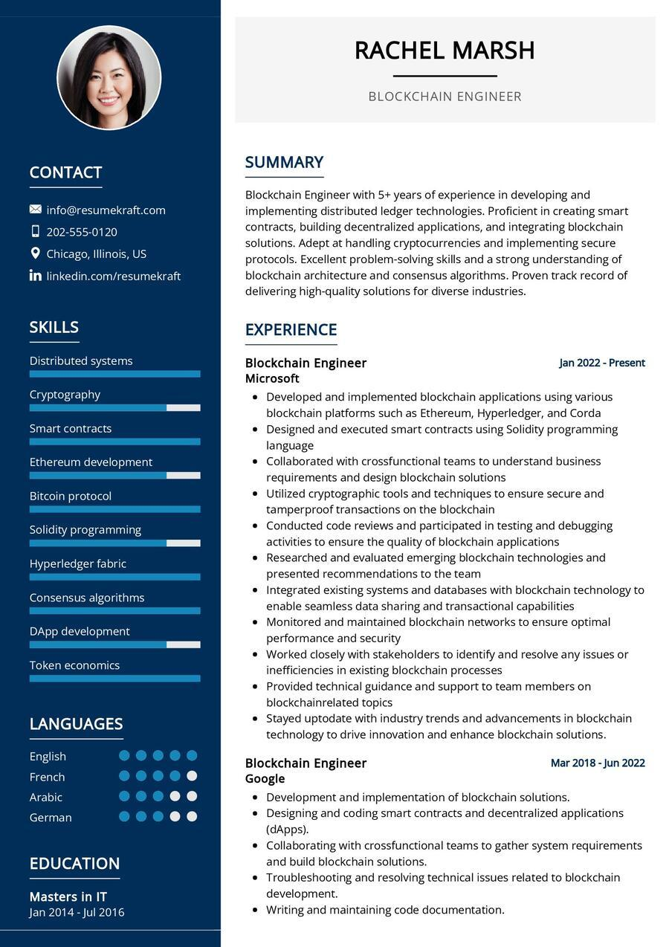

**O**

CONTACT

info@resumekraft.com

202-555-0120

Chicago, Illinois, US in linkedin.com/resumekraft

SKILLS

Distributed systems

Cryptography

Smart contracts

Ethereum development

Bitcoin protocol

Solidity programming

Hyperledger fabric

Consensus algorithms

DApp development

Token economics

LANGUAGES

English

French

Arabic

German

EDUCATION

Masters in IT

Jan 2014 - Jul 2016

SUMMARY

RACHEL MARSH

BLOCKCHAIN ENGINEER

Blockchain Engineer with 5+ years of experience in developing and implementing distributed ledger technologies. Proficient in creating smart contracts, building decentralized applications, and integrating blockchain solutions. Adept at handling cryptocurrencies and implementing secure protocols. Excellent problem-solving skills and a strong understanding of blockchain architecture and consensus algorithms. Proven track record of delivering high-quality solutions for diverse industries.

EXPERIENCE

Blockchain Engineer Microsoft

Jan 2022 - Present

• Developed and implemented blockchain applications using various blockchain platforms such as Ethereum, Hyperledger, and Corda

• Designed and executed smart contracts using Solidity programming language

• Collaborated with crossfunctional teams to understand business requirements and design blockchain solutions

• Utilized cryptographic tools and techniques to ensure secure and tamperproof transactions on the blockchain

• Conducted code reviews and participated in testing and debugging activities to ensure the quality of blockchain applications

• Researched and evaluated emerging blockchain technologies and presented recommendations to the team

• Integrated existing systems and databases with blockchain technology to enable seamless data sharing and transactional capabilities

• Monitored and maintained blockchain networks to ensure optimal performance and security

• Worked closely with stakeholders to identify and resolve any issues or inefficiencies in existing blockchain processes

• Provided technical guidance and support to team members on blockchainrelated topics

• Stayed uptodate with industry trends and advancements in blockchain technology to drive innovation and enhance blockchain solutions.

Blockchain Engineer

Google

Mar 2018-Jun 2022

• Development and implementation of blockchain solutions.

• Designing and coding smart contracts and decentralized applications (dApps)

• Collaborating with crossfunctional teams to gather system requirements and build blockchain solutions.

• Troubleshooting and resolving technical issues related to blockchain development.

• Writing and maintaining code documentation.