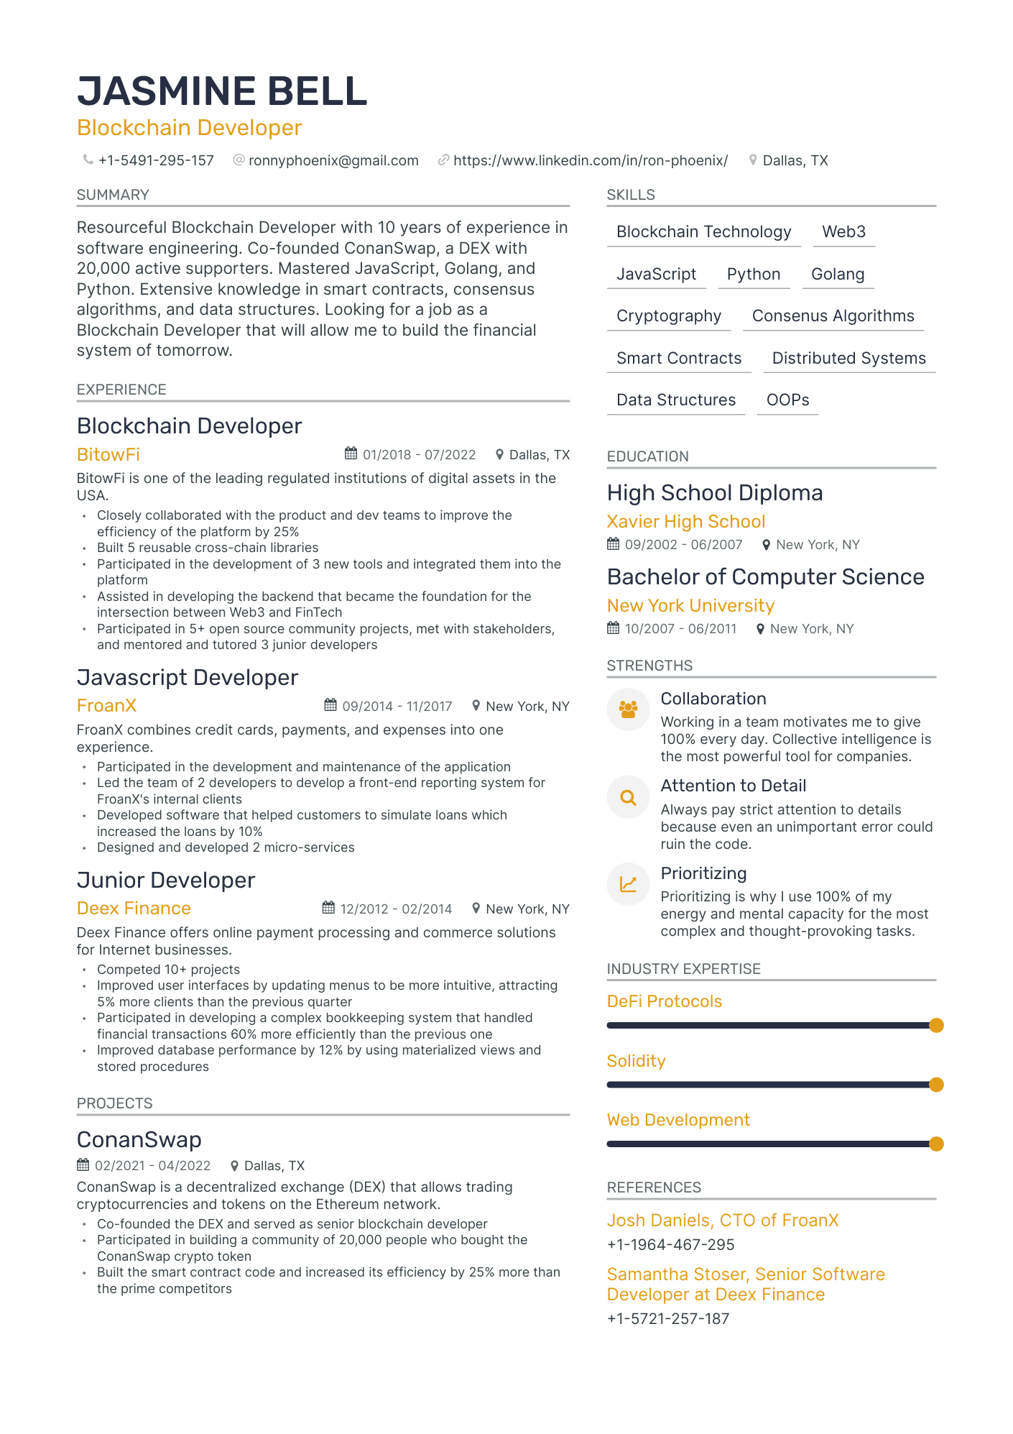

**JASMINE BELL**

Blockchain Developer

+1-5491-295-157

SUMMARY

@ronnyphoenix@gmail.com

https://www.linkedin.com/in/ron-phoenix/

Resourceful Blockchain Developer with 10 years of experience in software engineering. Co-founded ConanSwap, a DEX with 20,000 active supporters. Mastered JavaScript, Golang, and Python. Extensive knowledge in smart contracts, consensus algorithms, and data structures. Looking for a job as a Blockchain Developer that will allow me to build the financial system of tomorrow.

EXPERIENCE

Dallas, TX

SKILLS

Blockchain Technology

Web3

JavaScript Python

Golang

Cryptography

Consenus Algorithms

Smart Contracts

Distributed Systems

Data Structures

OOPS

Blockchain Developer

BitowFi

01/2018 - 07/2022

Dallas, TX

EDUCATION

BitowFi is one of the leading regulated institutions of digital assets in the USA.

.

.

Closely collaborated with the product and dev teams to improve the efficiency of the platform by 25%

Built 5 reusable cross-chain libraries

Participated in the development of 3 new tools and integrated them into the platform

Assisted in developing the backend that became the foundation for the intersection between Web3 and FinTech

Participated in 5+ open source community projects, met with stakeholders, and mentored and tutored 3 junior developers

Javascript Developer

FroanX

09/2014 - 11/2017

New York, NY

FroanX combines credit cards, payments, and expenses into one experience.

.

Participated in the development and maintenance of the application Led the team of 2 developers to develop a front-end reporting system for FroanX's internal clients

Developed software that helped customers to simulate loans which

increased the loans by 10%

Designed and developed 2 micro-services

Junior Developer

Deex Finance

12/2012 02/2014

High School Diploma Xavier High School

09/2002-06/2007

New York, NY

Bachelor of Computer Science New York University

10/2007 - 06/2011

STRENGTHS

2

New York, NY

Deex Finance offers online payment processing and commerce solutions for Internet businesses.

.

.

Competed 10+ projects

Improved user interfaces by updating menus to be more intuitive, attracting 5% more clients than the previous quarter

Participated in developing a complex bookkeeping system that handled financial transactions 60% more efficiently than the previous one Improved database performance by 12% by using materialized views and stored procedures

PROJECTS

ConanSwap

02/2021-04/2022 • Dallas, TX

ConanSwap is a decentralized exchange (DEX) that allows trading cryptocurrencies and tokens on the Ethereum network.

Co-founded the DEX and served as senior blockchain developer Participated in building a community of 20,000 people who bought the ConanSwap crypto token

• Built the smart contract code and increased its efficiency by 25% more than the prime competitors

Collaboration

New York, NY

Working in a team motivates me to give 100% every day. Collective intelligence is the most powerful tool for companies. Attention to Detail

Always pay strict attention to details

because even an unimportant error could ruin the code.

Prioritizing

Prioritizing is why I use 100% of my

energy and mental capacity for the most

complex and thought-provoking tasks.

INDUSTRY EXPERTISE

DeFi Protocols

Solidity

Web Development

REFERENCES

Josh Daniels, CTO of FroanX +1-1964-467-295

Samantha Stoser, Senior Software Developer at Deex Finance

+1-5721-257-187