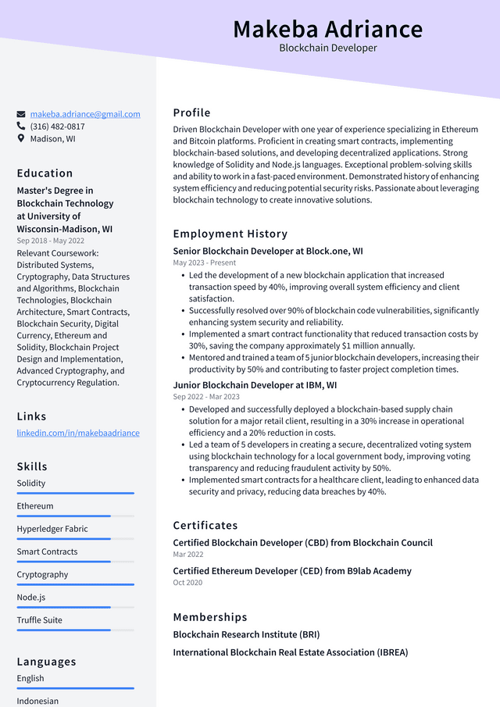

**Makeba Adriance**

Blockchain Developer

makeba.adriance@gmail.com

(316) 482-0817 Madison, WI

Education

Master's Degree in Blockchain Technology at University of Wisconsin-Madison, WI Sep 2018 - May 2022 Relevant Coursework: Distributed Systems, Cryptography, Data Structures and Algorithms, Blockchain Technologies, Blockchain Architecture, Smart Contracts, Blockchain Security, Digital Currency, Ethereum and Solidity, Blockchain Project Design and Implementation, Advanced Cryptography, and Cryptocurrency Regulation.

Links

linkedin.com/in/makebaadriance

Skills

Solidity

Ethereum

Hyperledger Fabric

Smart Contracts

Cryptography

Node.js

Truffle Suite

Profile

Driven Blockchain Developer with one year of experience specializing in Ethereum and Bitcoin platforms. Proficient in creating smart contracts, implementing blockchain-based solutions, and developing decentralized applications. Strong knowledge of Solidity and Node.js languages. Exceptional problem-solving skills and ability to work in a fast-paced environment. Demonstrated history of enhancing system efficiency and reducing potential security risks. Passionate about leveraging blockchain technology to create innovative solutions.

Employment History

Senior Blockchain Developer at Block.one, WI May 2023-Present

• Led the development of a new blockchain application that increased transaction speed by 40%, improving overall system efficiency and client satisfaction.

• Successfully resolved over 90% of blockchain code vulnerabilities, significantly enhancing system security and reliability.

• Implemented a smart contract functionality that reduced transaction costs by 30%, saving the company approximately $1 million annually.

• Mentored and trained a team of 5 junior blockchain developers, increasing their productivity by 50% and contributing to faster project completion times. Junior Blockchain Developer at IBM, WI

Sep 2022 - Mar 2023

• Developed and successfully deployed a blockchain-based supply chain solution for a major retail client, resulting in a 30% increase in operational efficiency and a 20% reduction in costs.

• Led a team of 5 developers in creating a secure, decentralized voting system using blockchain technology for a local government body, improving voting transparency and reducing fraudulent activity by 50%.

• Implemented smart contracts for a healthcare client, leading to enhanced data security and privacy, reducing data breaches by 40%.

Certificates

Certified Blockchain Developer (CBD) from Blockchain Council Mar 2022

Certified Ethereum Developer (CED) from B9lab Academy

Oct 2020

Memberships

Blockchain Research Institute (BRI)

International Blockchain Real Estate Association (IBREA)

Languages English

Indonesian