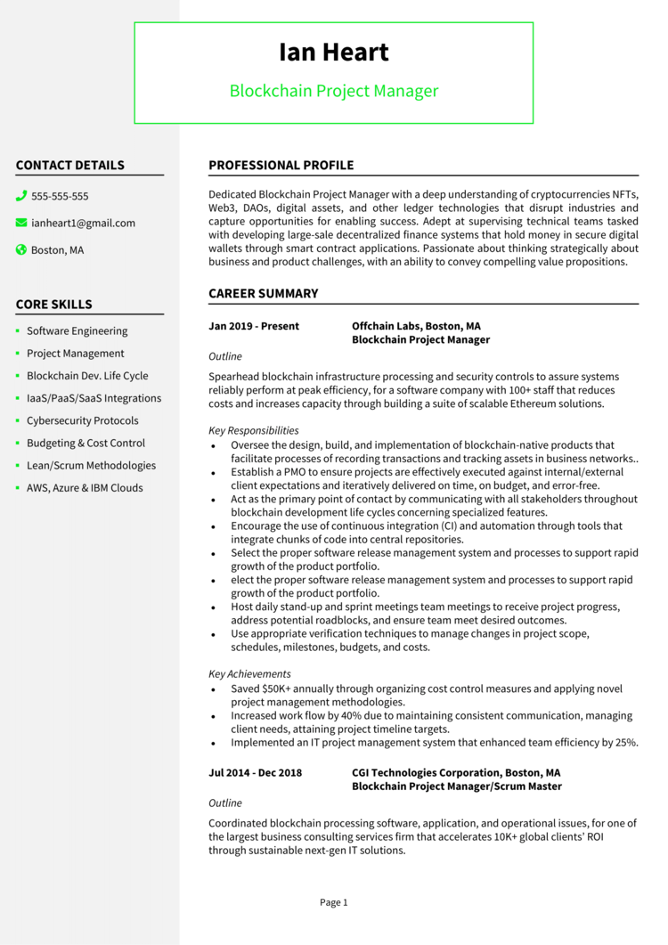

**lan Heart**

Blockchain Project Manager

**CONTACT DETAILS**

555-555-555

i ianheart1@gmail.com Boston, MA

**CORE SKILLS**

• Software Engineering

• Project Management

• Blockchain Dev. Life Cycle

⚫ laaS/PaaS/SaaS Integrations

• Cybersecurity Protocols

• Budgeting & Cost Control

• Lean/Scrum Methodologies

• AWS, Azure & IBM Clouds

**PROFESSIONAL PROFILE**

Dedicated Blockchain Project Manager with a deep understanding of cryptocurrencies NFTS, Web3, DAOS, digital assets, and other ledger technologies that disrupt industries and capture opportunities for enabling success. Adept at supervising technical teams tasked with developing large-sale decentralized finance systems that hold money in secure digital wallets through smart contract applications. Passionate about thinking strategically about business and product challenges, with an ability to convey compelling value propositions.

**CAREER SUMMARY**

**Jan 2019 - Present**

Outline

**Offchain Labs, Boston, MA Blockchain Project Manager**

Spearhead blockchain infrastructure processing and security controls to assure systems reliably perform at peak efficiency, for a software company with 100+ staff that reduces costs and increases capacity through building a suite of scalable Ethereum solutions.

*Key Responsibilities*

• Oversee the design, build, and implementation of blockchain-native products that facilitate processes of recording transactions and tracking assets in business networks.. • Establish a PMO to ensure projects are effectively executed against internal/external client expectations and iteratively delivered on time, on budget, and error-free.

.

• Act as the primary point of contact by communicating with all stakeholders throughout blockchain development life cycles concerning specialized features.

• Encourage the use of continuous integration (CI) and automation through tools that integrate chunks of code into central repositories.

·

•

·

Select the proper software release management system and processes to support rapid growth of the product portfolio.

elect the proper software release management system and processes to support rapid growth of the product portfolio.

Host daily stand-up and sprint meetings team meetings to receive project progress, address potential roadblocks, and ensure team meet desired outcomes.

⚫ Use appropriate verification techniques to manage changes in project scope, schedules, milestones, budgets, and costs.

*Key Achievements*

• Saved $50K+ annually through organizing cost control measures and applying novel project management methodologies.

• Increased work flow by 40% due to maintaining consistent communication, managing client needs, attaining project timeline targets.

• Implemented an IT project management system that enhanced team efficiency by 25%.

**Jul 2014 - Dec 2018**

*Outline*

**CGI Technologies Corporation, Boston, MA Blockchain Project Manager/Scrum Master**

Coordinated blockchain processing software, application, and operational issues, for one of the largest business consulting services firm that accelerates 10K+ global clients' ROI through sustainable next-gen IT solutions.

Page 1