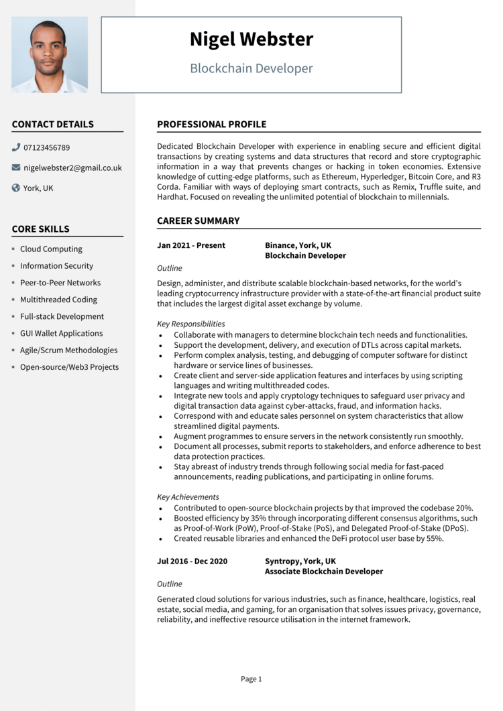

**Nigel Webster**

Blockchain Developer

**CONTACT DETAILS**

07123456789

nigelwebster2@gmail.co.uk

York, UK

**CORE SKILLS**

• Cloud Computing

• Information Security • Peer-to-Peer Networks

• Multithreaded Coding

• Full-stack Development

• GUI Wallet Applications

• Agile/Scrum Methodologies

• Open-source/Web3 Projects

**PROFESSIONAL PROFILE**

Dedicated Blockchain Developer with experience in enabling secure and efficient digital transactions by creating systems and data structures that record and store cryptographic information in a way that prevents changes or hacking in token economies. Extensive knowledge of cutting-edge platforms, such as Ethereum, Hyperledger, Bitcoin Core, and R3 Corda. Familiar with ways of deploying smart contracts, such as Remix, Truffle suite, and Hardhat. Focused on revealing the unlimited potential of blockchain to millennials.

**CAREER SUMMARY**

**Jan 2021 - Present**

*Outline*

**Binance, York, UK Blockchain Developer**

Design, administer, and distribute scalable blockchain-based networks, for the world's leading cryptocurrency infrastructure provider with a state-of-the-art financial product suite that includes the largest digital asset exchange by volume.

*Key Responsibilities*

·

.

·

•

Collaborate with managers to determine blockchain tech needs and functionalities. Support the development, delivery, and execution of DTLS across capital markets. Perform complex analysis, testing, and debugging of computer software for distinct hardware or service lines of businesses.

Create client and server-side application features and interfaces by using scripting languages and writing multithreaded codes.

Integrate new tools and apply cryptology techniques to safeguard user privacy and digital transaction data against cyber-attacks, fraud, and information hacks. Correspond with and educate sales personnel on system characteristics that allow streamlined digital payments.

Augment programmes to ensure servers in the network consistently run smoothly. Document all processes, submit reports to stakeholders, and enforce adherence to best data protection practices.

Stay abreast of industry trends through following social media for fast-paced announcements, reading publications, and participating in online forums.

*Key Achievements*

Contributed to open-source blockchain projects by that improved the codebase 20%. • Boosted efficiency by 35% through incorporating different consensus algorithms, such as Proof-of-Work (POW), Proof-of-Stake (POS), and Delegated Proof-of-Stake (DPoS). • Created reusable libraries and enhanced the DeFi protocol user base by 55%.

**Jul 2016 - Dec 2020**

Outline

**Syntropy, York, UK**

**Associate Blockchain Developer**

Generated cloud solutions for various industries, such as finance, healthcare, logistics, real estate, social media, and gaming, for an organisation that solves issues privacy, governance, reliability, and ineffective resource utilisation in the internet framework.

Page 1