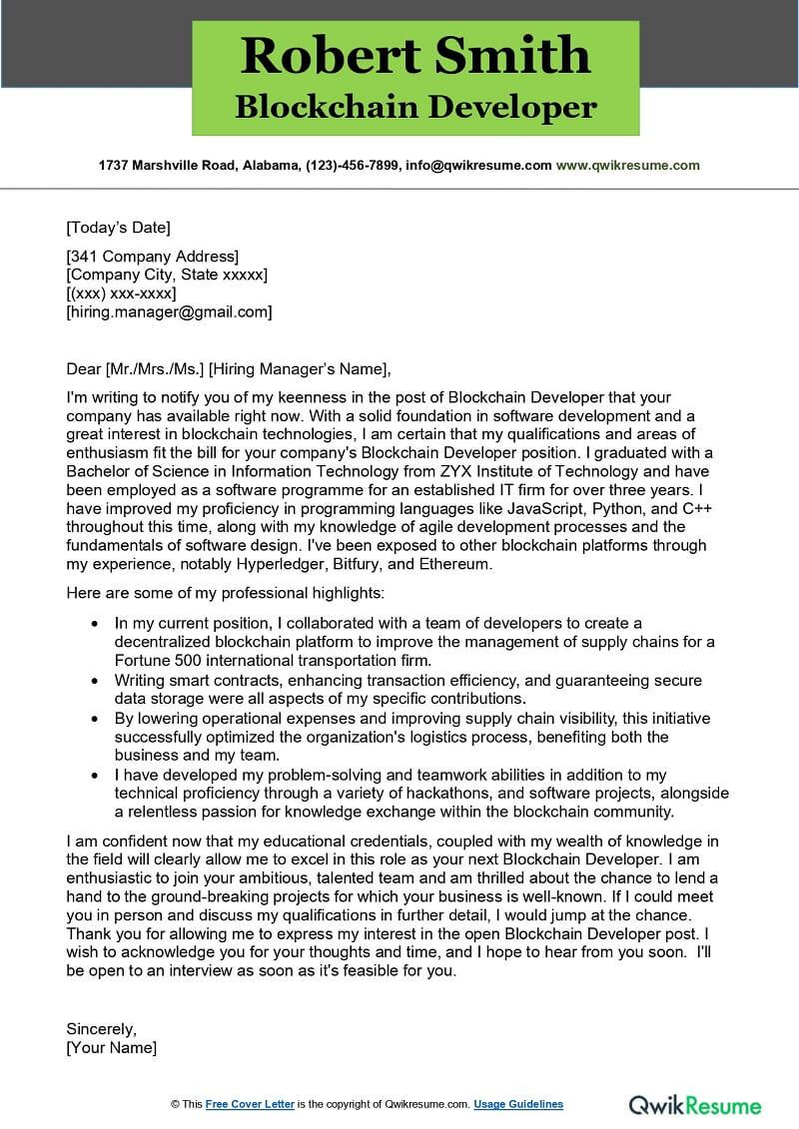

**Robert Smith**

**Blockchain Developer**

**1737 Marshville Road, Alabama, (123)-456-7899, info@qwikresume.com www.qwikresume.com**

[Today's Date]

[341 Company Address]

[Company City, State xxxxx] [(XXX) XXX-XXXX]

[hiring.manager@gmail.com]

Dear [Mr./Mrs./Ms.] [Hiring Manager's Name],

I'm writing to notify you of my keenness in the post of Blockchain Developer that your company has available right now. With a solid foundation in software development and a great interest in blockchain technologies, I am certain that my qualifications and areas of enthusiasm fit the bill for your company's Blockchain Developer position. I graduated with a Bachelor of Science in Information Technology from ZYX Institute of Technology and have been employed as a software programme for an established IT firm for over three years. I have improved my proficiency in programming languages like JavaScript, Python, and C++ throughout this time, along with my knowledge of agile development processes and the fundamentals of software design. I've been exposed to other blockchain platforms through my experience, notably Hyperledger, Bitfury, and Ethereum.

Here are some of my professional highlights:

• In my current position, I collaborated with a team of developers to create a

decentralized blockchain platform to improve the management of supply chains for a Fortune 500 international transportation firm.

• Writing smart contracts, enhancing transaction efficiency, and guaranteeing secure data storage were all aspects of my specific contributions.

⚫ By lowering operational expenses and improving supply chain visibility, this initiative successfully optimized the organization's logistics process, benefiting both the business and my team.

⚫ I have developed my problem-solving and teamwork abilities in addition to my technical proficiency through a variety of hackathons, and software projects, alongside a relentless passion for knowledge exchange within the blockchain community.

I am confident now that my educational credentials, coupled with my wealth of knowledge in the field will clearly allow me to excel in this role as your next Blockchain Developer. I am enthusiastic to join your ambitious, talented team and am thrilled about the chance to lend a hand to the ground-breaking projects for which your business is well-known. If I could meet you in person and discuss my qualifications in further detail, I would jump at the chance. Thank you for allowing me to express my interest in the open Blockchain Developer post. I wish to acknowledge you for your thoughts and time, and I hope to hear from you soon. I'll be open to an interview as soon as it's feasible for you.

Sincerely, [Your Name]

© This Free Cover Letter is the copyright of Qwikresume.com. Usage Guidelines

**Qwik Resume**