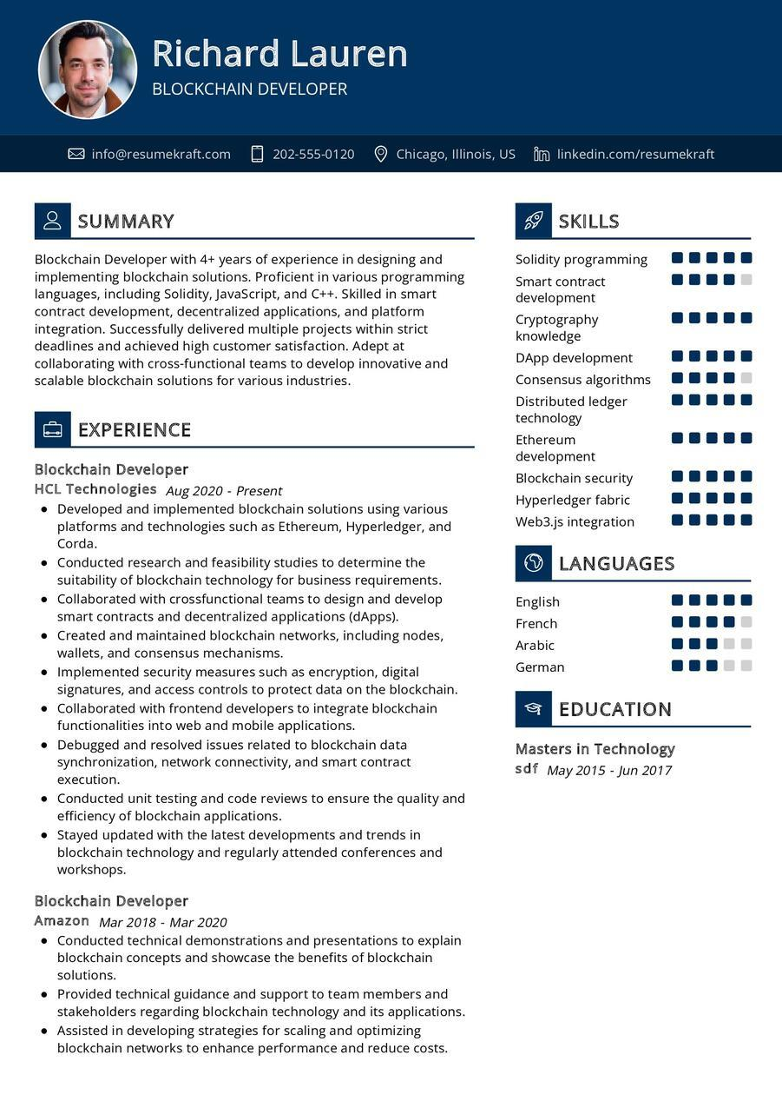

Richard Lauren

BLOCKCHAIN DEVELOPER

info@resumekraft.com

202-555-0120

Chicago, Illinois, US in linkedin.com/resumekraft

2 SUMMARY

Blockchain Developer with 4+ years of experience in designing and implementing blockchain solutions. Proficient in various programming languages, including Solidity, JavaScript, and C++. Skilled in smart contract development, decentralized applications, and platform integration. Successfully delivered multiple projects within strict deadlines and achieved high customer satisfaction. Adept at collaborating with cross-functional teams to develop innovative and scalable blockchain solutions for various industries.

SKILLS

Solidity programming

Smart contract development Cryptography knowledge

DApp development Consensus algorithms Distributed ledger

technology

Ethereum

EXPERIENCE

Blockchain Developer

HCL Technologies Aug 2020 - Present

• Developed and implemented blockchain solutions using various platforms and technologies such as Ethereum, Hyperledger, and Corda.

• Conducted research and feasibility studies to determine the suitability of blockchain technology for business requirements. • Collaborated with crossfunctional teams to design and develop smart contracts and decentralized applications (dApps). • Created and maintained blockchain networks, including nodes, wallets, and consensus mechanisms.

• Implemented security measures such as encryption, digital signatures, and access controls to protect data on the blockchain.

• Collaborated with frontend developers to integrate blockchain functionalities into web and mobile applications.

• Debugged and resolved issues related to blockchain data synchronization, network connectivity, and smart contract execution.

• Conducted unit testing and code reviews to ensure the quality and efficiency of blockchain applications.

• Stayed updated with the latest developments and trends in blockchain technology and regularly attended conferences and workshops.

Blockchain Developer

**Amazon Mar 2018 - Mar 2020**

• Conducted technical demonstrations and presentations to explain blockchain concepts and showcase the benefits of blockchain solutions.

• Provided technical guidance and support to team members and stakeholders regarding blockchain technology and its applications. • Assisted in developing strategies for scaling and optimizing blockchain networks to enhance performance and reduce costs.

development

Blockchain security

Hyperledger fabric

Web3.js integration

English

French

Arabic

LANGUAGES

German

EDUCATION

Masters in Technology

*sdf May 2015-Jun 2017*