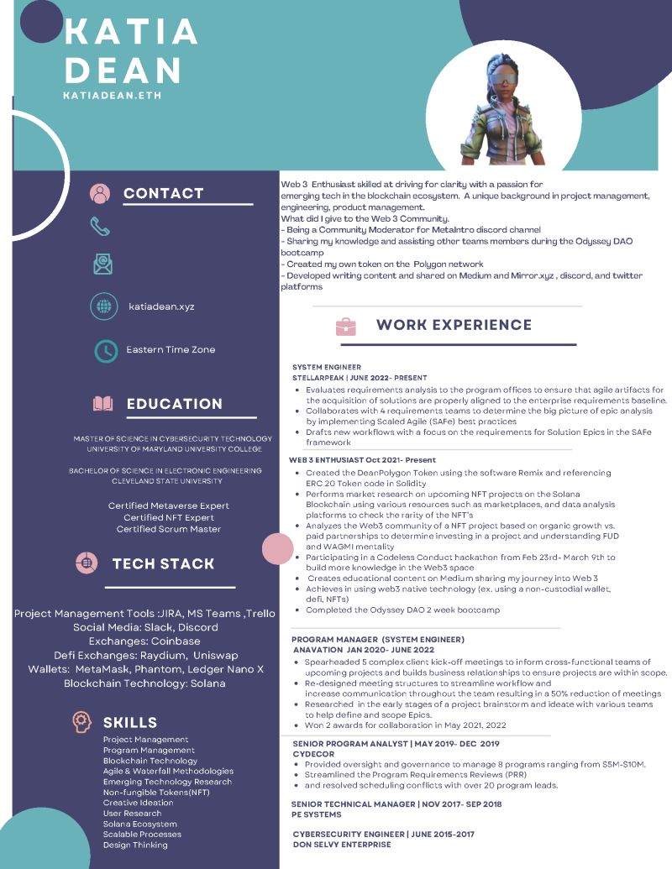

**ΚΑΤΙΑ DEAN**

KATIADEAN.ETH

CONTACT

Web 3 Enthusiast skilled at driving for clarity with a passion for

emerging tech in the blockchain ecosystem. A unique background in project management, engineering, product management.

What did I give to the Web 3 Community.

-Being a Community Moderator for Metalntro discord channel

-Sharing my knowledge and assisting other teams members during the Odyssey DAO bootcamp

-Created my own token on the Polygon network

-Developed writing content and shared on Medium and Mirror xyz, discord, and twitter platforms

katiadean.xyz

**WORK EXPERIENCE**

Eastern Time Zone

**EDUCATION**

MASTER OF SCIENCE IN CYBERSECURITY TECHNOLOGY UNIVERSITY OF MARYLAND UNIVERSITY COLLEGE BACHELOR OF SCIENCE IN ELECTRONIC ENGINEERING CLEVELAND STATE UNIVERSITY

Certified Metaverse Expert Certified NFT Expert Certified Scrum Master

**TECH STACK**

Project Management Tools :JIRA, MS Teams, Trello Social Media: Slack, Discord Exchanges: Coinbase

Defi Exchanges: Raydium, Uniswap

Wallets: MetaMask, Phantom, Ledger Nano X Blockchain Technology: Solana

**SKILLS**

Project Management

Program Management Blockchain Technology

Agile & Waterfall Methodologies

Emerging Technology Research

Non-fungible Tokens(NFT) Creative Ideation

User Research

Solana Ecosystem

Scalable Processes

Design Thinking

SYSTEM ENGINEER

STELLARPEAK | JUNE 2022- PRESENT

• Evaluates requirements analysis to the program offices to ensure that agile artifacts for the acquisition of solutions are properly aligned to the enterprise requirements baseline.

• Collaborates with 4 requirements teams to determine the big picture of epic analysis by implementing Scaled Agile (SAFe) best practices

• Drafts new workflows with a focus on the requirements for Solution Epics in the SAFe framework

WEB 3 ENTHUSIAST Oct 2021-Present

• Created the DeanPolygon Token using the software Remix and referencing ERC 20 Token code in Solidity

• Performs market research on upcoming NFT projects on the Solana Blockchain using various resources such as marketplaces, and data analysis platforms to check the rarity of the NFT's

• Analyzes the Web3 community of a NFT project based on organic growth vs. paid partnerships to determine investing in a project and understanding FUD and WAGMI mentality

Participating in a Codeless Conduct hackathon from Feb 23rd-March 9th to build more knowledge in the Web3 space

• Creates educational content on Medium sharing my journey into Web 3

• Achieves in using web3 native technology (ex. using a non-custodial wallet. defi, NFTs)

• Completed the Odyssey DAO 2 week bootcamp

PROGRAM MANAGER (SYSTEM ENGINEER) ANAVATION JAN 2020-JUNE 2022

• Spearheaded 5 complex client kick-off meetings to inform cross-functional teams of upcoming projects and builds business relationships to ensure projects are within scope.

• Re-designed meeting structures to streamline workflow and

increase communication throughout the team resulting in a 50% reduction of meetings:

• Researched in the early stages of a project brainstorm and ideate with various teams to help define and scope Epics.

• Won 2 awards for collaboration in May 2021, 2022

SENIOR PROGRAM ANALYST | MAY 2019- DEC 2019 CYDECOR

• Provided oversight and governance to manage 8 programs ranging from $5M-$10M.

• Streamlined the Program Requirements Reviews (PRR)

⚫ and resolved scheduling conflicts with over 20 program leads.

**SENIOR TECHNICAL MANAGER | NOV 2017- SEP 2018**

**PE SYSTEMS**

CYBERSECURITY ENGINEER | JUNE 2015-2017

DON SELVY ENTERPRISE