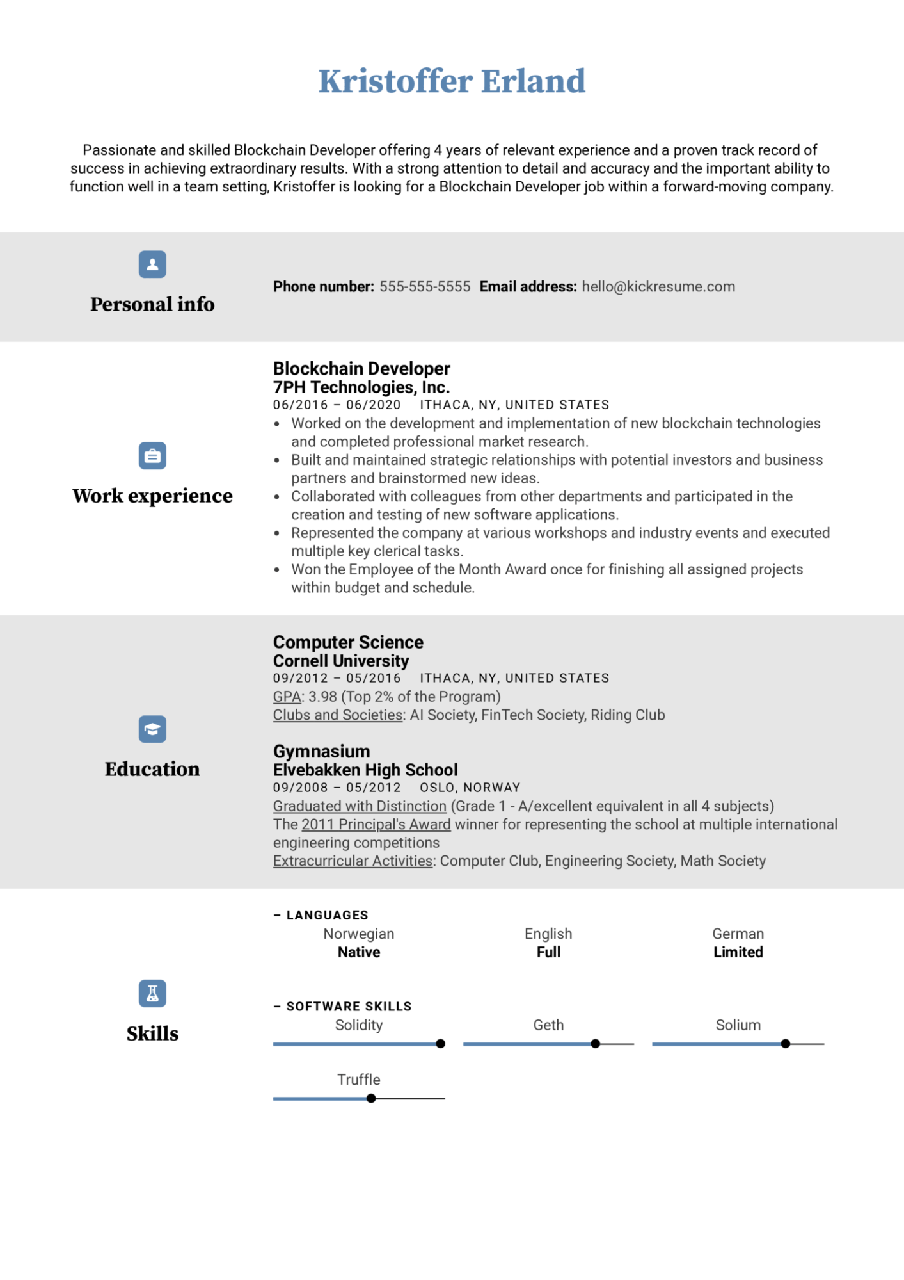

**Kristoffer Erland**

Passionate and skilled Blockchain Developer offering 4 years of relevant experience and a proven track record of success in achieving extraordinary results. With a strong attention to detail and accuracy and the important ability to function well in a team setting, Kristoffer is looking for a Blockchain Developer job within a forward-moving company.

**Personal info**

Phone number: 555-555-5555 Email address: hello@kickresume.com

**Work experience**

**Education**

**Skills**

**Blockchain Developer**

**7PH Technologies, Inc.**

06/2016 06/2020 ITHACA, NY, UNITED STATES

• Worked on the development and implementation of new blockchain technologies

·

and completed professional market research.

Built and maintained strategic relationships with potential investors and business partners and brainstormed new ideas.

• Collaborated with colleagues from other departments and participated in the creation and testing of new software applications.

Represented the company at various workshops and industry events and executed multiple key clerical tasks.

• Won the Employee of the Month Award once for finishing all assigned projects within budget and schedule.

**Computer Science**

**Cornell University**

09/2012 05/2016 ITHACA, NY, UNITED STATES

GPA: 3.98 (Top 2% of the Program)

Clubs and Societies: Al Society, FinTech Society, Riding Club

**Gymnasium**

**Elvebakken High School**

09/2008 05/2012 OSLO, NORWAY

Graduated with Distinction (Grade 1 - A/excellent equivalent in all 4 subjects)

The 2011 Principal's Award winner for representing the school at multiple international engineering competitions

Extracurricular Activities: Computer Club, Engineering Society, Math Society

**- LANGUAGES**

Norwegian Native

**SOFTWARE SKILLS**

Solidity

Truffle

English Full

**German Limited**

Geth

Solium