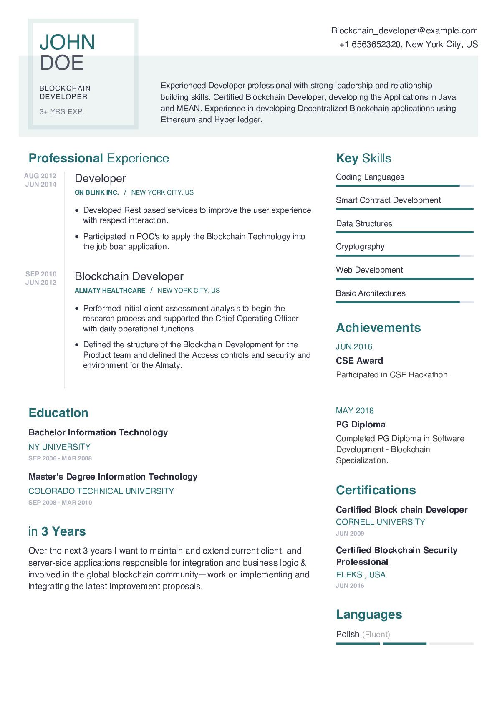

JOHN DOE

BLOCKCHAIN DEVELOPER

3+ YRS EXP.

Blockchain_developer@example.com

+1 6563652320, New York City, US

Experienced Developer professional with strong leadership and relationship building skills. Certified Blockchain Developer, developing the Applications in Java and MEAN. Experience in developing Decentralized Blockchain applications using Ethereum and Hyper ledger.

**Professional Experience**

AUG 2012

JUN 2014

SEP 2010

JUN 2012

Developer

**ON BLINK INC. / NEW YORK CITY, US**

• Developed Rest based services to improve the user experience with respect interaction.

• Participated in POC's to apply the Blockchain Technology into the job boar application.

Blockchain Developer

**ALMATY HEALTHCARE / NEW YORK CITY, US**

Performed initial client assessment analysis to begin the research process and supported the Chief Operating Officer with daily operational functions.

• Defined the structure of the Blockchain Development for the Product team and defined the Access controls and security and environment for the Almaty.

Key Skills Coding Languages

Smart Contract Development

Data Structures

Cryptography

Web Development

Basic Architectures

**Achievements**

JUN 2016

CSE Award

Participated in CSE Hackathon.

**Education**

**Bachelor Information Technology**

NY UNIVERSITY

SEP 2006 MAR 2008

**Master's Degree Information Technology**

COLORADO TECHNICAL UNIVERSITY SEP 2008-MAR 2010

**in 3 Years**

Over the next 3 years I want to maintain and extend current client- and server-side applications responsible for integration and business logic & involved in the global blockchain community-work on implementing and integrating the latest improvement proposals.

MAY 2018

**PG Diploma**

Completed PG Diploma in Software Development Blockchain Specialization.

**Certifications**

Certified Block chain Developer CORNELL UNIVERSITY

JUN 2009

**Certified Blockchain Security Professional**

ELEKS, USA

JUN 2016

**Languages**

Polish (Fluent)