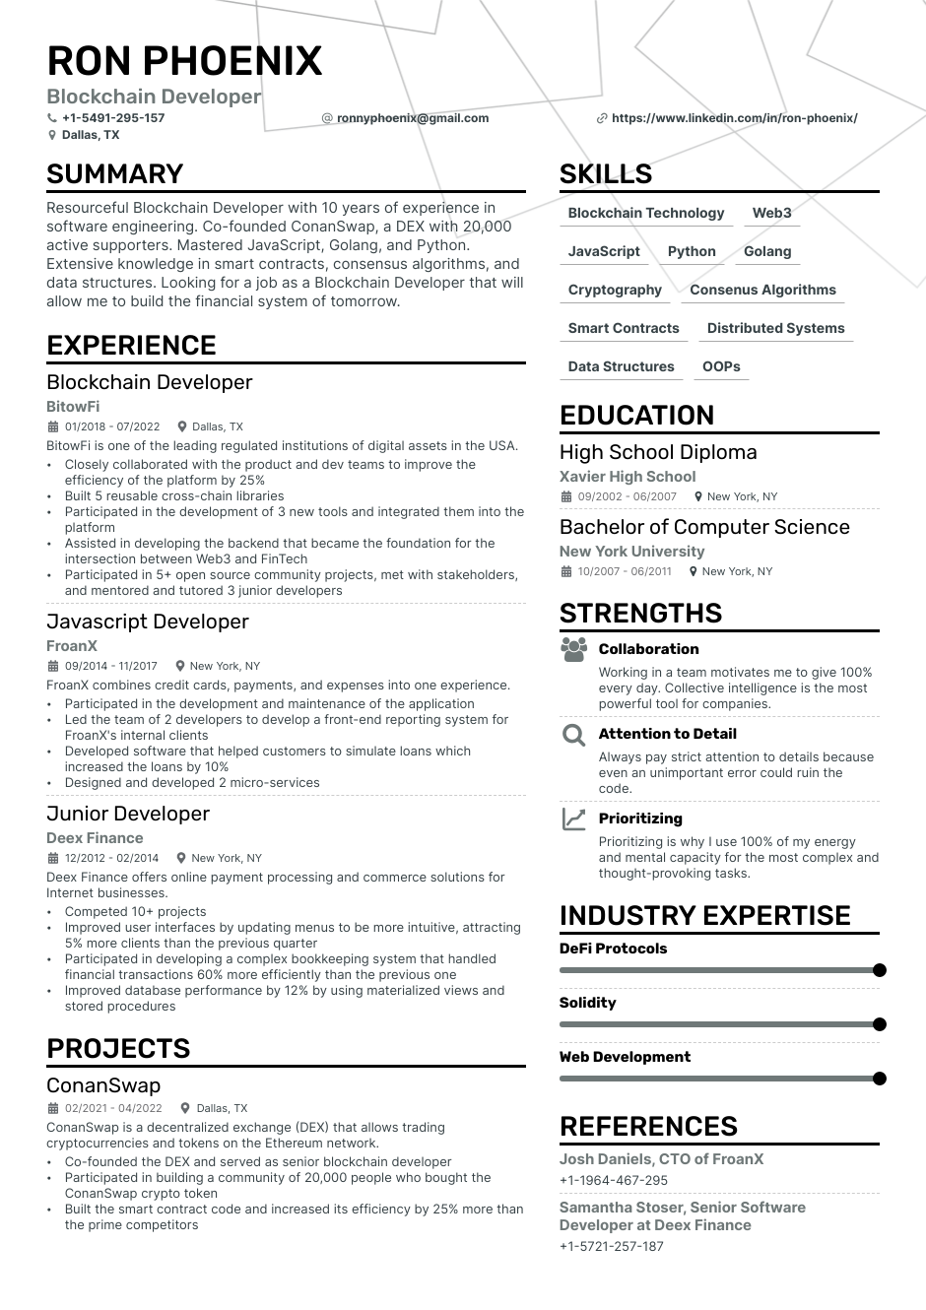

**RON PHOENIX**

**Blockchain Developer**

+1-5491-295-157 Dallas, TX

**SUMMARY**

**ronnyphoenix@gmail.com**

Resourceful Blockchain Developer with 10 years of experience in software engineering. Co-founded ConanSwap, a DEX with 20,000 active supporters. Mastered JavaScript, Golang, and Python. Extensive knowledge in smart contracts, consensus algorithms, and data structures. Looking for a job as a Blockchain Developer that will allow me to build the financial system of tomorrow.

**EXPERIENCE**

Blockchain Developer

**BitowFi**

01/2018 - 07/2022 Dallas, TX

BitowFi is one of the leading regulated institutions of digital assets in the USA. Closely collaborated with the product and dev teams to improve the efficiency of the platform by 25%

Built 5 reusable cross-chain libraries

Participated in the development of 3 new tools and integrated them into the platform

Assisted in developing the backend that became the foundation for the intersection between Web3 and FinTech

• Participated in 5+ open source community projects, met with stakeholders, and mentored and tutored 3 junior developers

Javascript Developer

**FroanX**

09/2014 - 11/2017

New York, NY

FroanX combines credit cards, payments, and expenses into one experience. Participated in the development and maintenance of the application

.

.

Led the team of 2 developers to develop a front-end reporting system for FroanX's internal clients

Developed software that helped customers to simulate loans which increased the loans by 10%

Designed and developed 2 micro-services

Junior Developer

**Deex Finance**

12/2012-02/2014

New York, NY

Deex Finance offers online payment processing and commerce solutions for Internet businesses.

.

.

.

Competed 10+ projects

Improved user interfaces by updating menus to be more intuitive, attracting 5% more clients than the previous quarter

• Participated in developing a complex bookkeeping system that handled financial transactions 60% more efficiently than the previous one

• Improved database performance by 12% by using materialized views and stored procedures

**PROJECTS**

**https://www.linkedin.com/in/ron-phoenix/**

**SKILLS**

Blockchain Technology

**Web3**

**JavaScript Python Golang**

**Cryptography Consenus Algorithms**

**Smart Contracts**

**Distributed Systems**

**Data Structures OOPS**

**EDUCATION**

High School Diploma Xavier High School

09/2002-06/2007 New York, NY

**Bachelor of Computer Science New York University**

10/2007 - 06/2011 New York, NY

**STRENGTHS**

**Collaboration**

Working in a team motivates me to give 100%

every day. Collective intelligence is the most powerful tool for companies.

**QAttention to Detail**

Always pay strict attention to details because even an unimportant error could ruin the code.

**Prioritizing**

Prioritizing is why I use 100% of my energy

and mental capacity for the most complex and thought-provoking tasks.

**INDUSTRY EXPERTISE**

**DeFi Protocols**

**Solidity**

**Web Development**

ConanSwap

02/2021-04/2022 Dallas, TX

ConanSwap is a decentralized exchange (DEX) that allows trading cryptocurrencies and tokens on the Ethereum network.

Co-founded the DEX and served as senior blockchain developer

Participated in building a community of 20,000 people who bought the ConanSwap crypto token

Built the smart contract code and increased its efficiency by 25% more than the prime competitors

**REFERENCES**

Josh Daniels, CTO of FroanX +1-1964-467-295

Samantha Stoser, Senior Software Developer at Deex Finance +1-5721-257-187