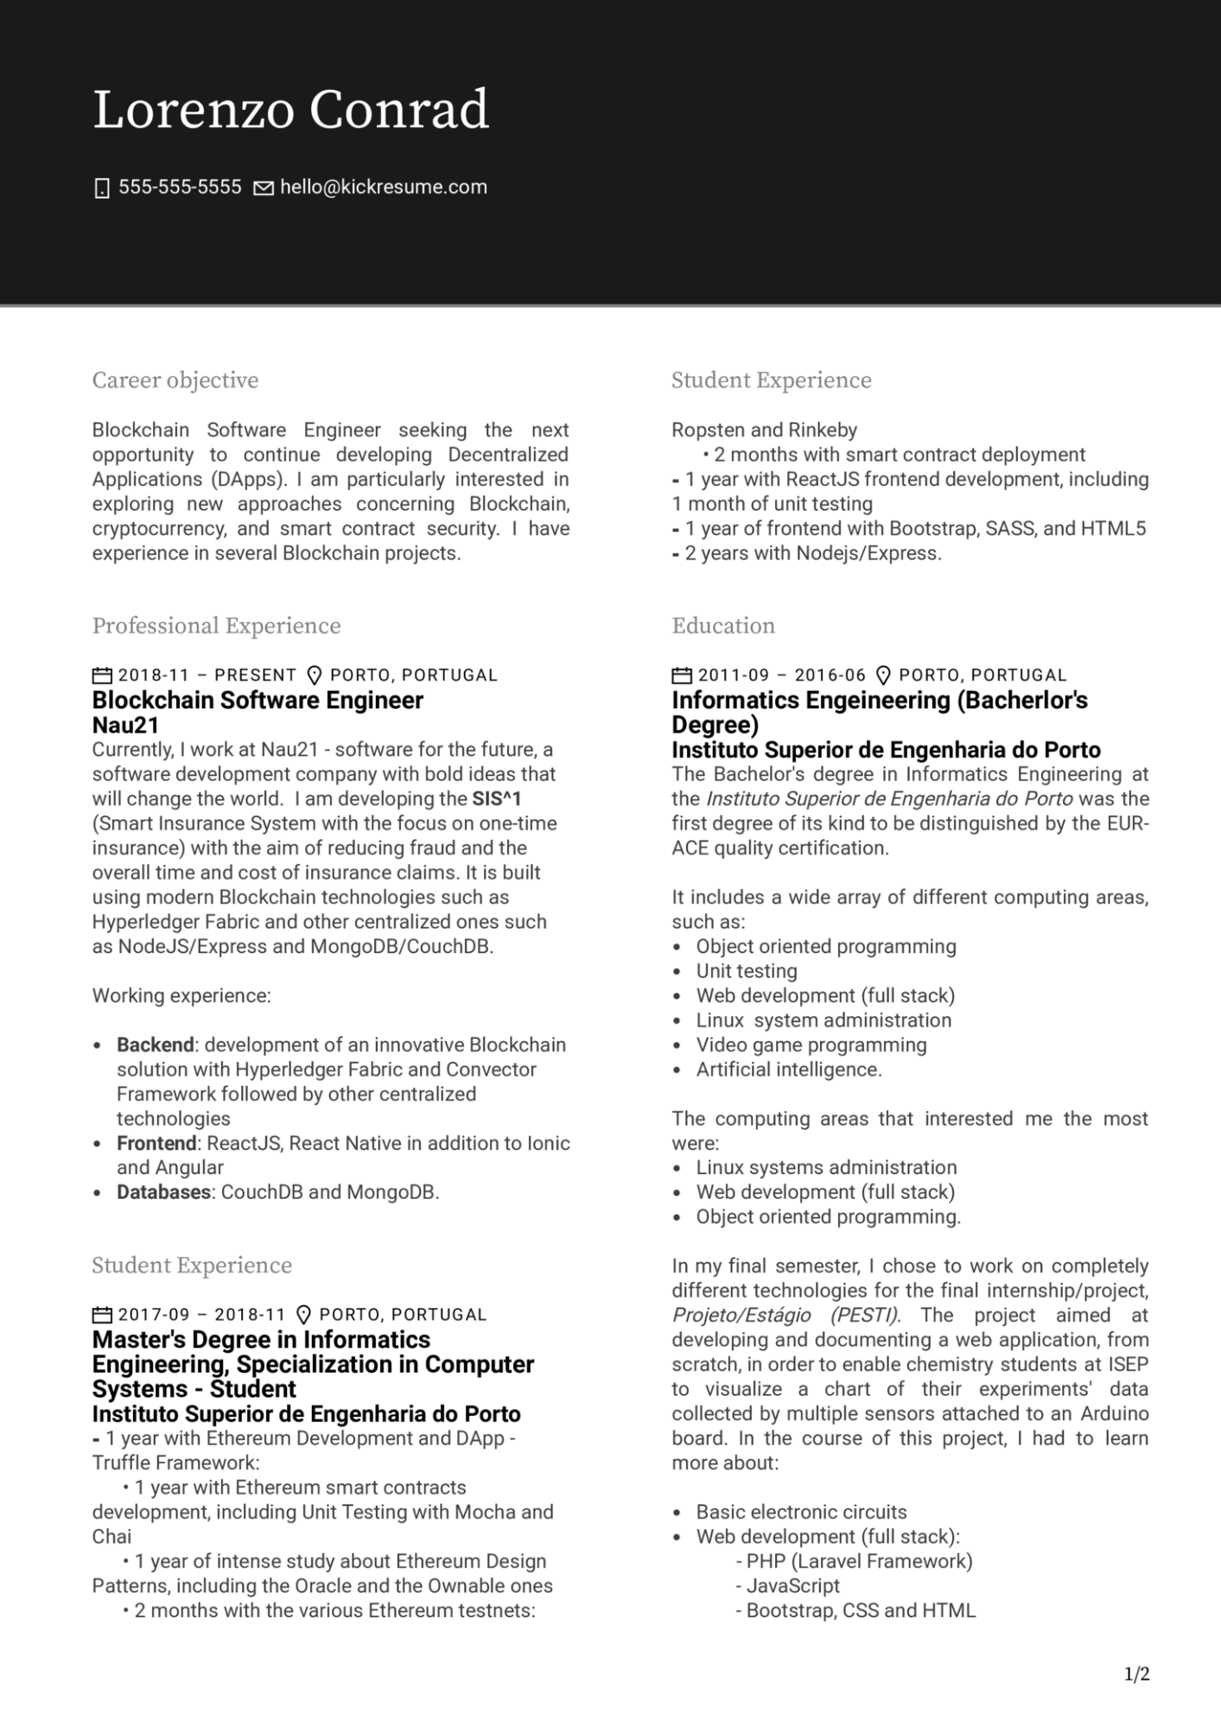

Lorenzo Conrad

555-555-5555 hello@kickresume.com

Career objective

Blockchain Software Engineer seeking the next opportunity to continue developing Decentralized Applications (DApps). I am particularly interested in exploring new approaches concerning Blockchain, cryptocurrency, and smart contract security. I have experience in several Blockchain projects.

Professional Experience

2018-11 PRESENT PORTO, PORTUGAL

**Blockchain Software Engineer Nau21**

Currently, I work at Nau21 - software for the future, a software development company with bold ideas that will change the world. I am developing the SIS^1 (Smart Insurance System with the focus on one-time insurance) with the aim of reducing fraud and the overall time and cost of insurance claims. It is built using modern Blockchain technologies such as Hyperledger Fabric and other centralized ones such as NodeJS/Express and MongoDB/CouchDB.

Working experience:

⚫ Backend: development of an innovative Blockchain solution with Hyperledger Fabric and Convector Framework followed by other centralized technologies

• Frontend: ReactJS, React Native in addition to lonic and Angular

**• Databases: CouchDB and MongoDB.**

Student Experience

2017-09 2018-11 PORTO, PORTUGAL

**Master's Degree in Informatics Engineering, Specialization in Computer Systems - Student**

**Instituto Superior de Engenharia do Porto - 1 year with Ethereum Development and DApp - Truffle Framework:**

• 1 year with Ethereum smart contracts development, including Unit Testing with Mocha and Chai

• 1 year of intense study about Ethereum Design Patterns, including the Oracle and the Ownable ones

2 months with the various Ethereum testnets:

Student Experience

Ropsten and Rinkeby

• 2 months with smart contract deployment

- 1 year with ReactJS frontend development, including 1 month of unit testing

-

1 year of frontend with Bootstrap, SASS, and HTML5 - 2 years with Nodejs/Express.

Education

2011-09- 2016-06 PORTO, PORTUGAL

**Informatics Engeineering (Bachelor's Degree)**

Instituto Superior de Engenharia do Porto The Bachelor's degree in Informatics Engineering at the Instituto Superior de Engenharia do Porto was the first degree of its kind to be distinguished by the EUR- ACE quality certification.

It includes a wide array of different computing areas, such as:

• Object oriented programming

• Unit testing

·

·

Web development (full stack)

Linux system administration

Video game programming

• Artificial intelligence.

The computing areas that interested me the most were:

·

Linux systems administration

·

Web development (full stack)

•

Object oriented programming.

In my final semester, I chose to work on completely different technologies for the final internship/project, Projeto/Estágio (PESTI). The project aimed at developing and documenting a web application, from scratch, in order to enable chemistry students at ISEP to visualize a chart of their experiments' data collected by multiple sensors attached to an Arduino board. In the course of this project, I had to learn more about:

· Basic electronic circuits Web development (full stack):

- PHP (Laravel Framework) - JavaScript

- Bootstrap, CSS and HTML

1/2