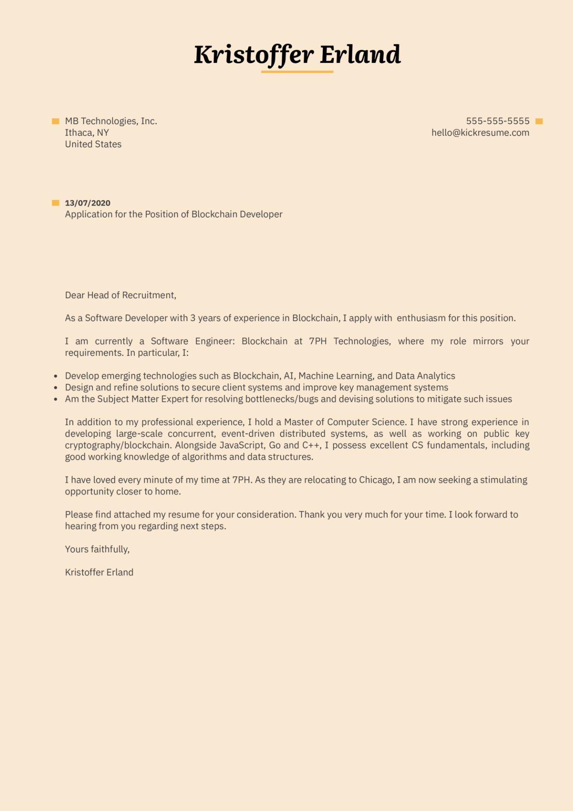

MB Technologies, Inc.

Ithaca, NY

United States

**Kristoffer Erland**

**13/07/2020**

Application for the Position of Blockchain Developer

555-555-5555 hello@kickresume.com

Dear Head of Recruitment,

As a Software Developer with 3 years of experience in Blockchain, I apply with enthusiasm for this position.

I am currently a Software Engineer: Blockchain at 7PH Technologies, where my role mirrors your requirements. In particular, I:

• Develop emerging technologies such as Blockchain, AI, Machine Learning, and Data Analytics

• Design and refine solutions to secure client systems and improve key management systems

·

Am the Subject Matter Expert for resolving bottlenecks/bugs and devising solutions to mitigate such issues

In addition to my professional experience, I hold a Master of Computer Science. I have strong experience in developing large-scale concurrent, event-driven distributed systems, as well as working on public key cryptography/blockchain. Alongside JavaScript, Go and C++, I possess excellent CS fundamentals, including good working knowledge of algorithms and data structures.

I have loved every minute of my time at 7PH. As they are relocating to Chicago, I am now seeking a stimulating opportunity closer to home.

Please find attached my resume for your consideration. Thank you very much for your time. I look forward to hearing from you regarding next steps.

Yours faithfully,

Kristoffer Erland