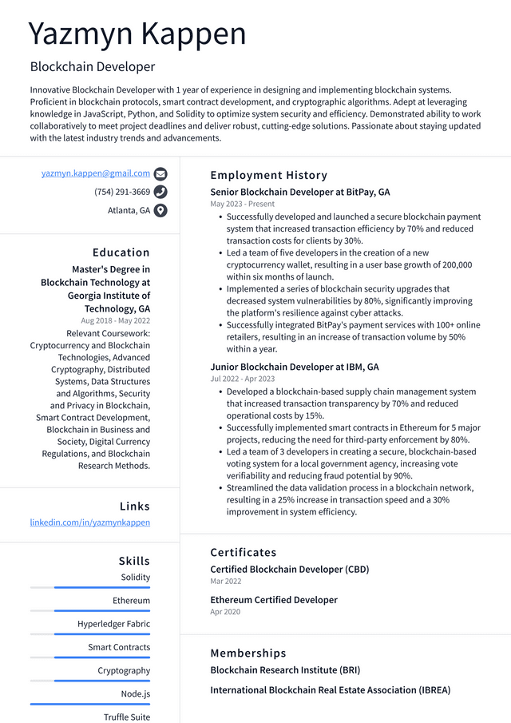

Yazmyn Kappen

Blockchain Developer

Innovative Blockchain Developer with 1 year of experience in designing and implementing blockchain systems. Proficient in blockchain protocols, smart contract development, and cryptographic algorithms. Adept at leveraging knowledge in JavaScript, Python, and Solidity to optimize system security and efficiency. Demonstrated ability to work collaboratively to meet project deadlines and deliver robust, cutting-edge solutions. Passionate about staying updated with the latest industry trends and advancements.

yazmyn.kappen@gmail.com

(754) 291-3669 Atlanta, GA

Education Master's Degree in Blockchain Technology at Georgia Institute of Technology, GA Aug 2018 - May 2022 Relevant Coursework:

Cryptocurrency and Blockchain Technologies, Advanced Cryptography, Distributed Systems, Data Structures and Algorithms, Security and Privacy in Blockchain, Smart Contract Development, Blockchain in Business and Society, Digital Currency Regulations, and Blockchain Research Methods.

Links

Employment History

Senior Blockchain Developer at BitPay, GA May 2023 - Present

• Successfully developed and launched a secure blockchain payment system that increased transaction efficiency by 70% and reduced transaction costs for clients by 30%.

• Led a team of five developers in the creation of a new cryptocurrency wallet, resulting in a user base growth of 200,000 within six months of launch.

• Implemented a series of blockchain security upgrades that decreased system vulnerabilities by 80%, significantly improving the platform's resilience against cyber attacks.

• Successfully integrated BitPay's payment services with 100+ online retailers, resulting in an increase of transaction volume by 50% within a year.

Junior Blockchain Developer at IBM, GA

Jul 2022-Apr 2023

• Developed a blockchain-based supply chain management system that increased transaction transparency by 70% and reduced operational costs by 15%.

• Successfully implemented smart contracts in Ethereum for 5 major projects, reducing the need for third-party enforcement by 80%. • Led a team of 3 developers in creating a secure, blockchain-based voting system for a local government agency, increasing vote verifiability and reducing fraud potential by 90%.

• Streamlined the data validation process in a blockchain network, resulting in a 25% increase in transaction speed and a 30% improvement in system efficiency.

linkedin.com/in/yazmynkappen

Skills

Solidity

Ethereum

Hyperledger Fabric

Smart Contracts

Cryptography

Node.js

Truffle Suite

Certificates

Certified Blockchain Developer (CBD)

Mar 2022

Ethereum Certified Developer Apr 2020

Memberships

Blockchain Research Institute (BRI)

International Blockchain Real Estate Association (IBREA)