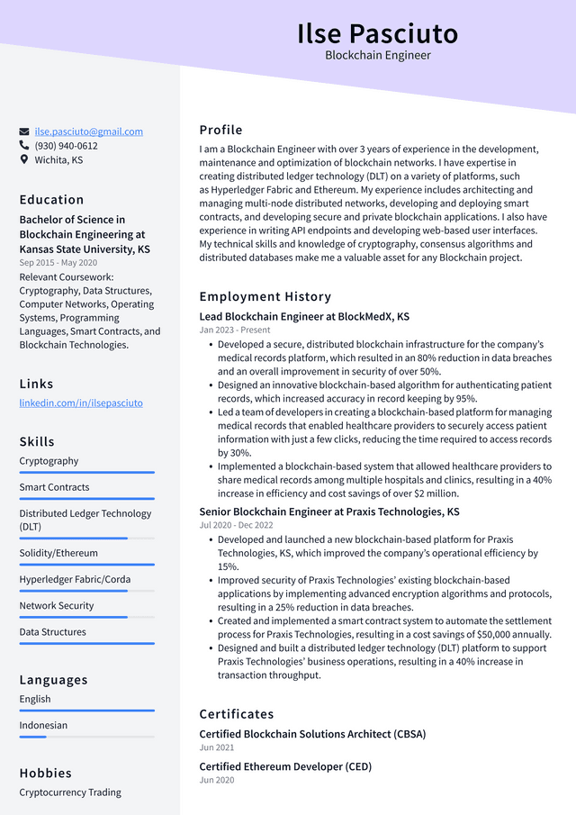

**Ilse Pasciuto**

Blockchain Engineer

ilse.pasciuto@gmail.com (930) 940-0612

Wichita, KS

Education

Bachelor of Science in Blockchain Engineering at Kansas State University, KS Sep 2015 - May 2020 Relevant Coursework: Cryptography, Data Structures, Computer Networks, Operating Systems, Programming Languages, Smart Contracts, and Blockchain Technologies.

Links

linkedin.com/in/ilsepasciuto

Skills

Cryptography

Smart Contracts

Distributed Ledger Technology (DLT)

Solidity/Ethereum

Hyperledger Fabric/Corda

Network Security

Data Structures

Languages

English

Indonesian

Hobbies

Cryptocurrency Trading

Profile

I am a Blockchain Engineer with over 3 years of experience in the development, maintenance and optimization of blockchain networks. I have expertise in creating distributed ledger technology (DLT) on a variety of platforms, such as Hyperledger Fabric and Ethereum. My experience includes architecting and managing multi-node distributed networks, developing and deploying smart contracts, and developing secure and private blockchain applications. I also have experience in writing API endpoints and developing web-based user interfaces. My technical skills and knowledge of cryptography, consensus algorithms and distributed databases make me a valuable asset for any Blockchain project.

Employment History

Lead Blockchain Engineer at BlockMedX, KS

Jan 2023 - Present

• Developed a secure, distributed blockchain infrastructure for the company's medical records platform, which resulted in an 80% reduction in data breaches and an overall improvement in security of over 50%.

• Designed an innovative blockchain-based algorithm for authenticating patient records, which increased accuracy in record keeping by 95%.

• Led a team of developers in creating a blockchain-based platform for managing medical records that enabled healthcare providers to securely access patient information with just a few clicks, reducing the time required to access records by 30%.

• Implemented a blockchain-based system that allowed healthcare providers to share medical records among multiple hospitals and clinics, resulting in a 40% increase in efficiency and cost savings of over $2 million.

Senior Blockchain Engineer at Praxis Technologies, KS Jul 2020 - Dec 2022

• Developed and launched a new blockchain-based platform for Praxis Technologies, KS, which improved the company's operational efficiency by 15%.

• Improved security of Praxis Technologies' existing blockchain-based applications by implementing advanced encryption algorithms and protocols, resulting in a 25% reduction in data breaches.

• Created and implemented a smart contract system to automate the settlement process for Praxis Technologies, resulting in a cost savings of $50,000 annually. • Designed and built a distributed ledger technology (DLT) platform to support Praxis Technologies' business operations, resulting in a 40% increase in transaction throughput.

Certificates

Certified Blockchain Solutions Architect (CBSA)

Jun 2021

Certified Ethereum Developer (CED)

Jun 2020