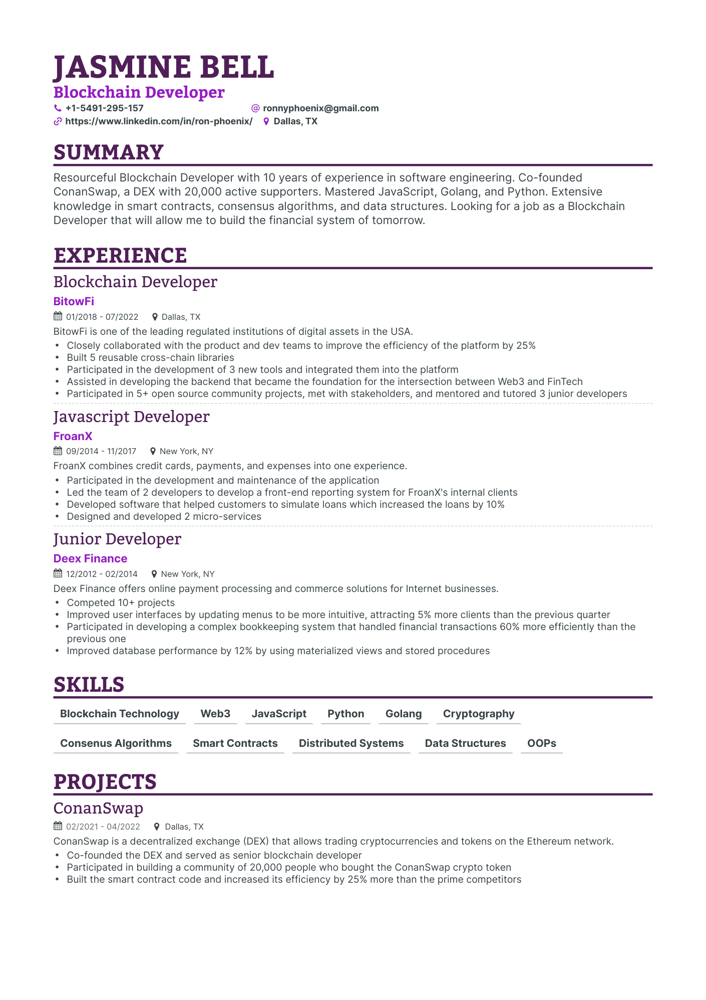

**JASMINE BELL**

**Blockchain Developer**

**+1-5491-295-157**

**@ronnyphoenix@gmail.com**

**https://www.linkedin.com/in/ron-phoenix/ Dallas, TX**

**SUMMARY**

Resourceful Blockchain Developer with 10 years of experience in software engineering. Co-founded ConanSwap, a DEX with 20,000 active supporters. Mastered JavaScript, Golang, and Python. Extensive knowledge in smart contracts, consensus algorithms, and data structures. Looking for a job as a Blockchain Developer that will allow me to build the financial system of tomorrow.

**EXPERIENCE**

Blockchain Developer

**BitowFi**

01/2018 07/2022

Dallas, TX

BitowFi is one of the leading regulated institutions of digital assets in the USA.

• Closely collaborated with the product and dev teams to improve the efficiency of the platform by 25% Built 5 reusable cross-chain libraries

Participated in the development of 3 new tools and integrated them into the platform

Assisted in developing the backend that became the foundation for the intersection between Web3 and FinTech Participated in 5+ open source community projects, met with stakeholders, and mentored and tutored 3 junior developers

Javascript Developer

**FroanX**

09/2014 11/2017

New York, NY

FroanX combines credit cards, payments, and expenses into one experience.

•

•

•

Participated in the development and maintenance of the application

Led the team of 2 developers to develop a front-end reporting system for FroanX's internal clients Developed software that helped customers to simulate loans which increased the loans by 10% Designed and developed 2 micro-services

Junior Developer

**Deex Finance**

12/2012 02/2014

New York, NY

Deex Finance offers online payment processing and commerce solutions for Internet businesses.

•

.

.

Competed 10+ projects

Improved user interfaces by updating menus to be more intuitive, attracting 5% more clients than the previous quarter Participated in developing a complex bookkeeping system that handled financial transactions 60% more efficiently than the previous one

•

Improved database performance by 12% by using materialized views and stored procedures

**SKILLS**

**Blockchain Technology Web3**

**JavaScript**

**Python Golang**

**Cryptography**

**Consenus Algorithms**

**Smart Contracts**

**Distributed Systems**

**Data Structures**

**OOPS**

**PROJECTS**

ConanSwap

02/2021-04/2022

Dallas, TX

ConanSwap is a decentralized exchange (DEX) that allows trading cryptocurrencies and tokens on the Ethereum network. Co-founded the DEX and served as senior blockchain developer

•

•

•

Participated in building a community of 20,000 people who bought the ConanSwap crypto token

Built the smart contract code and increased its efficiency by 25% more than the prime competitors