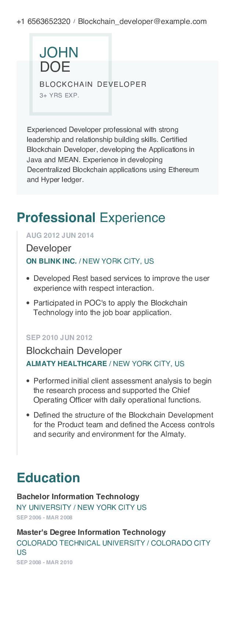

+1 6563652320 Blockchain_developer@example.com

JOHN DOE

BLOCKCHAIN DEVELOPER 3+ YRS EXP.

Experienced Developer professional with strong leadership and relationship building skills. Certified Blockchain Developer, developing the Applications in Java and MEAN. Experience in developing

Decentralized Blockchain applications using Ethereum and Hyper ledger.

**Professional Experience**

**AUG 2012 JUN 2014**

Developer

ON BLINK INC./NEW YORK CITY, US

• Developed Rest based services to improve the user experience with respect interaction.

• Participated in POC's to apply the Blockchain Technology into the job boar application.

**SEP 2010 JUN 2012**

Blockchain Developer

**ALMATY HEALTHCARE / NEW YORK CITY, US**

• Performed initial client assessment analysis to begin the research process and supported the Chief Operating Officer with daily operational functions.

• Defined the structure of the Blockchain Development for the Product team and defined the Access controls and security and environment for the Almaty.

**Education**

**Bachelor Information Technology**

NY UNIVERSITY / NEW YORK CITY US

SEP 2006 - MAR 2008

**Master's Degree Information Technology**

COLORADO TECHNICAL UNIVERSITY/COLORADO CITY US

SEP 2008 - MAR 2010