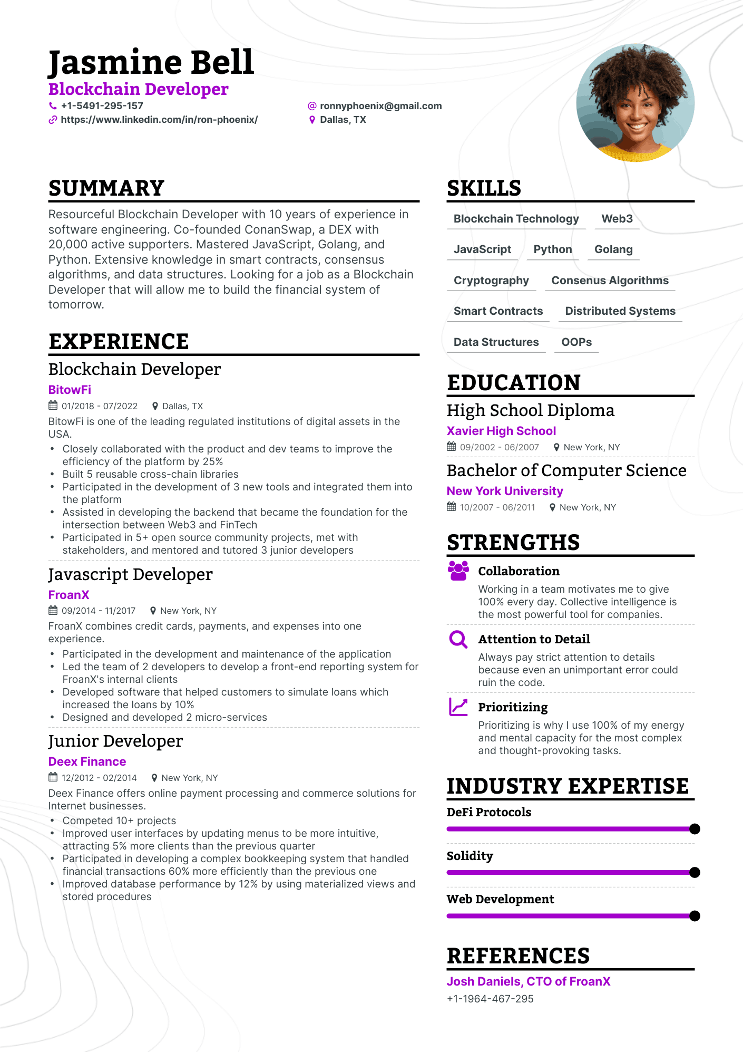

**Jasmine Bell**

**Blockchain Developer**

**+1-5491-295-157**

**https://www.linkedin.com/in/ron-phoenix/**

**@ronnyphoenix@gmail.com • Dallas, TX**

**SUMMARY**

Resourceful Blockchain Developer with 10 years of experience in software engineering. Co-founded ConanSwap, a DEX with 20,000 active supporters. Mastered JavaScript, Golang, and Python. Extensive knowledge in smart contracts, consensus algorithms, and data structures. Looking for a job as a Blockchain Developer that will allow me to build the financial system of tomorrow.

**EXPERIENCE**

Blockchain Developer

**BitowFi**

01/2018 - 07/2022

Dallas, TX

BitowFi is one of the leading regulated institutions of digital assets in the USA.

•

•

•

·

•

Closely collaborated with the product and dev teams to improve the efficiency of the platform by 25%

Built 5 reusable cross-chain libraries

Participated in the development of 3 new tools and integrated them into the platform

Assisted in developing the backend that became the foundation for the intersection between Web3 and FinTech

Participated in 5+ open source community projects, met with

stakeholders, and mentored and tutored 3 junior developers

Javascript Developer

**FroanX**

09/2014 11/2017

New York, NY

FroanX combines credit cards, payments, and expenses into one experience.

• Participated in the development and maintenance of the application

• Led the team of 2 developers to develop a front-end reporting system for FroanX's internal clients

Developed software that helped customers to simulate loans which increased the loans by 10%

• Designed and developed 2 micro-services

Junior Developer

**Deex Finance**

12/2012-02/2014

New York, NY

Deex Finance offers online payment processing and commerce solutions for Internet businesses.

**SKILLS**

**Blockchain Technology Web3**

**JavaScript Python Golang**

**Cryptography Consenus Algorithms**

**Smart Contracts**

**Distributed Systems**

**Data Structures**

**OOPS**

**EDUCATION**

High School Diploma Xavier High School

09/2002-06/2007

New York, NY

Bachelor of Computer Science New York University

10/2007 - 06/2011

New York, NY

**STRENGTHS**

**Collaboration**

Working in a team motivates me to give 100% every day. Collective intelligence is the most powerful tool for companies.

**QAttention to Detail**

Always pay strict attention to details

because even an unimportant error could ruin the code.

**Prioritizing**

Prioritizing is why I use 100% of my energy and mental capacity for the most complex and thought-provoking tasks.

**INDUSTRY EXPERTISE**

**DeFi Protocols**

·

Competed 10+ projects

.

Improved user interfaces by updating menus to be more intuitive, attracting 5% more clients than the previous quarter

•

Participated in developing a complex bookkeeping system that handled financial transactions 60% more efficiently than the previous one

Improved database performance by 12% by using materialized views and stored procedures

**Solidity**

**Web Development**

**REFERENCES**

**Josh Daniels, CTO of FroanX**

+1-1964-467-295