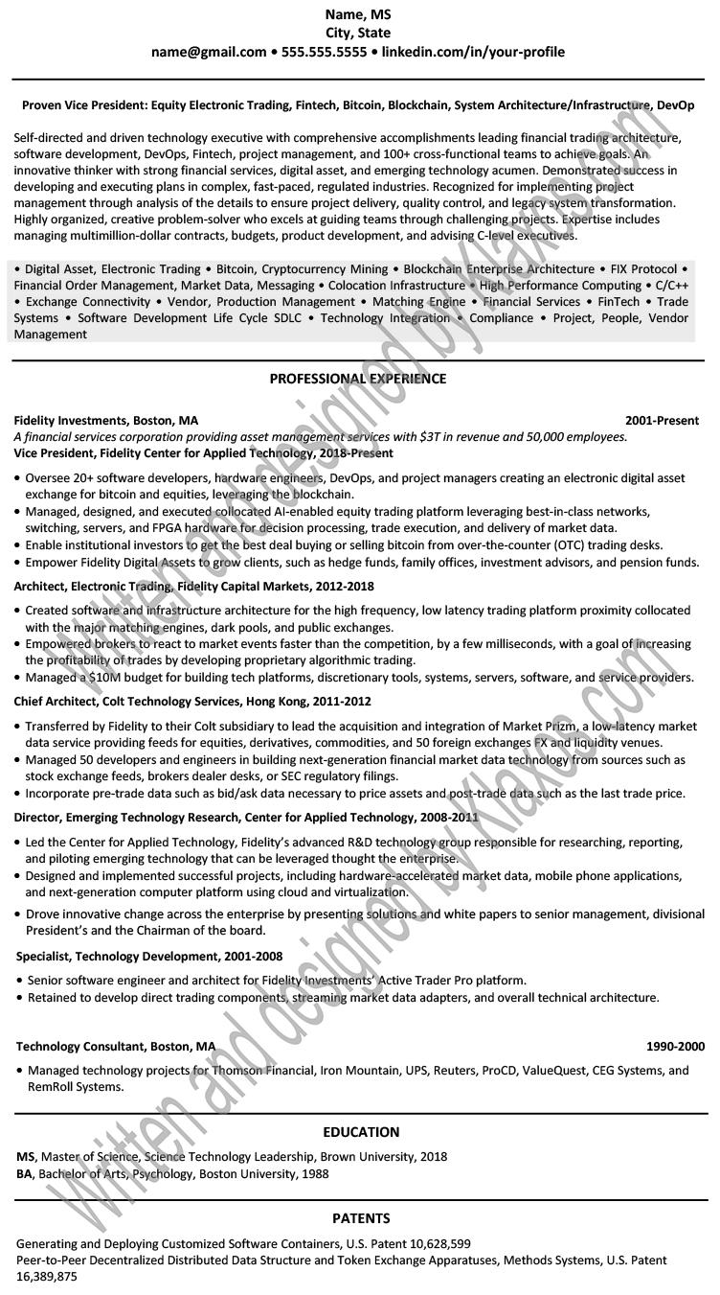

Name, MS City, State

**name@gmail.com⚫ 555.555.5555⚫ linkedin.com/in/your-profile**

Proven Vice President: Equity Electronic Trading, Fintech, Bitcoin, Blockchain, System Architecture/Infrastructure, DevOp

Self-directed and driven technology executive with comprehensive accomplishments leading financial trading architecture, software development, DevOps, Fintech, project management, and 100+ cross-functional teams to achieve goals. An innovative thinker with strong financial services, digital asset, and emerging technology acumen. Demonstrated success in developing and executing plans in complex, fast-paced, regulated industries. Recognized for implementing project management through analysis of the details to ensure project delivery, quality control, and legacy system transformation. Highly organized, creative problem-solver who excels at guiding teams through challenging projects. Expertise includes managing multimillion-dollar contracts, budgets, product development, and advising C-level executives.

High Performance Computing • C/C++ Financial Services FinTech Trade Compliance Project, People, Vendor

• Digital Asset, Electronic Trading Bitcoin, Cryptocurrency Mining Blockchain Enterprise Architecture ⚫ FIX Protocol ⚫ Financial Order Management, Market Data, Messaging. Colocation Infrastructure • Exchange Connectivity Vendor, Production Management Matching Engine Systems • Software Development Life Cycle SDLC Technology Integration Management

**Fidelity Investments, Boston, MA**

*A financial services corporation providing asset management services with $3T in revenue and 50,000 employees. Vice President, Fidelity Center for Applied Technology, 2018-Present*

2001-Present

• Oversee 20+ software developers, hardware engineers, DevOps, and project managers creating an electronic digital asset exchange for bitcoin and equities, leveraging the blockchain.

• Managed, designed, and executed collocated Al-enabled equity trading platform leveraging best-in-class networks, switching, servers, and FPGA hardware for decision processing, trade execution, and delivery of market data.

• Enable institutional investors to get the best deal buying or selling bitcoin from over-the-counter (OTC) trading desks.

• Empower Fidelity Digital Assets to grow clients, such as hedge funds, family offices, investment advisors, and pension funds. Architect, Electronic Trading, Fidelity Capital Markets, 2012-2018

• Created software and infrastructure architecture for the high frequency, low latency trading platform proximity collocated with the major matching engines, dark pools, and public exchanges.

• Empowered brokers to react to market events faster than the competition, by a few milliseconds, with a goal of increasing the profitability of trades by developing proprietary algorithmic trading.

• Managed a $10M budget for building tech platforms, discretionary tools, systems, servers, software, and servic

**Chief Architect, Colt Technology Services, Hong Kong, 2011-2012**

• Transferred by Fidelity to their Colt subsidiary to lead the acquisition and integration of Market Prizm, a low-latency market data service providing feeds for equities, derivatives, commodities, and 50 foreign exchanges FX and liquidity venues.

• Managed 50 developers and engineers in building next-generation financial market data technology from sources such as stock exchange feeds, brokers dealer desks, or SEC regulatory filings.

• Incorporate pre-trade data such as bid/ask data necessary to price assets and post-trade

**Director, Emerging Technology Research, Center for Applied Technology, 2008-201**

such as the last trade price.

• Led the Center for Applied Technology, Fidelity's advanced R&D technology group responsible for researching, reporting, and piloting emerging technology that can be leveraged thought the enterprise.

• Designed and implemented successful projects, including hardware-accelerated market data, mobile phone applications, and next-generation computer platform using cloud and virtualization.

• Drove innovative change across the enterprise by presenting solutions and white papers to senior management, divisional President's and the Chairman of the board.

Written and designed by area.com

Specialist, Technology Development, 2001-2008

• Senior software engineer and architect for Fidelity Investments' Active Trader Pro platform.

• Retained to develop direct trading components, streaming market data adapters, and overall technical architecture.

**Technology Consultant, Boston, MA**

• Managed technology projects for RemRoll Systems.

1990-2000

Financial, Iron Mountain, UPS, Reuters, ProCD, ValueQuest, CEG Systems, and

**EDUCATION**

MS, Master of Science, Science Technology Leadership, Brown University, 2018

BA, Bachelor of Arts, Psychology, Boston University, 1988

**PATENTS**

Generating and Deploying Customized Software Containers, U.S. Patent 10,628,599

Peer-to-Peer Decentralized Distributed Data Structure and Token Exchange Apparatuses, Methods Systems, U.S. Patent

16,389,875