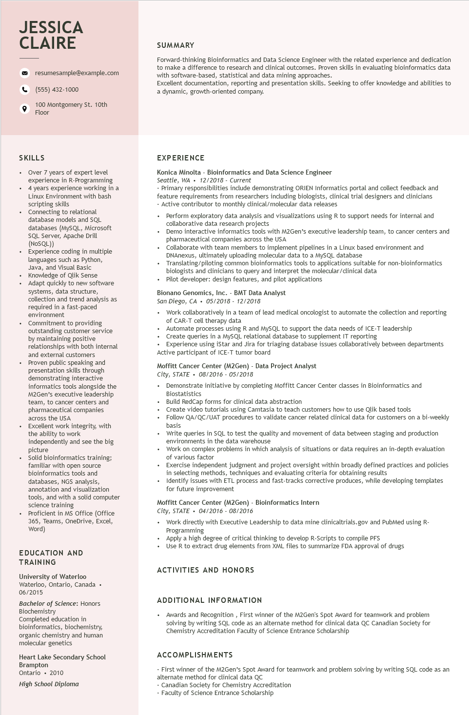

**JESSICA CLAIRE**

resumesample@example.com

(555) 432-1000

100 Montgomery St. 10th Floor

**SUMMARY**

Forward-thinking Bioinformatics and Data Science Engineer with the related experience and dedication to make a difference to research and clinical outcomes. Proven skills in evaluating bioinformatics data with software-based, statistical and data mining approaches.

Excellent documentation, reporting and presentation skills. Seeking to offer knowledge and abilities to a dynamic, growth-oriented company.

SKILLS

• Over 7 years of expert level experience in R-Programming

• 4 years experience working in a

·

•

.

+

Linux Environment with bash

scripting skills

Connecting to relational

database models and SQL

databases (MySQL, Microsoft

SQL Server, Apache Drill (NoSQL))

Experience coding in multiple

languages such as Python,

Java, and Visual Basic

Knowledge of Qlik Sense

Adapt quickly to new software

systems, data structure,

collection and trend analysis as

required in a fast-paced environment

Commitment to providing outstanding customer service by maintaining positive relationships with both internal and external customers Proven public speaking and presentation skills through demonstrating interactive informatics tools alongside the M2Gen's executive leadership team, to cancer centers and pharmaceutical companies across the USA

Excellent work integrity, with

the ability to work

independently and see the big picture

• Solid bioinformatics training; familiar with open source

•

bioinformatics tools and databases, NGS analysis, annotation and visualization

tools, and with a solid computer

science training

Proficient in MS Office (Office

365, Teams, OneDrive, Excel, Word)

EDUCATION AND TRAINING

University of Waterloo

Waterloo, Ontario, Canada. 06/2015

Bachelor of Science: Honors Biochemistry

Completed education in bioinformatics, biochemistry, organic chemistry and human molecular genetics

Heart Lake Secondary School Brampton

Ontario. 2010

*High School Diploma*

**EXPERIENCE**

Konica Minolta - Bioinformatics and Data Science Engineer Seattle, WA. 12/2018 - Current

• Primary responsibilities include demonstrating ORIEN Informatics portal and collect feedback and feature requirements from researchers including biologists, clinical trial designers and clinicians • Active contributor to monthly clinical/molecular data releases

• Perform exploratory data analysis and visualizations using R to support needs for internal and collaborative data research projects

• Demo interactive informatics tools with M2Gen's executive leadership team, to cancer centers and pharmaceutical companies across the USA

• Collaborate with team members to implement pipelines in a Linux based environment and DNAnexus, ultimately uploading molecular data to a MySQL database

Translating/piloting common bioinformatics tools to applications suitable for non-bioinformatics biologists and clinicians to query and interpret the molecular/clinical data

• Pilot developer: design features, and pilot applications

Bionano Genomics, Inc. - BMT Data Analyst

San Diego, CA⚫ 05/2018 - 12/2018

• Work collaboratively in a team of lead medical oncologist to automate the collection and reporting of CAR-T cell therapy data

• Automate processes using R and MySQL to support the data needs of ICE-T leadership

• Create queries in a MySQL relational database to supplement IT reporting

• Experience using iStar and Jira for triaging database issues collaboratively between departments Active participant of ICE-T tumor board

Moffitt Cancer Center (M2Gen) - Data Project Analyst

*City, STATE⚫ 08/2016 - 05/2018*

• Demonstrate initiative by completing Moffitt Cancer Center classes in Bioinformatics and Biostatistics

•

Build RedCap forms for clinical data abstraction

•

Create video tutorials using Camtasia to teach customers how to use Qlik based tools

• Follow QA/QC/UAT procedures to validate cancer related clinical data for customers on a bi-weekly basis

• Write queries in SQL to test the quality and movement of data between staging and production environments in the data warehouse

• Work on complex problems in which analysis of situations or data requires an in-depth evaluation of various factor

• Exercise independent judgment and project oversight within broadly defined practices and policies in selecting methods, techniques and evaluating criteria for obtaining results

• Identify issues with ETL process and fast-tracks corrective produces, while developing templates for future improvement

Moffitt Cancer Center (M2Gen) - Bioinformatics Intern

*City, STATE⚫ 04/2016 - 08/2016*

• Work directly with Executive Leadership to data mine clinicaltrials.gov and PubMed using R- Programming

Apply a high degree of critical thinking to develop R-Scripts to compile PFS

• Use R to extract drug elements from XML files to summarize FDA approval of drugs

ACTIVITIES AND HONORS

**ADDITIONAL INFORMATION**

• Awards and Recognition, First winner of the M2Gen's Spot Award for teamwork and problem solving by writing SQL code as an alternate method for clinical data QC Canadian Society for Chemistry Accreditation Faculty of Science Entrance Scholarship

**ACCOMPLISHMENTS**

First winner of the M2Gen's Spot Award for teamwork and problem solving by writing SQL code as an alternate method for clinical data QC

• Canadian Society for Chemistry Accreditation

• Faculty of Science Entrance Scholarship