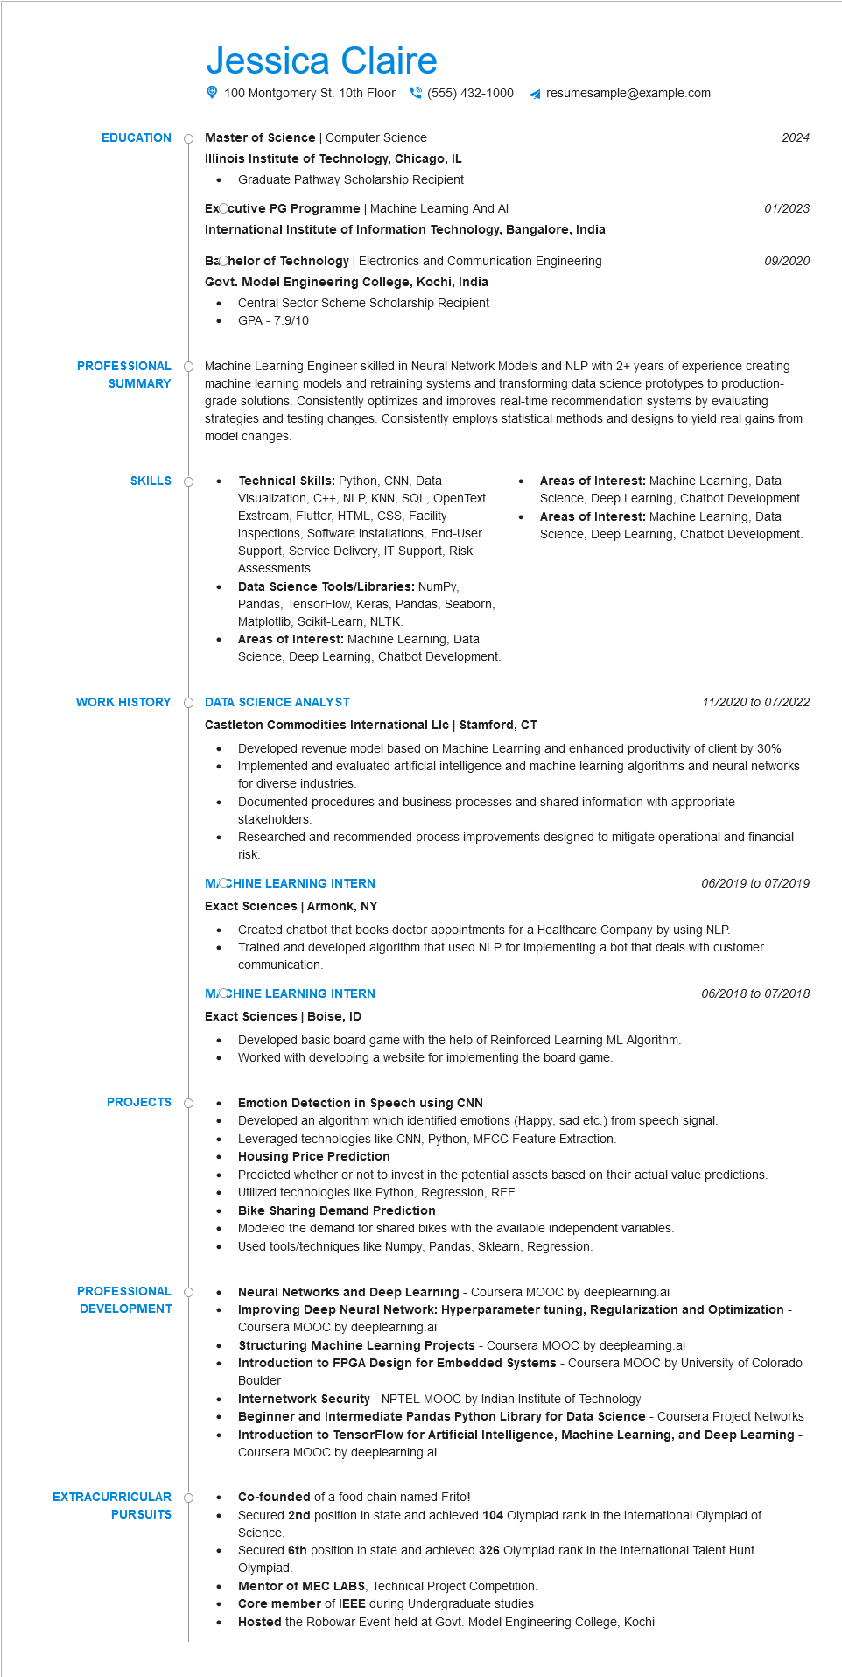

**EDUCATION**

Jessica Claire

100 Montgomery St. 10th Floor(555) 432-1000 resumesample@example.com

Master of Science | Computer Science

2024

**Illinois Institute of Technology, Chicago, IL**

• Graduate Pathway Scholarship Recipient

**ExOcutive PG Programme | Machine Learning And Al**

01/2023

**International Institute of Information Technology, Bangalore, India**

Bachelor of Technology | Electronics and Communication Engineering

09/2020

**Govt. Model Engineering College, Kochi, India**

•

Central Sector Scheme Scholarship Recipient GPA - 7.9/10

**PROFESSIONAL**

**SUMMARY**

**SKILLS Ò**

Machine Learning Engineer skilled in Neural Network Models and NLP with 2+ years of experience creating machine learning models and retraining systems and transforming data science prototypes to production- grade solutions. Consistently optimizes and improves real-time recommendation systems by evaluating strategies and testing changes. Consistently employs statistical methods and designs to yield real gains from model changes.

Technical Skills: Python, CNN, Data Visualization, C++, NLP, KNN, SQL, OpenText Exstream, Flutter, HTML, CSS, Facility Inspections, Software Installations, End-User Support, Service Delivery, IT Support, Risk Assessments.

Data Science Tools/Libraries: NumPy, Pandas, TensorFlow, Keras, Pandas, Seaborn, Matplotlib, Scikit-Learn, NLTK.

Areas of Interest: Machine Learning, Data Science, Deep Learning, Chatbot Development.

**WORK HISTORY O DATA SCIENCE ANALYST**

**Castleton Commodities International Llc | Stamford, CT**

•

•

Areas of Interest: Machine Learning, Data Science, Deep Learning, Chatbot Development. Areas of Interest: Machine Learning, Data Science, Deep Learning, Chatbot Development.

11/2020 to 07/2022

Developed revenue model based on Machine Learning and enhanced productivity of client by 30% Implemented and evaluated artificial intelligence and machine learning algorithms and neural networks for diverse industries.

Documented procedures and business processes and shared information with appropriate stakeholders.

Researched and recommended process improvements designed to mitigate operational and financial risk.

**MACCHINE LEARNING INTERN**

**Exact Sciences | Armonk, NY**

*06/2019 to 07/2019*

Created chatbot that books doctor appointments for a Healthcare Company by using NLP. Trained and developed algorithm that used NLP for implementing a bot that deals with customer communication.

**MACCHINE LEARNING INTERN**

**Exact Sciences | Boise, ID**

•

*06/2018 to 07/2018*

Developed basic board game with the help of Reinforced Learning ML Algorithm.

Worked with developing a website for implementing the board game.

**PROJECTS**

•

Emotion Detection in Speech using CNN

Developed an algorithm which identified emotions (Happy, sad etc.) from speech signal.

•

Leveraged technologies like CNN, Python, MFCC Feature Extraction.

**Housing Price Prediction**

**PROFESSIONAL**

**DEVELOPMENT**

**EXTRACURRICULAR**

**PURSUITS**

Predicted whether or not to invest in the potential assets based on their actual value predictions. Utilized technologies like Python, Regression, RFE.

**Bike Sharing Demand Prediction**

Modeled the demand for shared bikes with the available independent variables.

•

Used tools/techniques like Numpy, Pandas, Sklearn, Regression.

•

•

**Neural Networks and Deep Learning - Coursera MOOC by deeplearning.ai**

**Improving Deep Neural Network: Hyperparameter tuning, Regularization and Optimization - Coursera MOOC by deeplearning.ai**

**Structuring Machine Learning Projects - Coursera MOOC by deeplearning.ai**

**Introduction to FPGA Design for Embedded Systems - Coursera MOOC by University of Colorado Boulder**

**Internetwork Security - NPTEL MOOC by Indian Institute of Technology**

**Beginner and Intermediate Pandas Python Library for Data Science - Coursera Project Networks Introduction to TensorFlow for Artificial Intelligence, Machine Learning, and Deep Learning Coursera MOOC by deeplearning.ai**

Co-founded of a food chain named Frito!

Secured 2nd position in state and achieved 104 Olympiad rank in the International Olympiad of Science.

Secured 6th position in state and achieved 326 Olympiad rank in the International Talent Hunt Olympiad.

Mentor of MEC LABS, Technical Project Competition.

Core member of IEEE during Undergraduate studies

Hosted the Robowar Event held at Govt. Model Engineering College, Kochi