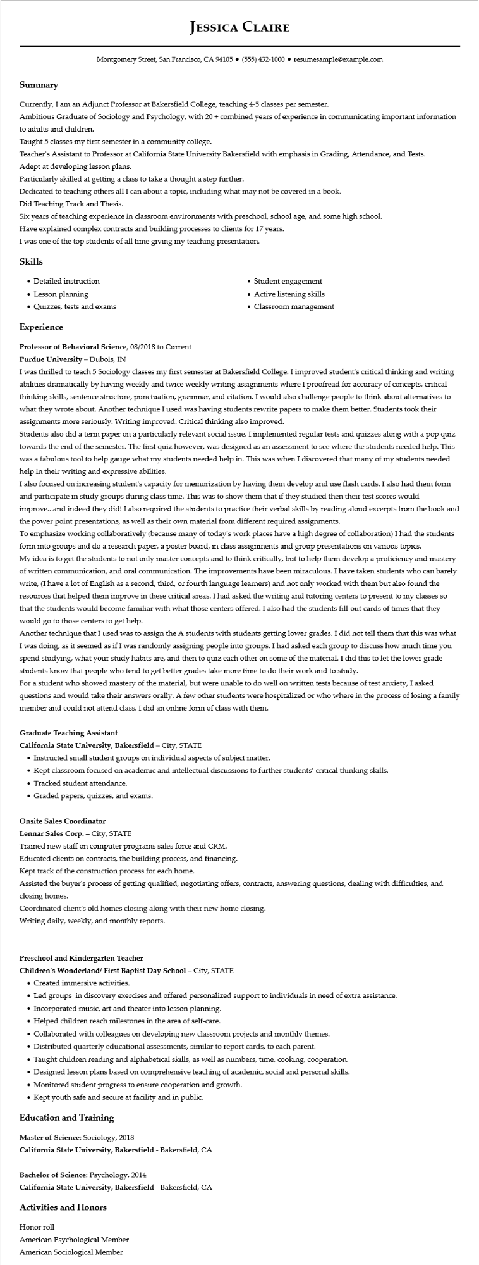

**Summary**

**JESSICA CLAIRE**

Montgomery Street, San Francisco, CA 94105⚫ (555) 432-1000⚫ resumesample@example.com

Currently, I am an Adjunct Professor at Bakersfield College, teaching 4-5 classes per semester.

Ambitious Graduate of Sociology and Psychology, with 20+ combined years of experience in communicating important information

to adults and children.

Taught 5 classes my first semester in a community college.

Teacher's Assistant to Professor at California State University Bakersfield with emphasis in Grading, Attendance, and Tests.

Adept at developing lesson plans.

Particularly skilled at getting a class to take a thought a step further.

Dedicated to teaching others all I can about a topic, including what may not be covered in a book.

Did Teaching Track and Thesis.

Six years of teaching experience in classroom environments with preschool, school age, and some high school.

Have explained complex contracts and building processes to clients for 17 years.

I was one of the top students of all time giving my teaching presentation.

Skills

• Detailed instruction

• Lesson planning

• Quizzes, tests and exams

**Experience**

**Professor of Behavioral Science, 08/2018 to Current**

Purdue University - Dubois, IN

• Student engagement

• Active listening skills

• Classroom management

I was thrilled to teach 5 Sociology classes my first semester at Bakersfield College. I improved student's critical thinking and writing abilities dramatically by having weekly and twice weekly writing assignments where I proofread for accuracy of concepts, critical thinking skills, sentence structure, punctuation, grammar, and citation. I would also challenge people to think about alternatives to what they wrote about. Another technique I used was having students rewrite papers to make them better. Students took their assignments more seriously. Writing improved. Critical thinking also improved.

Students also did a term paper on a particularly relevant social issue. I implemented regular tests and quizzes along with a pop quiz towards the end of the semester. The first quiz however, was designed as an assessment to see where the students needed help. This was a fabulous tool to help gauge what my students needed help in. This was when I discovered that many of my students needed help in their writing and expressive abilities.

I also focused on increasing student's capacity for memorization by having them develop and use flash cards. I also had them form and participate in study groups during class time. This was to show them that if they studied then their test scores would

improve...and indeed they did! I also required the students to practice their verbal skills by reading aloud excerpts from the book and the power point presentations, as well as their own material from different required assignments.

To emphasize working collaboratively (because many of today's work places have a high degree of collaboration) I had the students form into groups and do a research paper, a poster board, in class assignments and group presentations on various topics. My idea is to get the students to not only master concepts and to think critically, but to help them develop a proficiency and mastery of written communication, and oral communication. The improvements have been miraculous. I have taken students who can barely write, (I have a lot of English as a second, third, or fourth language learners) and not only worked with them but also found the resources that helped them improve in these critical areas. I had asked the writing and tutoring centers to present to my classes so that the students would become familiar with what those centers offered. I also had the students fill-out cards of times that they would go to those centers to get help.

Another technique that I used was to assign the A students with students getting lower grades. I did not tell them that this was what I was doing, as it seemed as if I was randomly assigning people into groups. I had asked each group to discuss how much time you spend studying, what your study habits are, and then to quiz each other on some of the material. I did this to let the lower grade students know that people who tend to get better grades take more time to do their work and to study.

For a student who showed mastery of the material, but were unable to do well on written tests because of test anxiety, I asked questions and would take their answers orally. A few other students were hospitalized or who where in the process of losing a family member and could not attend class. I did an online form of class with them.

**Graduate Teaching Assistant**

**California State University, Bakersfield - City, STATE**

• Instructed small student groups on individual aspects of subject matter.

• Kept classroom focused on academic and intellectual discussions to further students' critical thinking skills.

• Tracked student attendance.

• Graded papers, quizzes, and exams.

**Onsite Sales Coordinator**

Lennar Sales Corp. - City, STATE

Trained new staff on computer programs sales force and CRM.

Educated clients on contracts, the building process, and financing.

Kept track of the construction process for each home.

Assisted the buyer's process of getting qualified, negotiating offers, contracts, answering questions, dealing with difficulties, and closing homes.

Coordinated client's old homes closing along with their new home closing.

Writing daily, weekly, and monthly reports.

**Preschool and Kindergarten Teacher**

**Children's Wonderland/ First Baptist Day School - City, STATE**

• Created immersive activities.

• Led groups in discovery exercises and offered personalized support to individuals in need of extra assistance.

• Incorporated music, art and theater into lesson planning.

• Helped children reach milestones in the area of self-care.

• Collaborated with colleagues on developing new classroom projects and monthly themes.

• Distributed quarterly educational assessments, similar to report cards, to each parent.

• Taught children reading and alphabetical skills, as well as numbers, time, cooking, cooperation.

• Designed lesson plans based on comprehensive teaching of academic, social and personal skills.

• Monitored student progress to ensure cooperation and growth.

• Kept youth safe and secure at facility and in public.

**Education and Training**

Master of Science: Sociology, 2018

**California State University, Bakersfield - Bakersfield, CA**

Bachelor of Science: Psychology, 2014

**California State University, Bakersfield - Bakersfield, CA**

**Activities and Honors**

Honor roll

American Psychological Member

American Sociological Member