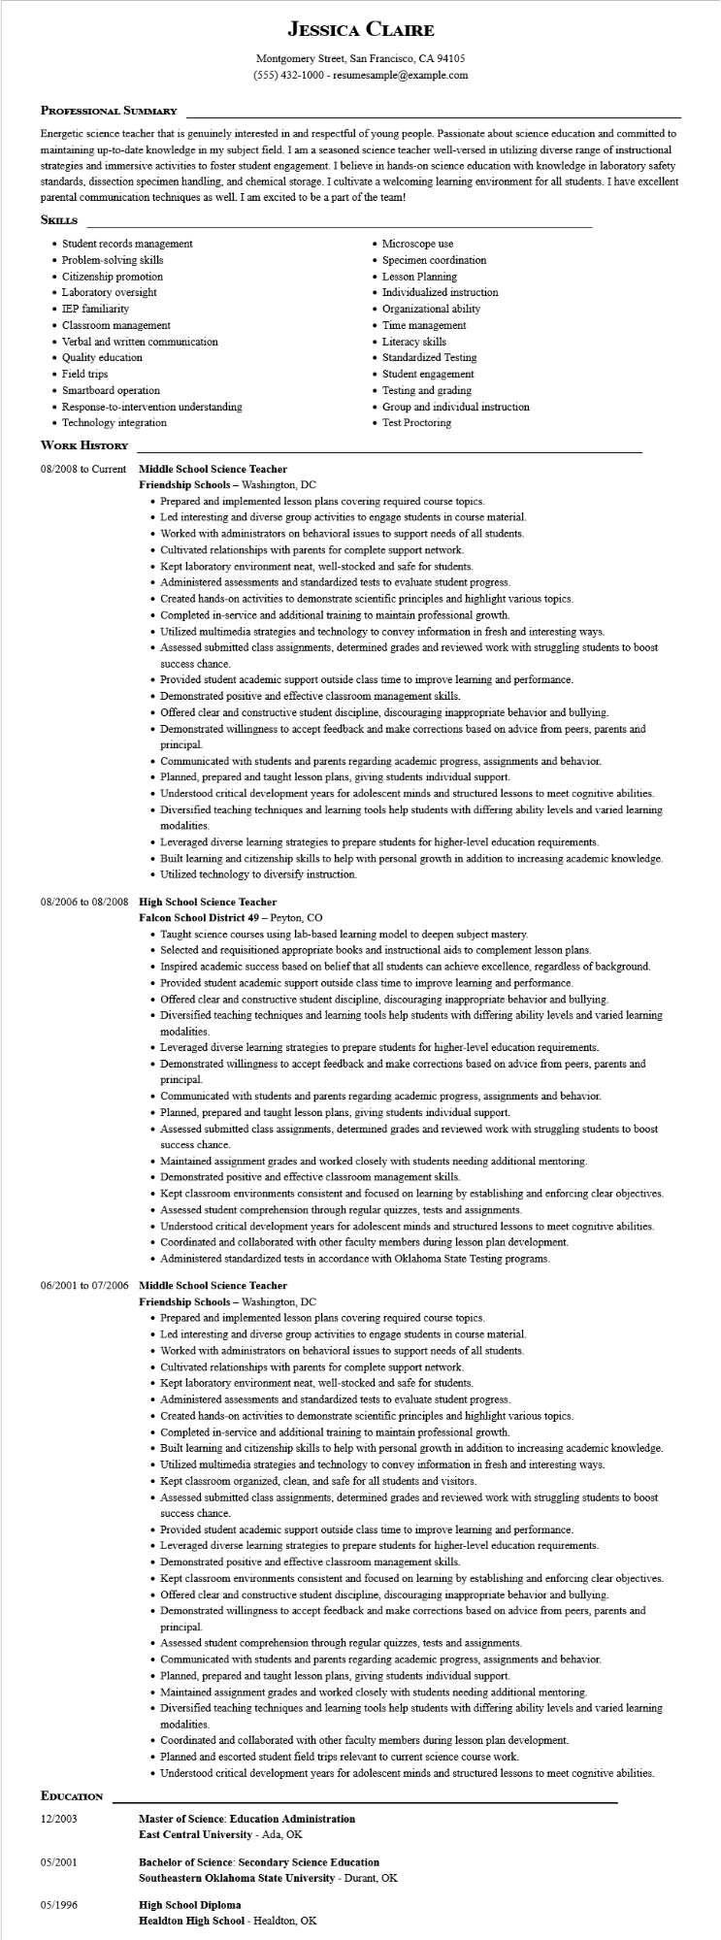

**JESSICA CLAIRE**

Montgomery Street, San Francisco, CA 94105 (555) 432-1000 - resumesample@example.com

**PROFESSIONAL SUMMARY**

Energetic science teacher that is genuinely interested in and respectful of young people. Passionate about science education and committed to maintaining up-to-date knowledge in my subject field. I am a seasoned science teacher well-versed in utilizing diverse range of instructional strategies and immersive activities to foster student engagement. I believe in hands-on science education with knowledge in laboratory safety standards, dissection specimen handling, and chemical storage. I cultivate a welcoming learning environment for all students. I have excellent parental communication techniques as well. I am excited to be a part of the team!

**SKILLS**

• Student records management

• Problem-solving skills

• Citizenship promotion

• Laboratory oversight

• IEP familiarity

⚫ Classroom management

• Verbal and written communication

• Quality education

• Field trips

• Smartboard operation

• Response-to-intervention understanding

• Technology integration

**WORK HISTORY**

08/2008 to Current Middle School Science Teacher

**Friendship Schools - Washington, DC**

• Microscope use

•

Specimen coordination

• Lesson Planning

• Individualized instruction

Organizational ability

• Time management

• Literacy skills

• Standardized Testing

• Student engagement

• Testing and grading

• Group and individual instruction • Test Proctoring

• Prepared and implemented lesson plans covering required course topics.

• Led interesting and diverse group activities to engage students in course material.

• Worked with administrators on behavioral issues to support needs of all students.

• Cultivated relationships with parents for complete support network.

• Kept laboratory environment neat, well-stocked and safe for students.

• Administered assessments and standardized tests to evaluate student progress.

• Created hands-on activities to demonstrate scientific principles and highlight various topics.

• Completed in-service and additional training to maintain professional growth.

• Utilized multimedia strategies and technology to convey information in fresh and interesting ways.

• Assessed submitted class assignments, determined grades and reviewed work with struggling students to boost success chance.

• Provided student academic support outside class time to improve learning and performance.

• Demonstrated positive and effective classroom management skills.

• Offered clear and constructive student discipline, discouraging inappropriate behavior and bullying.

• Demonstrated willingness to accept feedback and make corrections based on advice from peers, parents and principal

• Communicated with students and parents regarding academic progress, assignments and behavior.

• Planned, prepared and taught lesson plans, giving students individual support.

• Understood critical development years for adolescent minds and structured lessons to meet cognitive abilities.

• Diversified teaching techniques and learning tools help students with differing ability levels and varied learning modalities.

• Leveraged diverse learning strategies to prepare students for higher-level education requirements.

• Built learning and citizenship skills to help with personal growth in addition to increasing academic knowledge. • Utilized technology to diversify instruction.

**08/2006 to 08/2008 High School Science Teacher**

Falcon School District 49 - Peyton, CO

• Taught science courses using lab-based learning model to deepen subject mastery.

• Selected and requisitioned appropriate books and instructional aids to complement lesson plans.

• Inspired academic success based on belief that all students can achieve excellence, regardless of background.

• Provided student academic support outside class time to improve learning and performance.

• Offered clear and constructive student discipline, discouraging inappropriate behavior and bullying.

• Diversified teaching techniques and learning tools help students with differing ability levels and varied learning modalities.

• Leveraged diverse learning strategies to prepare students for higher-level education requirements.

• Demonstrated willingness to accept feedback and make corrections based on advice from peers, parents and principal.

• Communicated with students and parents regarding academic progress, assignments and behavior.

• Planned, prepared and taught lesson plans, giving students individual support.

• Assessed submitted class assignments, determined grades and reviewed work with struggling students to boost success chance.

• Maintained assignment grades and worked closely with students needing additional mentoring.

• Demonstrated positive and effective classroom management skills.

• Kept classroom environments consistent and focused on learning by establishing and enforcing clear objectives.

• Assessed student comprehension through regular quizzes, tests and assignments.

• Understood critical development years for adolescent minds and structured lessons to meet cognitive abilities.

• Coordinated and collaborated with other faculty members during lesson plan development.

• Administered standardized tests in accordance with Oklahoma State Testing programs.

06/2001 to 07/2006 Middle School Science Teacher

**Friendship Schools - Washington, DC**

• Prepared and implemented lesson plans covering required course topics.

• Led interesting and diverse group activities to engage students in course material.

• Worked with administrators on behavioral issues to support needs of all students.

• Cultivated relationships with parents for complete support network.

• Kept laboratory environment neat, well-stocked and safe for students.

• Administered assessments and standardized tests to evaluate student progress.

• Created hands-on activities to demonstrate scientific principles and highlight various topics.

• Completed in-service and additional training to maintain professional growth.

• Built learning and citizenship skills to help with personal growth in addition to increasing academic knowledge.

• Utilized multimedia strategies and technology to convey information in fresh and interesting ways.

• Kept classroom organized, clean, and safe for all students and visitors.

• Assessed submitted class assignments, determined grades and reviewed work with struggling students to boost success chance.

• Provided student academic support outside class time to improve learning and performance.

• Leveraged diverse learning strategies to prepare students for higher-level education requirements.

• Demonstrated positive and effective classroom management skills.

• Kept classroom environments consistent and focused on learning by establishing and enforcing clear objectives.

• Offered clear and constructive student discipline, discouraging inappropriate behavior and bullying.

• Demonstrated willingness to accept feedback and make corrections based on advice from peers, parents and principal.

• Assessed student comprehension through regular quizzes, tests and assignments.

• Communicated with students and parents regarding academic progress, assignments and behavior.

• Planned, prepared and taught lesson plans, giving students individual support.

• Maintained assignment grades and worked closely with students needing additional mentoring.

• Diversified teaching techniques and learning tools help students with differing ability levels and varied learning modalities.

• Coordinated and collaborated with other faculty members during lesson plan development.

• Planned and escorted student field trips relevant to current science course work.

• Understood critical development years for adolescent minds and structured lessons to meet cognitive abilities.

**EDUCATION**

12/2003

05/2001

**Master of Science: Education Administration**

**East Central University - Ada, OK**

**Bachelor of Science: Secondary Science Education**

**Southeastern Oklahoma State University - Durant, OK**

05/1996

**High School Diploma**

**Healdton High School - Healdton, OK**