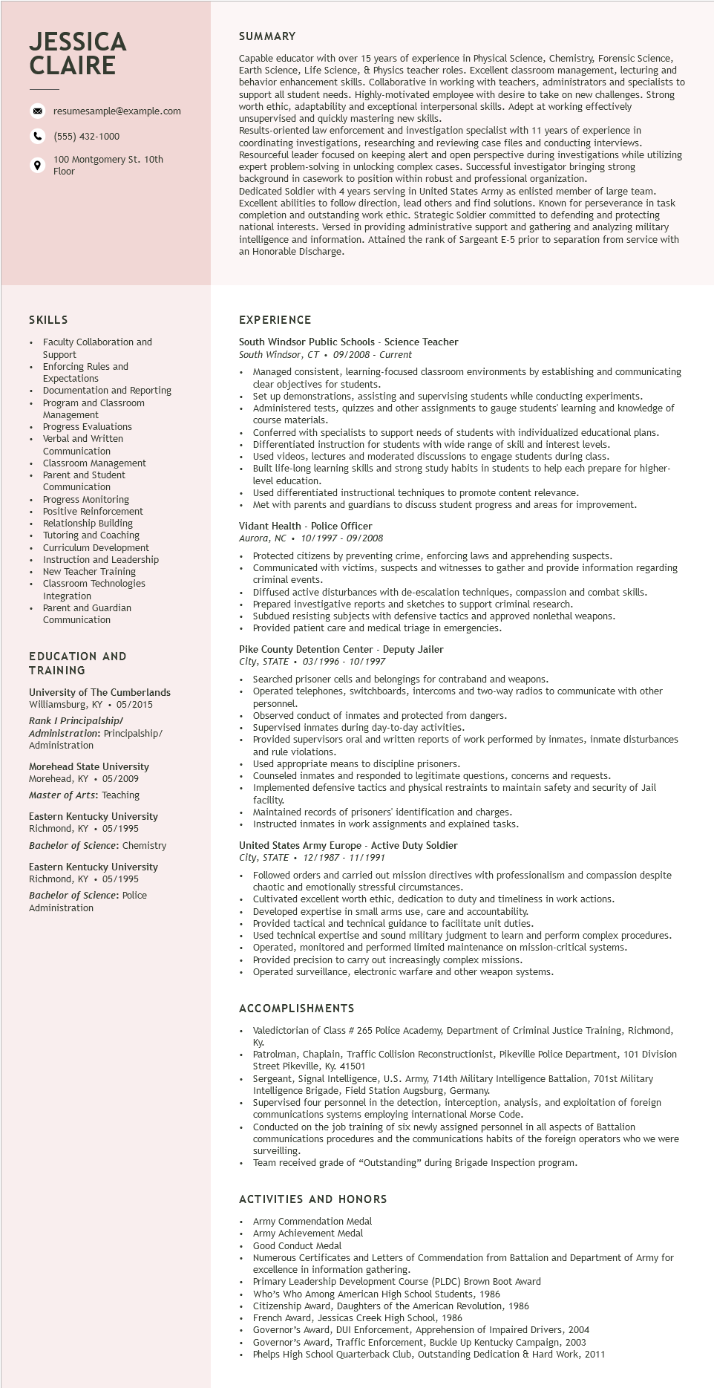

**JESSICA CLAIRE**

resumesample@example.com

(555) 432-1000

100 Montgomery St. 10th Floor

SUMMARY

Capable educator with over 15 years of experience in Physical Science, Chemistry, Forensic Science, Earth Science, Life Science, & Physics teacher roles. Excellent classroom management, lecturing and behavior enhancement skills. Collaborative in working with teachers, administrators and specialists to support all student needs. Highly-motivated employee with desire to take on new challenges. Strong worth ethic, adaptability and exceptional interpersonal skills. Adept at working effectively unsupervised and quickly mastering new skills.

Results. s-oriented

law enforcement and investigation specialist with 11 years of experience in coordinating investigations, researching and reviewing case files and conducting interviews. Resourceful leader focused on keeping alert and open perspective during investigations while utilizing expert problem-solving in unlocking complex cases. Successful investigator bringing strong background in in casework to position within robust and professional organization. Dedicated Soldier with 4 years serving in United States Army as enlisted member of large team. Excellent abilities to follow direction, lead others and find solutions. Known for perseverance in task completion and outstanding work ethic. Strategic Soldier committed to defending and protecting national interests. Versed in providing administrative support and gathering and analyzing military intelligence and information. Attained the rank of Sargeant E-5 prior to separation from service with an Honorable Discharge.

SKILLS

• Faculty Collaboration and Support

Enforcing Rules and Expectations

• Documentation and Reporting

Program and Classroom

Management

Progress Evaluations

Verbal and written

Communication

Classroom Management

Parent and Student Communication

Commu

Progress Monitoring Positive Reinforcement

Relationship Building

Tutoring and Coaching Curriculum Development Instruction and Leadership New Teacher Training Classroom Technologies Integration

• Parent and Guardian Communication

EDUCATION AND

TRAINING

University of The Cumberlands Williamsburg, KY ⚫ 05/2015 Rank I Principalship/ Administration: Principalship/ Administration

Morehead State University Morehead, KY⚫ 05/2009

Master of Arts: Teaching

Eastern Kentucky University Richmond, KY. 05/1995

Bachelor of Science: Chemistry

Eastern Kentucky University Richmond, KY • 05/1995 Bachelor of Science: Police Administration

EXPERIENCE

South Windsor Public Schools - Science Teacher

South Windsor, CT 09/2008 - Current

• Managed consistent, learning-focused classroom environments by establishing and communicating clear objectives for students.

Set up demonstrations, assisting and supervising students while conducting experiments.

Administered tests, quizzes and other assignments to gauge students' learning and knowledge of course materials.

course ma

Conferred with specialists to support needs of students with individualized educational plans. Differentiated instruction for students with wide range of skill and interest levels.

Used videos, lectures and moderated discussions to engage students during class.

Built life-long learning skills and strong study habits in students to help each prepare for higher- level education.

Used differentiated instructional techniques to promote content relevance.

Met with parents and guardians to discuss student progress and areas for improvement.

Vidant Health - Police Officer

Aurora, NC

10/1997-09/2008

Protected citizens by preventing crime, enforcing laws and apprehending suspects.

Communicated with victims, suspects and witnesses to gather and provide information regarding criminal events.

Diffused active disturbances with de-escalation techniques, compassion and combat skills.

Prepared investigative reports and sketches to support criminal research.

Subdued resisting subjects with defensive tactics and approved nonlethal weapons.

Provided patient care and medical triage in emergencies.

Pike County Detention Center - Deputy Jailer

City, STATE. 03/1996 - 10/1997

Searched prisoner cells and belongings for contraband and weapons.

Operated telephones, switchboards, intercoms and two-way radios to communicate with other personnel.

Observed conduct of inmates and protected from dangers.

Supervised inmates during day-to-day activities.

Provided supervisors oral and written reports of work performed by inmates, inmate disturbances and rule violations.

Used appropriate means to discipline prisoners.

Counseled inmates and responded to legitimate questions, concerns and requests.

Implemented defensive tactics and physical restraints to maintain safety and security of Jail facility.

Maintained records of prisoners' identification and charges.

Instructed inmates in work assignments and explained tasks.

United States Army Europe - Active Duty Soldier

*City, STATE. 12/1987 11/1991*

• Followed orders and carried out mission directives with professionalism and compassion despite chaotic and emotionally stressful circumstances.

Cultivated excellent worth ethic, dedication to duty and timeliness in work actions.

Developed expertise in small arms use, care and accountability.

Provided tactical and technical guidance to facilitate unit duties.

Used technical expertise and sound military judgment to learn and perform complex procedures.

• Operated, monitored and performed limited maintenance on mission-critical systems.

Provided precision to carry out increasingly complex missions.

Operated surveillance, electronic warfare and other weapon systems.

**ACCOMPLISHMENTS**

.

.

Valedictorian of Class # 265 Police Academy, Department of Criminal Justice Training, Richmond,

Ky.

Patrolman, Chaplain, Traffic Collision Reconstructionist, Pikeville Police Department, 101 Division Street Pikeville, Ky. 41501

Sergeant, Signal Intelligence, U.S. Army, 714th Military Intelligence Battalion, 701st Military Intelligence Brigade, Field Station Augsburg, Germany.

Supervised four personnel in the detection, interception, analysis, and exploitation of foreign

communications systems employing international Morse Code.

Conducted on the job training of six newly assigned personnel in all aspects of Battalion

communications procedures and the communications habits of the foreign operators who we were surveilling.

Team received grade of "Outstanding" during Brigade Inspection program.

**ACTIVITIES AND HONORS**

Army Commendation Medal

Army Achievement Medal

Good Conduct Medal

Numerous Certificates and Letters of Commendation from Battalion and Department of Army for excellence in information gathering.

Primary Leadership Development Course (PLDC) Brown Boot Award

Who's Who Among American High School Students, 1986

Citizenship Award, Daughters of the American Revolution, 1986

French Award, Jessicas Creek High School, 1986

Governor's Award, DUI Enforcement, Apprehension of Impaired Drivers, 2004 Governor's Award, Traffic Enforcement, Buckle Up Kentucky Campaign, 2003

Phelps High School Quarterback Club, Outstanding Dedication & Hard Work, 2011