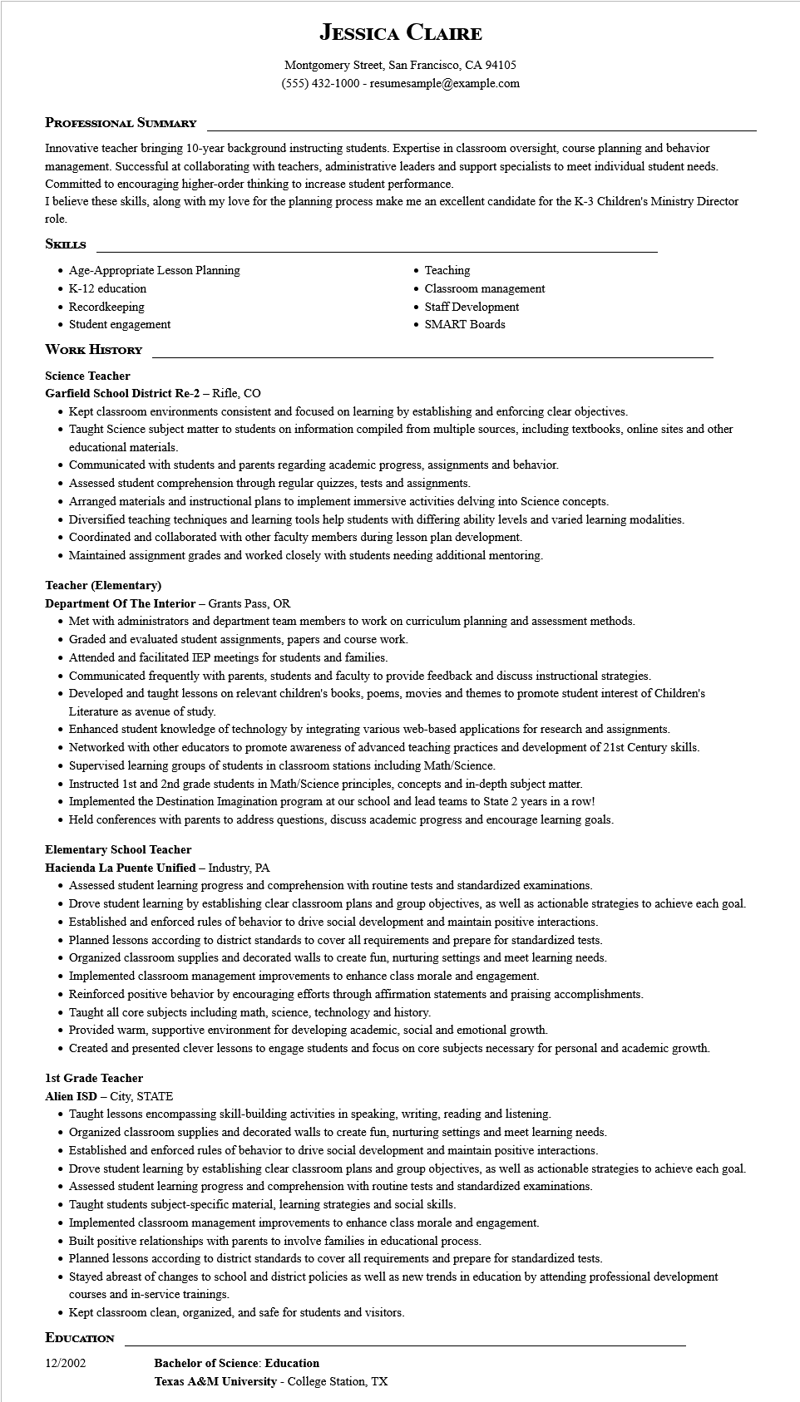

**JESSICA CLAIRE**

Montgomery Street, San Francisco, CA 94105

(555) 432-1000 - resumesample@example.com

**PROFESSIONAL SUMMARY**

Innovative teacher bringing 10-year background instructing students. Expertise in classroom oversight, course planning and behavior management. Successful at collaborating with teachers, administrative leaders and support specialists to meet individual student needs. Committed to encouraging higher-order thinking to increase student performance.

I believe these skills, along with my love for the planning process make me an excellent candidate for the K-3 Children's Ministry Director role.

**SKILLS**

• Age-Appropriate Lesson Planning

• K-12 education.

• Recordkeeping

• Student engagement

**WORK HISTORY**

**Science Teacher**

**Garfield School District Re-2 - Rifle, CO**

Teaching Classroom management

• Staff Development

• SMART Boards

• Kept classroom environments consistent and focused on learning by establishing and enforcing clear objectives.

• Taught Science subject matter to students on information compiled from multiple sources, including textbooks, online sites and other educational materials.

• Communicated with students and parents regarding academic progress, assignments and behavior.

• Assessed student comprehension through regular quizzes, tests and assignments.

• Arranged materials and instructional plans to implement immersive activities delving into Science concepts.

• Diversified teaching techniques and learning tools help students with differing ability levels and varied learning modalities.

• Coordinated and collaborated with other faculty members during lesson plan development.

• Maintained assignment grades and worked closely with students needing additional mentoring.

**Teacher (Elementary)**

**Department Of The Interior - Grants Pass, OR**

• Met with administrators and department team members to work on curriculum planning and assessment methods.

• Graded and evaluated student assignments, papers and course work.

Attended and facilitated IEP meetings for students and families.

• Communicated frequently with parents, students and faculty to provide feedback and discuss instructional strategies.

• Developed and taught lessons on relevant children's books, poems, movies and themes to promote student interest of Children's Literature as avenue of study.

• Enhanced student knowledge of technology by integrating various web-based applications for research and assignments.

• Networked with other educators to promote awareness of advanced teaching practices and development of 21st Century skills.

• Supervised learning groups of students in classroom stations including Math/Science.

• Instructed 1st and 2nd grade students in Math/Science principles, concepts and in-depth subject matter.

• Implemented the Destination Imagination program at our school and lead teams to State 2 years in a row!

• Held conferences with parents to address questions, discuss academic progress and encourage learning goals.

**Elementary School Teacher**

**Hacienda La Puente Unified - Industry, PA**

• Assessed student learning progress and comprehension with routine tests and standardized examinations.

• Drove student learning by establishing clear classroom plans and group objectives, as well as actionable strategies to achieve each goal.

• Established and enforced rules of behavior to drive social development and maintain positive interactions.

• Planned lessons according to district standards to cover all requirements and prepare for standardized tests.

• Organized classroom supplies and decorated walls to create fun, nurturing settings and meet learning needs.

• Implemented classroom management improvements to enhance class morale and engagement.

• Reinforced positive behavior by encouraging efforts through affirmation statements and praising accomplishments.

• Taught all core subjects including math, science, technology and history.

• Provided warm, supportive environment for developing academic, social and emotional growth.

• Created and presented clever lessons to engage students and focus on core subjects necessary for personal and academic growth.

**1st Grade Teacher**

**Alien ISD - City, STATE**

• Taught lessons encompassing skill-building activities in speaking, writing, reading and listening.

• Organized classroom supplies and decorated walls to create fun, nurturing settings and meet learning needs.

Established and enforced rules of behavior to drive social development and maintain positive interactions.

• Drove student learning by establishing clear classroom plans and group objectives, as well as actionable strategies to achieve each goal.

• Assessed student learning progress and comprehension with routine tests and standardized examinations.

• Taught students subject-specific material, learning strategies and social skills.

• Implemented classroom management improvements to enhance class morale and engagement.

• Built positive relationships with parents to involve families in educational process.

• Planned lessons according to district standards to cover all requirements and prepare for standardized tests.

• Stayed abreast of changes to school and district policies as well as new trends in education by attending professional development courses and in-service trainings.

• Kept classroom clean, organized, and safe for students and visitors.

**EDUCATION**

12/2002

**Bachelor of Science: Education**

**Texas A&M University - College Station, TX**