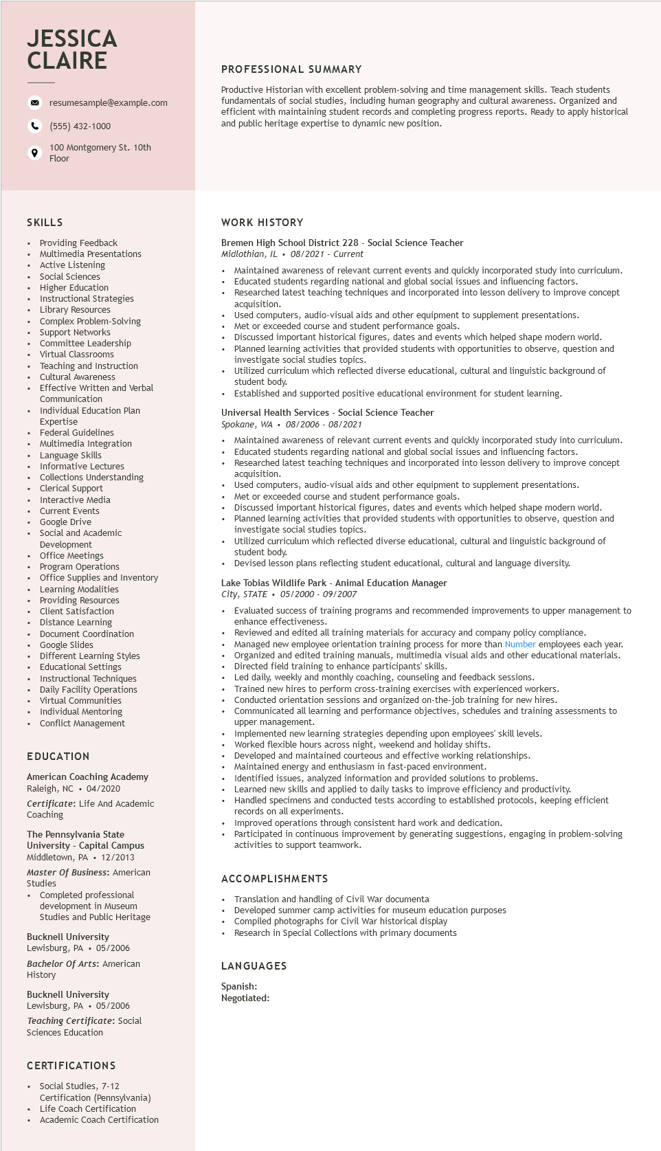

**JESSICA CLAIRE**

resumesample@example.com

(555) 432-1000

100 Montgomery St. 10th Floor

**PROFESSIONAL SUMMARY**

Productive Historian with excellent problem-solving and time management skills. Teach students fundamentals of social studies, including human geography and cultural awareness. Organized and efficient with maintaining student records and completing progress reports. Ready to apply historical and public heritage expertise to dynamic new position.

**SKILLS**

Providing Feedback

Multimedia Presentations

Active Listening Social Sciences Higher Education Instructional Stra

| Strategies

Library Resources

Complex Problem-Solving

Support Networks

suppor

Committee Leadership

Virtual

Classrooms

Teaching and Instruction reaching

Cultural Awareness

Effective Written and Verbal

Communication

Individual Education Plan

Expertise

Experts

Federal Guidelines

Multimedia Integration

Language Skills

Informative Lectures

Collections Understanding

Clerical Support Interactive Media

Current Events

• Google Drive

• Social and Academic

Development

Office Meetings

Program Operations

Office Supplies and Inventory

⚫ Learning Modalities Providing Resources

Client Satisfaction

⚫ Distance Learning

Document Coordination

• Google Slides

Different Learning Styles Educational

Settings

• Instructional Techniques

• Daily Facility Operations Virtual Communities Individual Mentoring

• Conflict Management

EDUCATION

American Coaching Academy Raleigh, NC 04/2020

Certificate: Life And Academic Coaching

The Pennsylvania State University - Capital Campus Middletown, PA • 12/2013 Master of Business: American Studies

• Completed professional development in Museum Studies and Public Heritage

Bucknell University Lewisburg, PA⚫ 05/2006

Bachelor of Arts: American History

Bucknell University

Lewisburg, PA

05/2006

**WORK HISTORY**

Bremen High School District 228 - Social Science Teacher Midlothian, IL. 08/2021 - Current

.

Maintained awareness of relevant current events and quickly incorporated study into curriculum. Educated students regarding national and global social issues and influencing factors.

Researched latest teaching techniques and incorporated into lesson delivery to improve concept acquisition.

Used computers, audio-visual aids and other equipment to supplement presentations. Met or exceeded course and student performance goals.

• Discussed important historical figures, dates and events which helped shape modern world. Planned learning activities that provided students with opportunities to observe, question and investigate social studies topics.

Utilized curriculum which reflected diverse educational, cultural and linguistic background of student body.

Established and supported positive educational environment for student learning.

Universal Health Services - Social Science Teacher

Spokane, WA. 08/2006- 08/2021

Maintained awareness of relevant current events and quickly incorporated study into curriculum. Educated students regarding national and global social issues and influencing factors.

Researched latest teaching techniques and incorporated into lesson delivery to improve concept acquisition.

Used computers, audio-visual aids and other equipment to supplement presentations. Met or exceeded course and student performance goals.

Discussed important historical figures, dates and events which helped shape modern world. Planned learning activities that provided students with opportunities to observe, question and investigate social studies topics.

Utilized curriculum which reflected diverse educational, cultural and linguistic background of student body.

Devised lesson plans reflecting student educational, cultural and language diversity.

Lake Tobias Wildlife Park - Animal Education Manager City, STATE

05/2000-09/2007

Evaluated success of training programs and recommended improvements to upper management to enhance effectiveness.

Reviewed and edited all training materials for accuracy and company policy compliance. Managed new employee orientation training process for more than Number employees each year. Organized and edited training manuals, multimedia visual aids and other educational materials. Directed field training to enhance participants' skills.

Led daily, weekly and monthly coaching, counseling and feedback sessions. Trained new hires to perform cross-training exercises with experienced workers. Conducted orientation sessions and organized on-the-job training for new hires. Communicated

comm all learning and performance objectives, schedules and training assessments to upper management.

Implemented new learning strategies depending upon employees' skill levels. Worked flexible hours across night, weekend and holiday shifts.

Developed and maintained courteous and effective working relationships.

Maintained ener

d energy and enthusiasm in fast-paced environment.

Identified issues, analyzed information and provided solutions to problems.

Learned new skills and applied to daily tasks to improve efficiency and productivity.

Handled specimens and conducted tests according to established protocols, keeping efficient records on all experiments.

Improved operations through consistent hard work and dedication.

Participated in continuous improvement by generating suggestions, engaging in problem-solving activities to support teamwork.

ACCOMPLISHMENTS

Translation and handling of Civil War documenta

Developed summer camp activities for museum education purposes

Compiled photographs for Civil War historical display

Research in Special Collections with primary documents

LANGUAGES

Spanish: Negotiated:

*Teaching Certificate: Social*

Sciences Education

CERTIFICATIONS

• Social Studies, 7-12

Certification (Pennsylvania)

• Life Coach Certification

• Academic Coach Certification