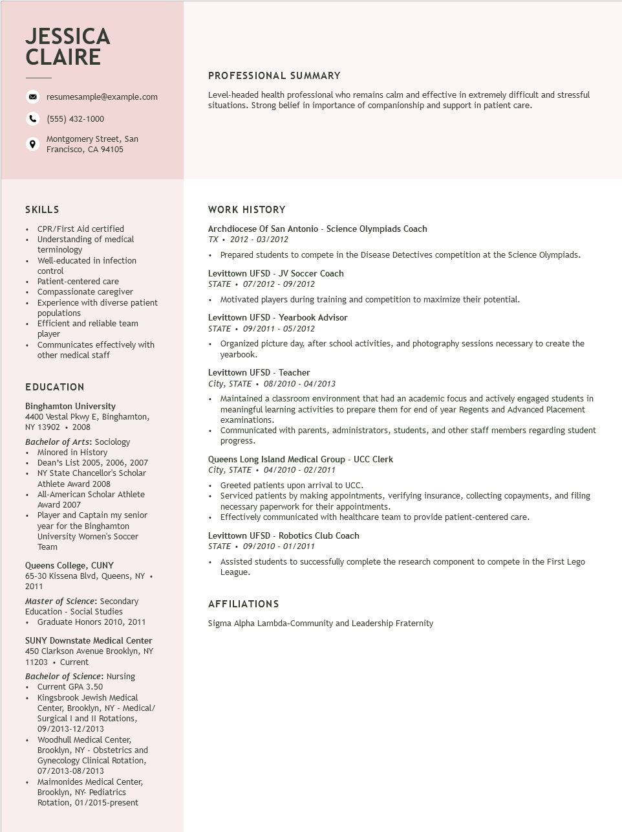

**JESSICA CLAIRE**

resumesample@example.com

(555) 432-1000

Montgomery Street, San Francisco, CA 94105

PROFESSIONAL SUMMARY

Level-headed health professional who remains calm and effective in extremely difficult and stressful situations. Strong belief in importance of companionship and support in patient care.

SKILLS

• CPR/First Aid certified

• Understanding of medical terminology

• Well-educated in infection control

• Patient-centered care

• Compassionate caregiver

Experience with diverse patient populations

• Efficient and reliable team player

• Communicates effectively with

other medical staff

EDUCATION

**Binghamton University**

4400 Vestal Pkwy E, Binghamton, NY 13902. 2008

Bachelor of Arts: Sociology • Minored in History

• Dean's List 2005, 2006, 2007

·

·

•

NY State Chancellor's Scholar

Athlete Award 2008

All-American Scholar Athlete

Award 2007

Player and Captain my senior

year for the Binghamton

University Women's Soccer Team

Queens College, CUNY

65-30 Kissena Blvd, Queens, NY. 2011

Master of Science: Secondary Education - Social Studies

• Graduate Honors 2010, 2011

SUNY Downstate Medical Center 450 Clarkson Avenue Brooklyn, NY 11203. Current

Bachelor of Science: Nursing

• Current GPA 3.50

Kingsbrook Jewish Medical

Center, Brooklyn, NY - Medical/ Surgical I and II Rotations, 09/2013-12/2013

⚫ Woodhull Medical Center, Brooklyn, NY - Obstetrics and

Gynecology Clinical Rotation, 07/2013-08/2013

Maimonides Medical Center,

Brooklyn, NY- Pediatrics

Rotation, 01/2015-present

WORK HISTORY

Archdiocese of San Antonio - Science Olympiads Coach

TX 2012-03/2012

• Prepared students to compete in the Disease Detectives competition at the Science Olympiads.

Levittown UFSD - JV Soccer Coach

STATE⚫ 07/2012 - 09/2012

• Motivated players during training and competition to maximize their potential.

Levittown UFSD - Yearbook Advisor

*STATE⚫ 09/2011- 05/2012*

• Organized picture day, after school activities, and photography sessions necessary to create the yearbook.

Levittown UFSD - Teacher

*City, STATE 08/2010 - 04/2013*

• Maintained a classroom environment that had an academic focus and actively engaged students in meaningful learning activities to prepare them for end of year Regents and Advanced Placement examinations.

• Communicated with parents, administrators, students, and other staff members regarding student progress.

Queens Long Island Medical Group - UCC Clerk

*City, STATE⚫ 04/2010- 02/2011*

• Greeted patients upon arrival to UCC.

• Serviced patients by making appointments, verifying insurance, collecting copayments, and filing necessary paperwork for their appointments.

• Effectively communicated with healthcare team to provide patient-centered care.

Levittown UFSD - Robotics Club Coach

STATE⚫ 09/2010 - 01/2011

• Assisted students to successfully complete the research component to compete in the First Lego League.

**AFFILIATIONS**

Sigma Alpha Lambda-Community and Leadership Fraternity