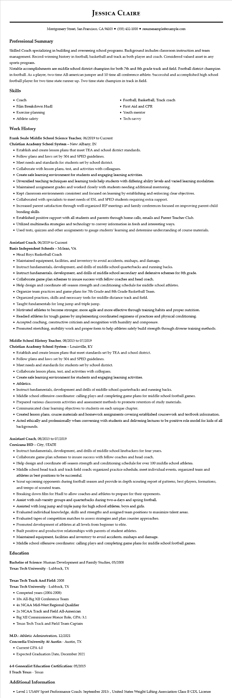

**JESSICA CLAIRE**

Montgomery Street, San Francisco, CA 94105 ⚫ (555) 432-1000⚫ resumesample@example.com

**Professional Summary**

Skilled Coach specializing in building and overseeing school programs. Background includes classroom instruction and team management. Record-winning history in football, basketball and track as both player and coach. Considered valued asset in any sports program.

Notable accomplishments are middle school district champion for both 7th and 8th grade track and field. Football district champion in football. As a player, two-time All-american jumper and 10 time all conference athlete. Successful and accomplished high school football player for two time state runner up. Two time state champion in track in field.

Skills

• Coach

• Film Breakdown Hudl

• Exercise planning

• Athlete safety

**Work History**

Frank Seale Middle School Science Teacher, 06/2019 to Current

Christian Academy School System - New Albany, IN

• Football, Basketball, Track coach

• First Aid and CPR

• Youth mentor

• Tech-savvy

• Establish and create lesson plans that meet TEA and school district standards.

• Follow plans and laws set by 504 and SPED guidelines.

• Meet needs and standards for students set by school district.

• Collaborate with lesson plans, test, and activities with colleagues.

• Create safe learning environment for students and engaging learning activities.

• Diversified teaching techniques and learning tools help students with differing ability levels and varied learning modalities.

• Maintained assignment grades and worked closely with students needing additional mentoring.

• Kept classroom environments consistent and focused on learning by establishing and enforcing clear objectives.

• Collaborated with specialists to meet needs of ESL and SPED students requiring extra support.

• Increased parent satisfaction through well-organized IEP meetings and family conferences focused on improving parent-child bonding skills.

• Established positive rapport with all students and parents through home calls, emails and Parent Teacher Club.

• Utilized multimedia strategies and technology to convey information in fresh and interesting ways.

• Used tests, quizzes and other assignments to gauge students' learning and determine understanding of course materials.

Assistant Coach, 06/2019 to Current

Basis Independent Schools - Mclean, VA

• Head Boys Basketball Coach

• Maintained equipment, facilities, and inventory to avoid accidents, mishaps, and damage.

• Instruct fundamentals, development, and drills of middle school quarterbacks and running backs.

• Instruct fundamentals, development, and drills of middle school secondary and defensive schemes for 8th grade.

• Collaborate game plan schemes to insure success with fellow coaches and head coach.

• Help design and coordinate off-season strength and conditioning schedule for middle school athletes.

• Organize team practices and game plans for 7th Grade and 8th Grade Basketball Team.

• Organized practices, skills and necessary tools for middle-distance track and field.

• Taught fundamentals for long jump and triple jump.

• Motivated athletes to become stronger, more agile and more effective through training habits and proper nutrition.

• Readied athletes for tough games by implementing coordinated regimens of practices and physical conditioning.

• Accepted coaching, constructive criticism and recognition with humility and composure.

• Promoted stretching, mobility work and proper form to help athletes safely build strength through diverse training methods.

Middle School History Teacher, 08/2015 to 07/2019

Christian Academy School System - Louisville, KY

• Establish and create lesson plans that meet standards set by TEA and school district.

• Follow plans and laws set by 504 and SPED guidelines.

• Meet needs and standards for students set by school district.

• Collaborate lesson plans, test, and activities with collogues.

• Create safe learning environment for students and engaging learning activities.

• Athletics.

• Instruct fundamentals, development and drills of middle school quarterbacks and running backs.

• Middle school offensive coordinator: calling plays and completing game plans for middle school football games.

• Prepared various classroom activities and assessment methods to promote retention of study materials.

• Communicated clear learning objectives to students on each unique chapter.

• Created lesson plans, course materials and homework assignments covering established coursework and textbook information.

• Acted ethically and professionally when conversing with students and delivering lectures to be positive role model for kids of all backgrounds.

Assistant Coach, 08/2015 to 07/2019

Corsicana ISD - City, STATE

• Instruct fundamentals, development, and drills of middle school linebackers for four years.

• Collaborate game plan schemes to insure success with fellow coaches and head coach.

• Help design and coordinate off-season strength and conditioning schedule for over 100 middle school athletes.

• Middle school head track and track field coach: organized practice schedule, meet individual events, organized team and athletes in best positions to be successful.

• Scout upcoming opponents during football season and provide in depth scouting report of patterns, best players, formations, and tempo of scouted team.

• Breaking down film for Hudl to allow coaches and athletes to prepare for their opponents.

• Assist with sub-varsity groups and quarterbacks during two-a-days and spring football.

• Assisted with long jump and triple jump for high school athletes, boys and girls.

• Evaluated individual knowledge, skills and strengths and assigned team positions to maximize talent areas.

• Evaluated tapes of competition matches to assess strategies and plan counter approaches.

• Promoted development of athletes at all levels from beginner to elite.

• Built positive and productive relationships with parents of student athletes.

• Maintained equipment, facilities and inventory to avoid accidents, mishaps and damage.

• Middle school offensive coordinator: calling plays and completing game plans for middle school football games.

**Education**

Bachelor of Science: Human Development and Family Studies, 05/2008

**Texas Tech University - Lubbock, TX**

**Texas Tech Track And Field: 2008**

**Texas Tech University - Lubbock, TX**

• Competed years (2004-2008)

• 10x All-Big XII Conference Team

• 4x NCAA Mid-West Regional Qualifier

• 2x NCAA Track and Field All-American

• Big XII Commissioner Honor Role, GPA: 3.1

• Texas Tech Track and Field Team Captain

**M.D.: Athletic Adminstration, 12/2021 Concordia University At Austin - Austin, TX**

• Current GPA 4.0

• Expected Graduation Date, December 2021

**4-8 Generalist Education Certification: 05/2015**

I Teach Texas - Texas

**Additional Information**

• Level 1 USAW Sport Performance Coach: September 2015:, United States Weight Lifting Association Class B CDL License