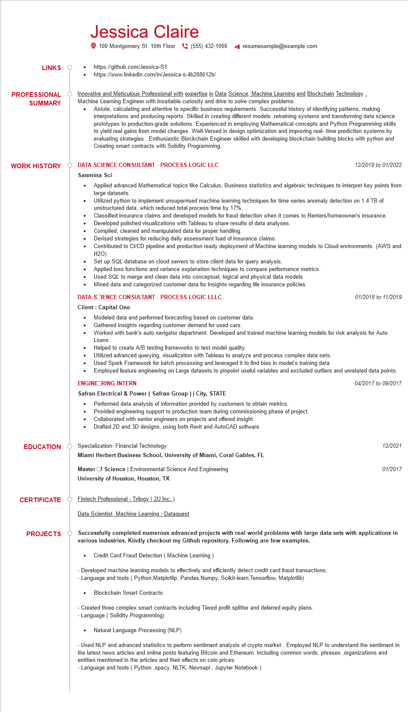

**LINKS**

**PROFESSIONAL**

**SUMMARY**

Jessica Claire

100 Montgomery St. 10th Floor (555) 432-1000

https://github.com/Jessica-S1

https://www.linkedin.com/in/Jessica-s-4b288612b/

resumesample@example.com

Innovative and Meticulous Professional with expertise in Data Science, Machine Learning and Blockchain Technology. Machine Learning Engineer with Insatiable curiosity and drive to solve complex problems.

Astute, calculating and attentive to specific business requirements. Successful history of identifying patterns, making interpretations and producing reports. Skilled in creating different models,retraining systems and transforming data science prototypes to production-grade solutions. Experienced in employing Mathematical concepts and Python Programming skills to yield real gains from model changes. Well-Versed in design optimization and improving real-time prediction systems by evaluating strategies. Enthusiastic Blockchain Engineer skilled with developing blockchain building blocks with python and Creating smart contracts with Solidity Programming.

WORK HISTORY DATA SCIENCE CONSULTANT - PROCESS LOGIC LLC

Sanmina Sci

•

12/2019 to 01/2022

Applied advanced Mathematical topics like Calculus, Business statistics and algebraic techniques to interpret key points from large datasets.

Utilized python to implement unsupervised machine learning techniques for time series anomaly detection on 1.4 TB of unstructured data, which reduced total process time by 17%.

Classified insurance claims and developed models for fraud detection when it comes to Renters/homeowner's insurance. Developed polished visualizations with Tableau to share results of data analyses.

Compiled, cleaned and manipulated data for proper handling.

Devised strategies for reducing daily assessment load of Insurance claims.

Contributed to CI/CD pipeline and production ready deployment of Machine learning models to Cloud environments. (AWS and H2O)

Set up SQL database on cloud servers to store client data for query analysis.

Applied loss functions and variance explanation techniques to compare performance metrics.

Used SQL to merge and clean data into conceptual, logical and physical data models Mined data and categorized customer data for Insights regarding life insurance policies.

DATA SCIENCE CONSULTANT - PROCESS LOGIC LLLC

Client: Capital One

· Modeled data and performed forecasting based on customer data. Gathered insights regarding customer demand for used cars.

01/2018 to 11/2019

Worked with bank's auto navigator department. Developed and trained machine learning models for risk analysis for Auto Loans.

Helped to create A/B testing frameworks to test model quality.

Utilized advanced querying, visualization with Tableau to analyze and process complex data sets.

Used Spark Framework for batch processing and leveraged it to find bias in model's training data.

Employed feature engineering on Large datasets to pinpoint useful variables and excluded outliers and unrelated data points. ENGINE RING INTERN

Safran Electrical & Power (Safran Group) | City, STATE

04/2017 to 09/2017

Performed data analysis of information provided by customers to obtain metrics.

Provided engineering support to production team during commissioning phase of project. Collaborated with senior engineers on projects and offered insight.

Drafted 2D and 3D designs, using both Revit and AutoCAD software.

EDUCATION Specialization- Financial Technology

**Miami Herbert Business School, University of Miami, Coral Gables, FL**

Master of Science | Environmental Science And Engineering

**University of Houston, Houston, TX**

**CERTIFICATE**

Fintech Professional - Trilogy (2U Inc.)

Data Scientist, Machine Learning - Dataquest

**PROJECTS**

12/2021

01/2017

**Successfully completed numerous advanced projects with real world problems with large data sets with applications in various industries. Kindly checkout my Github repository. Following are few examples.**

Credit Card Fraud Detection (Machine Learning)

-Developed machine learning models to effectively and efficiently detect credit card fraud transactions. - Language and tools (Python, Matplotlip, Pandas, Numpy, Scikit-learn, Tensorflow, Matplotlib)

. Blockchain Smart Contracts

Created three complex smart contracts including Tiered profit splitter and deferred equity plans. Language (Solidity Programming)

Natural Language Processing (NLP)

Used NLP and advanced statistics to perform sentiment analysis of crypto market. Employed NLP to understand the sentiment in the latest news articles and online posts featuring Bitcoin and Ethereum. Including common words, phrases, organizations and entities mentioned in the articles and their effects on coin prices.

- Language and tools (Python,spacy, NLTK, Newsapi, Jupyter Notebook)