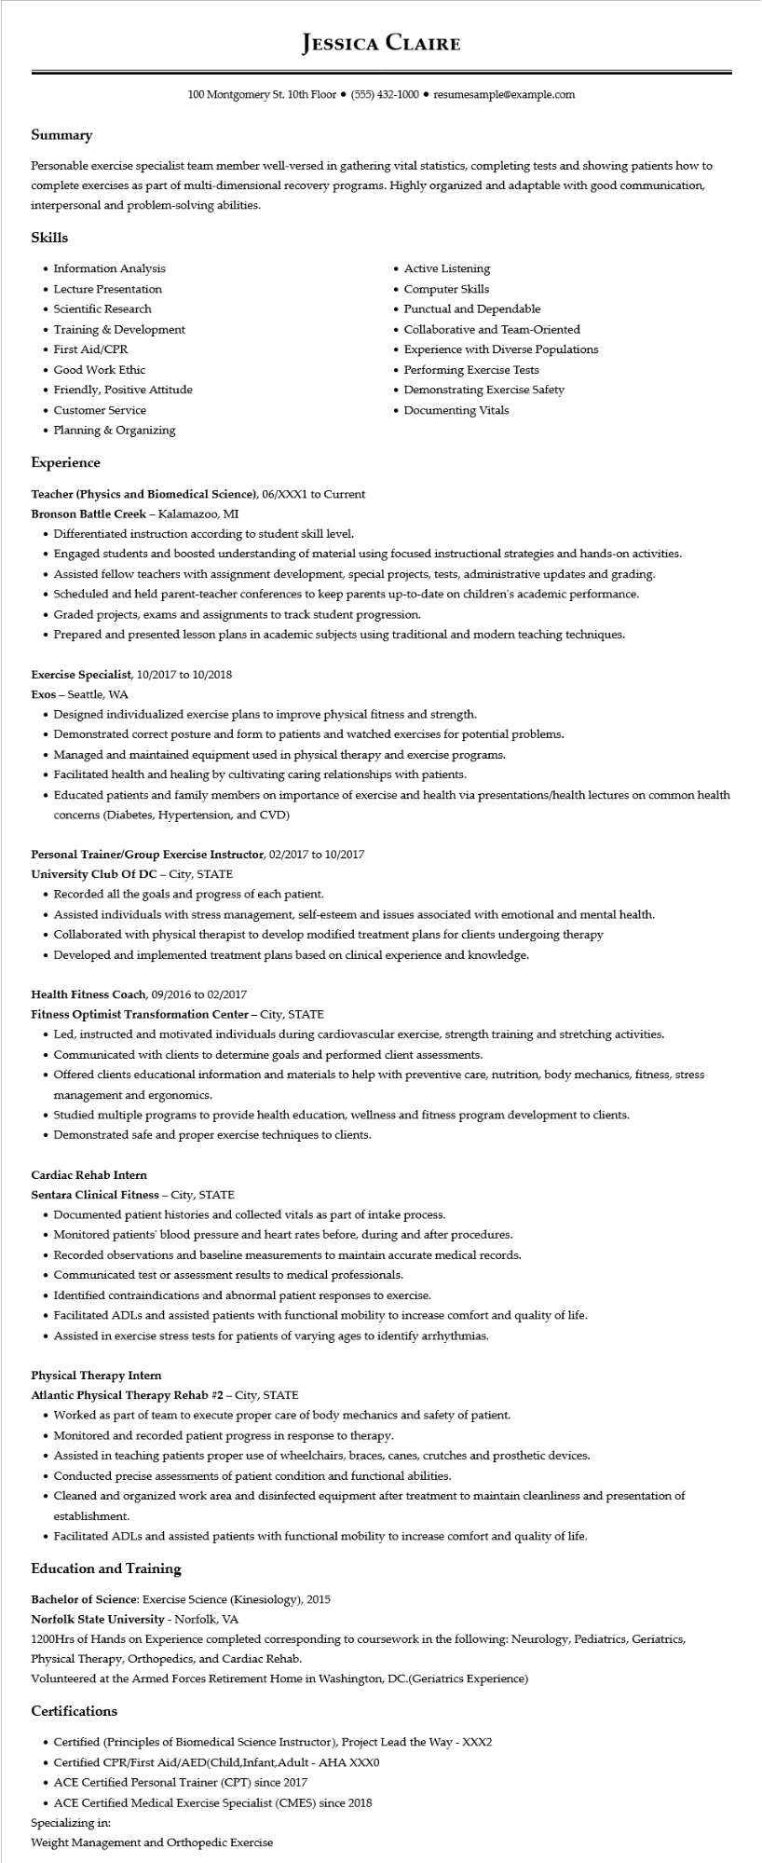

**JESSICA CLAIRE**

100 Montgomery St. 10th Floor ⚫ (555) 432-1000⚫ resumesample@example.com

**Summary**

Personable exercise specialist team member well-versed in gathering vital statistics, completing tests and showing patients how to complete exercises as part of multi-dimensional recovery programs. Highly organized and adaptable with good communication, interpersonal and problem-solving abilities.

**Skills**

• Information Analysis

• Lecture Presentation

• Scientific Research

• Training & Development

• First Aid/CPR

• Good Work Ethic

• Friendly, Positive Attitude

• Customer Service

• Planning & Organizing

**Experience**

**Teacher (Physics and Biomedical Science), 06/XXX1 to Current Bronson Battle Creek - Kalamazoo, MI**

• Differentiated instruction according to student skill level.

• Active Listening

• Computer Skills

• Punctual and Dependable

• Collaborative and Team-Oriented

• Experience with Diverse Populations

• Performing Exercise Tests

• Demonstrating Exercise Safety

• Documenting Vitals

• Engaged students and boosted understanding of material using focused instructional strategies and hands-on activities.

• Assisted fellow teachers with assignment development, special projects, tests, administrative updates and grading.

• Scheduled and held parent-teacher conferences to keep parents up-to-date on children's academic performance.

• Graded projects, exams and assignments to track student progression.

• Prepared and presented lesson plans in academic subjects using traditional and modern teaching techniques.

Exercise Specialist, 10/2017 to 10/2018

Exos Seattle, WA

• Designed individualized exercise plans to improve physical fitness and strength.

• Demonstrated correct posture and form to patients and watched exercises for potential problems.

• Managed and maintained equipment used in physical therapy and exercise programs.

• Facilitated health and healing by cultivating caring relationships with patients.

• Educated patients and family members on importance of exercise and health via presentations/health lectures on common health concerns (Diabetes, Hypertension, and CVD)

**Personal Trainer/Group Exercise Instructor, 02/2017 to 10/2017**

**University Club Of DC - City, STATE**

• Recorded all the goals and progress of each patient.

• Assisted individuals with stress management, self-esteem and issues associated with emotional and mental health.

• Collaborated with physical therapist to develop modified treatment plans for clients undergoing therapy

• Developed and implemented treatment plans based on clinical experience and knowledge.

Health Fitness Coach, 09/2016 to 02/2017

**Fitness Optimist Transformation Center - City, STATE**

• Led, instructed and motivated individuals during cardiovascular exercise, strength training and stretching activities.

• Communicated with clients to determine goals and performed client assessments.

• Offered clients educational information and materials to help with preventive care, nutrition, body mechanics, fitness, stress management and ergonomics.

• Studied multiple programs to provide health education, wellness and fitness program development to clients.

• Demonstrated safe and proper exercise techniques to clients.

Cardiac Rehab Intern

Sentara Clinical Fitness - City, STATE

• Documented patient histories and collected vitals as part of intake process.

• Monitored patients' blood pressure and heart rates before, during and after procedures.

• Recorded observations and baseline measurements to maintain accurate medical records.

• Communicated test or assessment results to medical professionals.

• Identified contraindications and abnormal patient responses to exercise.

• Facilitated ADLs and assisted patients with functional mobility to increase comfort and quality of life.

• Assisted in exercise stress tests for patients of varying ages to identify arrhythmias.

Physical Therapy Intern

**Atlantic Physical Therapy Rehab #2 - City, STATE**

• Worked as part of team to execute proper care of body mechanics and safety of patient.

• Monitored and recorded patient progress in response to therapy.

• Assisted in teaching patients proper use of wheelchairs, braces, canes, crutches and prosthetic devices.

• Conducted precise assessments of patient condition and functional abilities.

• Cleaned and organized work area and disinfected equipment after treatment to maintain cleanliness and presentation of establishment.

• Facilitated ADLs and assisted patients with functional mobility to increase comfort and quality of life.

**Education and Training**

Bachelor of Science: Exercise Science (Kinesiology), 2015

**Norfolk State University - Norfolk, VA**

1200Hrs of Hands on Experience completed corresponding to coursework in the following: Neurology, Pediatrics, Geriatrics, Physical Therapy, Orthopedics, and Cardiac Rehab.

Volunteered at the Armed Forces Retirement Home in Washington, DC.(Geriatrics Experience)

**Certifications**

• Certified (Principles of Biomedical Science Instructor), Project Lead the Way - XXX2

• Certified CPR/First Aid/AED(Child,Infant,Adult - AHA XXX0

• ACE Certified Personal Trainer (CPT) since 2017

• ACE Certified Medical Exercise Specialist (CMES) since 2018

Specializing in:

Weight Management and Orthopedic Exercise